FOR IMMEDIATE RELEASE
NOVEMBER 25, 2019

GRAMMY-NOMINATED RODDY RICCH DROPS “TIP TOE” FT. A BOOGIE WIT DA HOODIE

ACCOMPANIED BY ELECTRIC VISUAL DIRECTED BY CHRISTIAN BRESLAUER

ANTISOCIAL TOUR BEGINS DECEMBER 28TH AT LOS ANGELES’ HOLLYWOOD PALLADIUM
PURCHASE TICKETS HERE

PLEASE EXCUSE ME FOR BEING ANTISOCIAL DROPS ON DECEMBER 6TH

WATCH & STREAM “TIP TOE” FT. A BOOGIE WIT DA HOODIE HERE

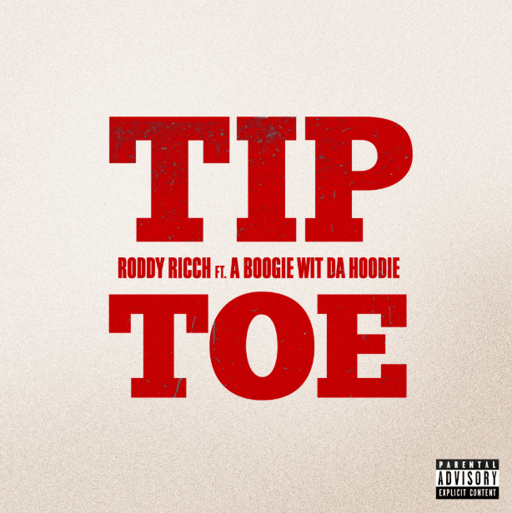
DOWNLOAD HIGH-RES SINGLE ARTWORK HERE

GRAMMY-nominated rapper Roddy Ricch unveils his latest offering “Tip Toe” ft. A Boogie Wit Da Hoodie after receiving three GRAMMY nominations last week. Directed by Christian Breslauer, the official companion video showcases stunning visuals alongside the electric track; watch HERE. The single proceeds Ricch’s half-time performance at the Los Angeles Clippers game last Friday; watch HERE. “Tip Toe” ft. A Boogie Wit Da Hoodie is available now on all DSPS and streaming services HERE.

Rising star Roddy Ricch received three nominations for the 2020 GRAMMY Awards. He was nominated for Best Rap Performance (Racks in the Middle by Nipsey Hussle ft. Roddy Ricch and Hit-Boy), Best Rap Song (Racks in the Middle by Nipsey Hussle ft. Roddy Ricch and Hit-Boy), and Best Rap/Sung Performance (Ballin by Mustard ft. Roddy Ricch). He performed both songs at the Los Angeles Clippers basketball game on Friday, November 22nd; watch the performance HERE.

Roddy Ricch announced plans for his first ever epic North American headline tour – The Antisocial Tour. The dates begin Saturday, December 28th at Los Angeles, CA’s world famous Hollywood Palladium and then continue into February 2020. For complete details and ticket information, please visit www.roddyricchofficial.com/tour. In addition, Roddy will join fellow stars like ScHoolboy Q and DaBaby at Winter Breakout 2019, set for Vancouver, BC’s Pacific Coliseum on Friday, December 13th. Complete details can be found HERE. Roddy made his festival debut earlier this season at the Day N Vegas Festival – more information HERE.

Ricch’s upcoming live schedule celebrates the eagerly awaited arrival of his major label debut album, PLEASE EXCUSE ME FOR BEING ANTISOCIAL, due Friday, December 6th via Atlantic Records. The LP is highlighted by the banging new single, “Start Wit Me (Feat. Gunna),” available for streaming and download HERE; the track is accompanied by an official companion video, directed by Spike Jordan, streaming HERE. “The brilliance of ‘Start Wit Me’ lies in its juxtaposition between flexes and threats, pure braggadocio and blunt brutality,” raved Rolling Stone upon the track’s release. “For a full calendar year, Roddy has been on the cusp of stardom. He’s managed to make a Marshmello beat sound hard, created a song of the year contender with DJ Mustard, and carved a new path for Compton music in the process. ‘Start Wit Me’ feels like a tipping point. Predictably, the Ricch continue to get richer.”

PLEASE EXCUSE ME FOR BEING ANTISOCIAL is star-studded with an array of iconic features, including Meek Mill, Ty Dolla $ign, and A Boogie wit Da Hoodie, among others. Highlights include the recently released single, “Big Stepper,” available for streaming and download HERE; the track is accompanied by an official companion video, directed by frequent collaborator JMP (XXXTentacion, G Herbo, Playboi Carti) and streaming HERE.

Ricch dropped the acclaimed hip-hop hit, “Out Tha Mud,” available for streaming and download HERE, earlier in the year. The track is joined by a companion video, directed by JMP and now boasting over 17 million YouTube views HERE. “Out Tha Mud” drew critical applause upon its release, with Pitchfork naming it among “The Ones,” noting, “Like usual with Roddy, his songwriting is catchy…and his gleaming melody calls for countless replays.”

Named earlier this year to the 2019 XXL Freshman Class, Ricch recently received two top nominations from the BET Hip Hop Awards, including “Best New Artist” and “Best Mixtape,” the latter honoring 2018’s FEED THA STREETS II, available for streaming and download HERE. The mixtape – which marked the 20-year-old Compton MC’s SoundScan/Billboard 200 chart debut – sees him teaming up with some of hip-hop’s top studio superstars, including Scott Storch (Post Malone, T.I., Young Thug), Cassius Jay (Cardi B, Migos, Gucci Mane), and hot emerging producer Sonic. FEED THA STREETS II is highlighted by such tracks as RIAA Platinum-Certified “Every Season“ and RIAA Platinum-Certified “Die Young,” both available at all DSPs and streaming services. Produced by London On Tha Track (Lil Wayne, Drake, Post Malone), “Die Young” earned online applause, with Passion of the Weiss raving, “Roddy Ricch sounds like Future, but he expresses his emotions with clarity…He blurs the lines between rap and R&B, delivering cold-hearted lyrics in a crystal clear fashion, like a one-man Jagged Edge… Roddy Ricch doesn’t need anyone to tell you he’s going to be good. He’ll be good. He already is good. This song is great.”

The “Die Young” companion visual – directed by JD Films – also proved a viral favorite, with individual YouTube views approaching 79 million HERE. In addition, Roddy went in depth on “Die Young” in a popular installment of Genius’ “Verified,” streaming HERE.

Wise beyond his years, schooled in real-life struggles, and eloquently effective, Roddy Ricch clearly and concisely conveys truth by way of cinematic rhymes and catchy hooks. The self-proclaimed “illustrator of the streets” uploaded his first single, “Ricch N****” to SoundCloud in 2016 and immediately caught fire, generating more than 200,000 streams within two months. He followed up with his debut mixtape, FEED THA STREETS, streaming HERE. The project includes the breakthrough hit single, “Fucc It Up,” accompanied by a smash companion video, now boasting more than 31 million individual views via Roddy Ricch’s official YouTube channel HERE.

In addition, Roddy celebrated the first anniversary of FEED THA STREETS with the 2019 smash single, RIAA Gold-Certified “Down Below.” The track’s companion visual –directed by JD Films – has now drawn YouTube views fast approaching 83 million HERE.

As if all that weren’t enough, Ricch has proven an in-demand featured artist, including 2018’s worldwide hit collaboration with Marshmello, “Project Dreams,” joined by an official video currently with over 60 million YouTube views HERE. More recently, Roddy teamed with Mustard for the blockbuster new single, “Ballin’ (Feat. Roddy Ricch),” joined by a companion visual boasting over 23 million views HERE.

(TOUR ITINERARY BELOW)

RODDY RICCH
NORTH AMERICAN TOUR 2019/20

DECEMBER
13 Vancouver, BC Pacific Coliseum *
28 Los Angeles, CA Hollywood Palladium

JANUARY
14 Seattle, WA The Showbox
15 Portland, OR Roseland Theater
17 San Francisco, CA The Regency Ballroom
19 Phoenix, AZ The Van Buren
22 Dallas, TX Canton Hall
23 Austin, TX Emo’s East
24 Houston, TX Warehouse Live
26 Atlanta, GA Masquerade - Heaven Stage
28 Washington, DC 9:30 Club
30 Philadelphia, PA Theatre of Living Arts (TLA)
31 Brooklyn, NY Brooklyn Steel

FEBRUARY
1 Allston, MA Brighton Music Hall
5 Montreal, QC Club Soda
6 Toronto, ON Phoenix Concert Theatre
7 Cleveland, OH House of Blues
9 Detroit, MI St. Andrews Hall
10 Chicago, IL Patio Theater
11 Minneapolis, MN First Avenue - Mainroom
13 Lawrence, KS Liberty Hall
15 Denver, CO Cervantes’ Masterpiece Ballroom

* Winter Breakout 2019

# # #

CONNECT WITH RODDY RICCH
OFFICIAL I TWITTER | SOUNDCLOUD | YOUTUBE | INSTAGRAM

PRESS CONTACT
Brittany Bell | Brittany.Bell@atlanticrecords.com

