FOR IMMEDIATE RELEASE
DECEMBER 6, 2019

RODDY RICCH UNLEASHES PLEASE EXCUSE ME FOR BEING ANTISOCIAL

3X GRAMMY® AWARD-NOMINATED RAPPER FINALLY DROPS MAJOR LABEL DEBUT ALBUM

HIGHLIGHTS INCLUDE SUCH HIP HOP HITS AS “START WIT ME (FEAT. GUNNA),”
“TIP TOE (FEAT. A BOOGIE WIT DA HOODIE),” AND “BIG STEPPER”

THE ANTISOCIAL TOUR BEGINS DECEMBER 28TH AT LOS ANGELES’ HOLLYWOOD PALLADIUM
PURCHASE TICKETS HERE

PLEASE EXCUSE ME FOR BEING ANTISOCIAL AVAILABLE NOW HERE

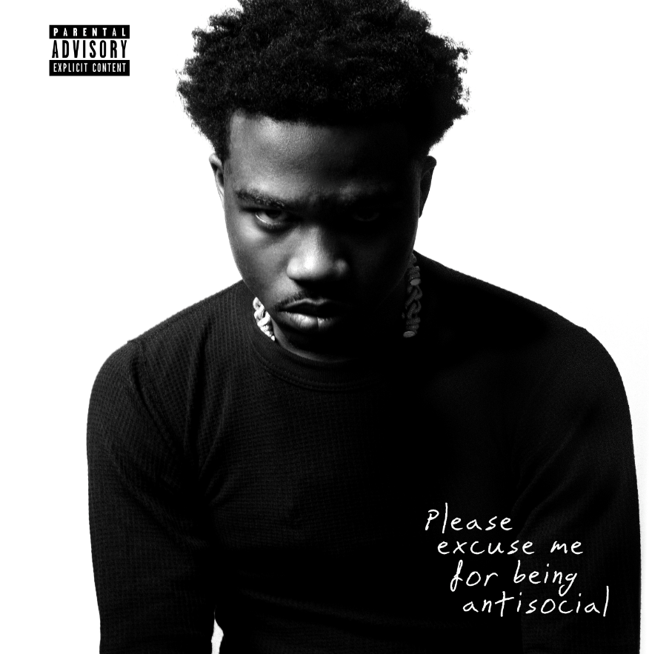
DOWNLOAD HIGH-RES COVER ART HERE

3x GRAMMY® Award-nominated rapper Roddy Ricch has announced today’s release of his long awaited major label debut album. PLEASE EXCUSE ME FOR BEING ANTISOCIAL is available now via Atlantic Records HERE.

PLEASE EXCUSE ME FOR BEING ANTISOCIAL includes iconic features from such superstars as Meek Mill, Ty Dolla $ign, Mustard, and Lil Durk alongside such stellar new singles as “Tip Toe (Feat. A Boogie Wit Da Hoodie),” “Start Wit Me (Feat. Gunna),” and “Big Stepper,” all of which are joined by companion visuals streaming now at the official Roddy Ricch YouTube channel HERE.

“Tip Toe (Feat. A Boogie Wit Da Hoodie)” arrived last week, mere days after Ricch was honored with three prestigious GRAMMY® Award nominations, including “Best Rap Performance” and “Best Rap Song” for Nipsey Hussle’s “Racks In The Middle (Feat. Roddy Ricch & Hit-Boy),” as well as a “Best Rap/Sung Performance” nod for Mustard’s “Ballin (Feat. Roddy Ricch).” The electrifying new track arrived with an equally spectacular companion video, directed by Christian Breslauer (YNW Melly, Chris Brown) and streaming HERE.

Directed by Spike Jordan (Lil Uzi Vert, Meek Mill), “Start Wit Me (Feat. Gunna)” was hailed by Rolling Stone upon its recent premiere: “The brilliance of ‘Start Wit Me’ lies in its juxtaposition between flexes and threats, pure braggadocio and blunt brutality…For a full calendar year, Roddy has been on the cusp of stardom. He’s managed to make a Marshmello beat sound hard, created a song of the year contender with DJ Mustard, and carved a new path for Compton music in the process. ‘Start Wit Me’ feels like a tipping point. Predictably, the Ricch continue to get richer.”

Produced by Lil Mexico, “Big Stepper” dropped in early October, joined by a powerful clip directed by frequent collaborator JMP (XXXTentacion, G Herbo, Playboi Carti), and streaming HERE.

Ricch – who recently heralded PLEASE EXCUSE ME FOR BEING ANTISOCIAL with an incredible halftime performance at the Los Angeles Clippers’ victory over the Houston Rockets on November 22nd, streaming HERE – is set to embark on his epic first-ever North American headline tour. The Antisocial Tour begins Saturday, December 28th at Los Angeles, CA’s world famous Hollywood Palladium and then continues into February 2020. For complete details and ticket information, please visit www.roddyricchofficial.com/tour.

In addition, Roddy – who made his acclaimed festival debut earlier this season at the Las Vegas, NV’s Day N Vegas Festival – will join fellow stars like ScHoolboy Q and DaBaby at Winter Breakout 2019, set for Vancouver, BC’s Pacific Coliseum on Friday, December 13th. Complete details can be found HERE.

Ricch dropped the acclaimed hip-hop hit, “Out Tha Mud,” earlier this year. The track – available for streaming and download HERE – is joined by a companion video, directed by JMP and now boasting over 17 million YouTube views HERE. “Out Tha Mud” drew critical applause upon its release, with Pitchfork naming it among “The Ones,” noting, “Like usual with Roddy, his songwriting is catchy…and his gleaming melody calls for countless replays.”

Named earlier this year to the 2019 XXL Freshman Class, Ricch has just been nominated for two leading BET Hip Hop Awards, including “Best New Artist” and “Best Mixtape,” the latter honoring 2018’s FEED THA STREETS II, available for streaming and download HERE. The mixtape – which marked Ricch’s SoundScan/Billboard 200 chart debut – sees him teaming up with some of hip hop’s top studio superstars, including Scott Storch (Post Malone, T.I., Young Thug), Cassius Jay (Cardi B, Migos, Gucci Mane), and hot emerging producer Sonic. FEED THA STREETS II is highlighted by such tracks as “Every Season” and “Die Young,” both available at all DSPs and streaming services. The “Die Young” companion visual – also directed by JD Films – also proved a viral favorite, with individual YouTube views exceeding 79 million HERE.

Wise beyond his years, schooled in real-life struggles, and eloquently effective, Roddy Ricch clearly and concisely conveys truth by way of cinematic rhymes and catchy hooks. The self-proclaimed “illustrator of the streets” uploaded his first single, “Ricch N****” to SoundCloud in 2016 and immediately caught fire, generating more than 200,000 streams within two months. He followed up with his debut mixtape, FEED THA STREETS, streaming HERE. The project includes the breakthrough hit single, “Fucc It Up,” accompanied by a smash companion video, now boasting close to 30 million individual views via Roddy Ricch’s official YouTube channel HERE.

As if all that weren’t enough, Ricch teamed with Marshmello for 2018’s worldwide hit single, “Project Dreams,” joined by an official video currently with over 61 million YouTube views HERE. More recently, Roddy teamed with Mustard for the GRAMMY® Award-nominated smash, “Ballin’ (Feat. Roddy Ricch),” joined by a companion visual boasting over 34 million views HERE. In addition, Roddy went in depth on “Ballin” in an exclusive installment of Genius’ “Verified,” streaming HERE.

As if all that weren’t enough, Ricch recently found time to join Complex for some Sneaker Shopping at New York City’s Stadium Goods. The clip – which includes an exclusive interview spanning Nipsey Hussle's influence, LeBron James co-signing his music, and shopping at the Compton Swap Meet while growing up – can be viewed now HERE.

PLEASE EXCUSE ME FOR BEING ANTISOCIAL
TRACKLISTING
- Intro
- The Box
- Start Wit Me (Feat. Gunna)
- Perfect Time
- Moonwalkin (Feat. Lil Durk)
- Big Stepper
- Gods Eyes
- Peta (Feat. Meek Mill)
- Boom Boom Room
- High Fashion (Feat. Mustard)
- Bacc Seat (Feat. Ty Dolla $ign)
- Roll Dice
- Prayers To The Trap God
- Tip Toe (Feat. A Boogie Wit Da Hoodie)
- War Baby

THE ANTISOCIAL TOUR 2019/20
ITINERARY
DECEMBER
13 Vancouver, BC Pacific Coliseum *
28 Los Angeles, CA Hollywood Palladium

JANUARY
14 Seattle, WA The Showbox
15 Portland, OR Roseland Theater
17 San Francisco, CA The Regency Ballroom
19 Phoenix, AZ The Van Buren
22 Dallas, TX Canton Hall
23 Austin, TX Emo’s East
24 Houston, TX Warehouse Live
26 Atlanta, GA Masquerade - Heaven Stage
28 Washington, DC 9:30 Club
30 Philadelphia, PA Theatre of Living Arts (TLA)
31 Brooklyn, NY Brooklyn Steel

FEBRUARY
1 Allston, MA Brighton Music Hall
5 Montreal, QC Club Soda
6 Toronto, ON Phoenix Concert Theatre
7 Cleveland, OH House of Blues
9 Detroit, MI St. Andrews Hall
10 Chicago, IL Patio Theater
11 Minneapolis, MN First Avenue - Mainroom
13 Lawrence, KS Liberty Hall
15 Denver, CO Cervantes’ Masterpiece Ballroom

* FESTIVAL PERFORMANCE @ Winter Breakout 2019

# # #

CONNECT WITH RODDY RICCH
OFFICIAL I TWITTER | SOUNDCLOUD | YOUTUBE | INSTAGRAM

PRESS CONTACT
Brittany Bell | Brittany.Bell@atlanticrecords.com

