FOR IMMEDIATE RELEASE
DECEMBER 16, 2019

RODDY RICCH DEBUTS AT NO. 1 ON BILLBOARD 200

PLEASE EXCUSE ME FOR BEING ANTISOCIAL ALSO TOPS
ROLLING STONE’S TOP 200 ALBUMS CHART

3X GRAMMY® AWARD-NOMINATED RAPPER EMBARKS ON THE ANTISOCIAL TOUR ON DECEMBER 28TH AT LOS ANGELES’ HOLLYWOOD PALLADIUM
PURCHASE TICKETS HERE

PLEASE EXCUSE ME FOR BEING ANTISOCIAL AVAILABLE NOW HERE

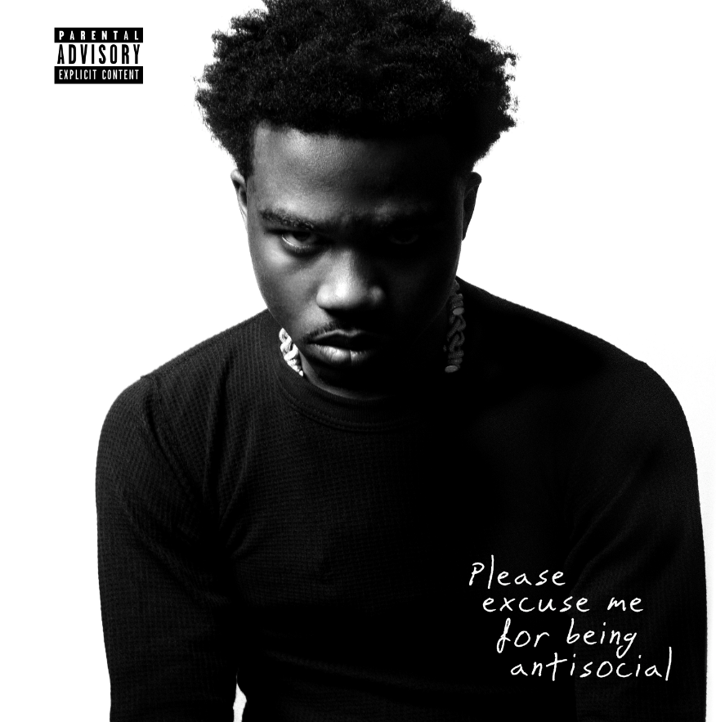
DOWNLOAD HIGH-RES COVER ART HERE

3x GRAMMY® Award-nominated rapper Roddy Ricch has debuted at number 1 on the Billboard 200 chart and Rolling Stone Top 200 Albums chart with his album PLEASE EXCUSE ME FOR BEING ANTISOCIAL. 16-song set, which includes features from Gunna, Ty Dolla $ign, and Mustard, earned 101,500 album-equivalent units in its first week. His long awaited major label debut album, PLEASE EXCUSE ME FOR BEING ANTISOCIAL, is available now via Atlantic Records HERE.

PLEASE EXCUSE ME FOR BEING ANTISOCIAL includes iconic features from such superstars as Meek Mill, Ty Dolla $ign, Mustard, and Lil Durk alongside such stellar new singles as “Tip Toe (Feat. A Boogie Wit Da Hoodie),” “Start Wit Me (Feat. Gunna),” and “Big Stepper,” all of which are joined by companion visuals streaming now at the official Roddy Ricch YouTube channel HERE. “Tip Toe (Feat. A Boogie Wit Da Hoodie)” arrived mere days after Ricch was honored with three prestigious GRAMMY® Award nominations, which include “Best Rap Performance” and “Best Rap Song” for Nipsey Hussle’s “Racks In The Middle (Feat. Roddy Ricch & Hit-Boy),” as well as a “Best Rap/Sung Performance” nod for Mustard’s “Ballin (Feat. Roddy Ricch).” The electrifying new track arrived with an equally spectacular companion video, directed by Christian Breslauer (YNW Melly, Chris Brown) and streaming HERE.

Ricch – who recently heralded PLEASE EXCUSE ME FOR BEING ANTISOCIAL with an incredible halftime performance at the Los Angeles Clippers’ victory over the Houston Rockets on November 22nd, streaming HERE – is set to embark on his epic first-ever North American headline tour. The Antisocial Tour begins Saturday, December 28th at Los Angeles, CA’s world-famous Hollywood Palladium and then continues into February 2020. For complete details and ticket information, please visit www.roddyricchofficial.com/tour.

Named earlier this year to the 2019 XXL Freshman Class, Ricch has just been nominated for two leading BET Hip Hop Awards, including “Best New Artist” and “Best Mixtape,” the latter honoring 2018’s FEED THA STREETS II, available for streaming and download HERE. The mixtape – which marked Ricch’s SoundScan/Billboard 200 chart debut – sees him teaming up with some of hip hop’s top studio superstars, including Scott Storch (Post Malone, T.I., Young Thug), Cassius Jay (Cardi B, Migos, Gucci Mane), and hot emerging producer Sonic. FEED THA STREETS II is highlighted by such tracks as “Every Season” and “Die Young,” both available at all DSPs and streaming services. The “Die Young” companion visual – also directed by JD Films – also proved a viral favorite, with individual YouTube views exceeding 79 million HERE.

Wise beyond his years, schooled in real-life struggles, and eloquently effective, Roddy Ricch clearly and concisely conveys truth by way of cinematic rhymes and catchy hooks. The self-proclaimed “illustrator of the streets” uploaded his first single, “Ricch N****” to SoundCloud in 2016 and immediately caught fire, generating more than 200,000 streams within two months. He followed up with his debut mixtape, FEED THA STREETS, streaming HERE. The project includes the breakthrough hit single, “Fucc It Up,” accompanied by a smash companion video, now boasting close to 30 million individual views via Roddy Ricch’s official YouTube channel HERE.

As if all that weren’t enough, Ricch teamed with Marshmello for 2018’s worldwide hit single, “Project Dreams,” joined by an official video currently with over 61 million YouTube views HERE. More recently, Roddy teamed with Mustard for the GRAMMY® Award-nominated smash, “Ballin’ (Feat. Roddy Ricch),” joined by a companion visual boasting over 34 million views HERE. In addition, Roddy went in depth on “Ballin” in an exclusive installment of Genius’ “Verified,” streaming HERE.

PLEASE EXCUSE ME FOR BEING ANTISOCIAL
TRACKLISTING
- Intro
- The Box
- Start Wit Me (Feat. Gunna)
- Perfect Time
- Moonwalkin (Feat. Lil Durk)
- Big Stepper
- Gods Eyes
- Peta (Feat. Meek Mill)
- Boom Boom Room
- High Fashion (Feat. Mustard)
- Bacc Seat (Feat. Ty Dolla $ign)
- Roll Dice
- Prayers To The Trap God
- Tip Toe (Feat. A Boogie Wit Da Hoodie)
- War Baby

THE ANTISOCIAL TOUR 2019/20
ITINERARY
DECEMBER
28 Los Angeles, CA Hollywood Palladium

JANUARY
14 Seattle, WA The Showbox
15 Portland, OR Roseland Theater
17 San Francisco, CA The Regency Ballroom
19 Phoenix, AZ The Van Buren
22 Dallas, TX Canton Hall
23 Austin, TX Emo’s East
24 Houston, TX Warehouse Live
26 Atlanta, GA Masquerade - Heaven Stage
28 Washington, DC 9:30 Club
30 Philadelphia, PA Theatre of Living Arts (TLA)
31 Brooklyn, NY Brooklyn Steel

FEBRUARY
1 Allston, MA Brighton Music Hall
5 Montreal, QC Club Soda
6 Toronto, ON Phoenix Concert Theatre
7 Cleveland, OH House of Blues
9 Detroit, MI St. Andrews Hall
10 Chicago, IL Patio Theater
11 Minneapolis, MN First Avenue - Mainroom
13 Lawrence, KS Liberty Hall
15 Denver, CO Cervantes’ Masterpiece Ballroom

* FESTIVAL PERFORMANCE @ Winter Breakout 2019

# # #

CONNECT WITH RODDY RICCH
OFFICIAL I TWITTER | SOUNDCLOUD | YOUTUBE | INSTAGRAM

PRESS CONTACT
Brittany Bell | Brittany.Bell@atlanticrecords.com

