FOR IMMEDIATE RELEASE

DECEMBER 16, 2020

**LIL EAZZYY PREMIERES “FEELING DIFFERENT” VISUAL**

**“FEELING DIFFERENT” PREMIERES TODAY AT 10AM PT / 1PM ET ON**

**NO MORE HEROES YOUTUBE CHANNEL** [**HERE**](http://lileazzyy.lnk.to/feelingdifferentvideo)

**DEBUT PROJECT FROM RISING CHICAGO RAPPER NOW STREAMING**

[**LILEAZZYY.LNK.TO/UNDERRATED**](https://nam04.safelinks.protection.outlook.com/?url=https%3A%2F%2Flileazzyy.lnk.to%2FUnderrated&data=04%7C01%7CChandler.Owen%40atlanticrecords.com%7C36492657e85a48a778e208d88cf06ef5%7C8367939002ec4ba1ad3d69da3fdd637e%7C0%7C0%7C637414311565309783%7CUnknown%7CTWFpbGZsb3d8eyJWIjoiMC4wLjAwMDAiLCJQIjoiV2luMzIiLCJBTiI6Ik1haWwiLCJXVCI6Mn0%3D%7C1000&sdata=Lq8g3KlcnYFA3m3HgnDCXAN0JFvFfCNK0%2F2YVW5FV7g%3D&reserved=0)

**BREAKTHROUGH HIT “ONNA COME UP” WITH OVER 21M U.S. STREAMS**

**LIL EAZZYY FEATURED IN THE HAWKS TALON GAMING CLUB LAST MONDAY**

**[WATCH HERE](https://www.twitch.tv/videos/837605729)**

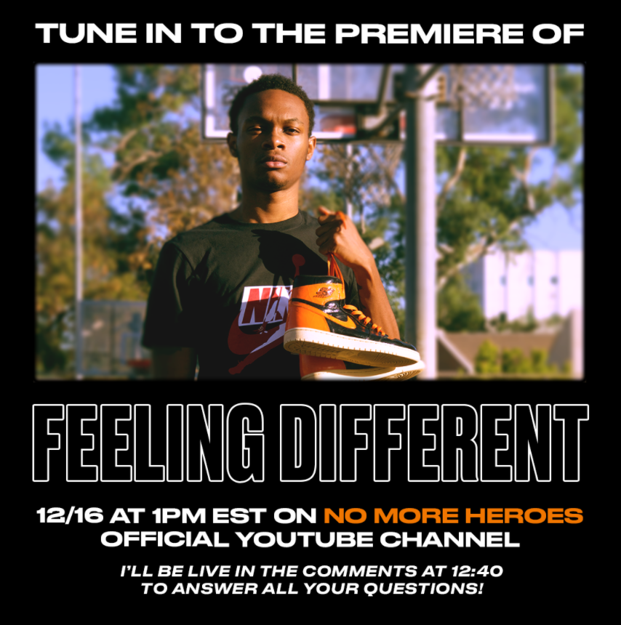

***THIS ARTIST HAS NOT BEEN OFFICIALLY ANNOUNCED.***

***PLEASE REFRAIN FROM ALL MENTIONS OF ATLANTIC RECORDS.***

Exploding Chicago rapper Lil Eazzyy premieres “Feeling Different” on No More Heroes official YouTube today his debut project *Underrated*. The premiere begins today at 10am PT / 1pm ET – tune in [HERE](http://lileazzyy.lnk.to/feelingdifferentvideo). “Feeling Different” arrives off his debut project, *Underrated*, available to stream and download at all streaming services [HERE](https://nam04.safelinks.protection.outlook.com/?url=https%3A%2F%2Flileazzyy.lnk.to%2FUnderrated&data=04%7C01%7CChandler.Owen%40atlanticrecords.com%7C36492657e85a48a778e208d88cf06ef5%7C8367939002ec4ba1ad3d69da3fdd637e%7C0%7C0%7C637414311565309783%7CUnknown%7CTWFpbGZsb3d8eyJWIjoiMC4wLjAwMDAiLCJQIjoiV2luMzIiLCJBTiI6Ik1haWwiLCJXVCI6Mn0%3D%7C1000&sdata=Lq8g3KlcnYFA3m3HgnDCXAN0JFvFfCNK0%2F2YVW5FV7g%3D&reserved=0).

Hawks Talon Gaming Club, the official NBA 2K League affiliate of the Atlanta Hawks, hosted Lil Eazzyy on their one-of-a-kind content series called Talon Takeover. The Chicago rapper played the popular video game NBA 2K21 online with the team’s Head Coach Wesley Acuff. The series is available for viewing for free on the team’s official Twitch channel [HERE](https://www.twitch.tv/videos/837605729).

Sporting an ironclad flow, razor sharp wordplay, spellbinding storytelling, and no shortage of ambition, Chicago rapper Lil Eazzyy tells the story of *“a kid who came from selling drugs to doing shit he had no business doing in the matter of a year*.*”* After dropping “Finesse” in 2019, he gained traction with “MIKEAMIRI” and “Handy Mandy.” Throughout 2020, he picked up even more steam via “Listen Up,” “Letter To Tracy,” and “Yerk Attack.” He also posted freestyles on Instagram and hit the studio daily. Around the time of his high school graduation, a freestyled snippet of “Onna Come Up” exploded to the tune of 155K views.

Meeting fan demand head-on, he finished the track, and it would be touted in video montages by top *Fortnite* players such as Chronic Hazard, Cultures, Yusa, Keeny, Fakeify, and more. “Onna Come Up” scaled the Spotify US Viral Chart, breaking him into Rolling Stone’s Breakthrough 25 Chart and into the Spotify Top 25 and Daily Top 100 while claiming real estate on premiere playlists, including the #5 spot on *RapCaviar*, debuting at #2 on *Most Necessary*, and prominent placement on *Get Turnt*, *Radar US*, and more. On Apple Music, he’s recently hit #2 on *The Plug* and #4 on *The New Chicago*. Reaching 1 million streams per week in September 2020, the song has continued to grow steadily, amassing over 20.6M streams in the US to date. The official “[Onna Come Up](https://nam04.safelinks.protection.outlook.com/?url=https%3A%2F%2Fwww.youtube.com%2Fwatch%3Fv%3DS3JUizWXdUM&data=04%7C01%7CChandler.Owen%40atlanticrecords.com%7Ce5b3823e6b3e4327e24a08d87c28aaae%7C8367939002ec4ba1ad3d69da3fdd637e%7C0%7C0%7C637395861395578846%7CUnknown%7CTWFpbGZsb3d8eyJWIjoiMC4wLjAwMDAiLCJQIjoiV2luMzIiLCJBTiI6Ik1haWwiLCJXVCI6Mn0%3D%7C1000&sdata=PgQVFL%2FBCB54JTPB7e6iYP0uLf%2BoiLG%2BxCZlSb0qtn0%3D&reserved=0)” video has over 1.5M views on YouTube.

Racking up 15 million streams worldwide in under six months and receiving looks from *RapCaviar*, *HipHopDX*, and more, Lil Eazzyy infuses intensity into a viscerally versatile signature style on a series of singles. Furthermore, his social presence is growing exponentially. Both his Instagram and Spotify follower growth has been doubling week over week, with his Instagram followers sitting at over 150k and Spotify at over 3 million monthly listeners.

***UNDERRATED* TRACKLISTING:**

1. Onna Come Up
2. Feeling Different
3. Finally Rich
4. Activated
5. For33
6. Kick Da Door (Produced by SephGotWaves & Iceberg)
7. Big Dog (Produced by Tee Romano)

**PHOTO CREDIT: thatgoodwork productions**

[*DOWNLOAD HIGH-RES PRESS PHOTOS HERE*](https://nam04.safelinks.protection.outlook.com/?url=https%3A%2F%2Fwarnermusicgroup.box.com%2Fs%2Fjiun8bxy2uy3wqexoxhtpfgkam7zdu8a&data=02%7C01%7CChandler.Owen%40atlanticrecords.com%7C10073c6b77ce492d10a308d87138b531%7C8367939002ec4ba1ad3d69da3fdd637e%7C0%7C0%7C637383835812278907&sdata=vgGqd%2F8TVbp9DR5QRF1%2BdKv3Moc4h8c4%2FVhI0aWfOZg%3D&reserved=0)

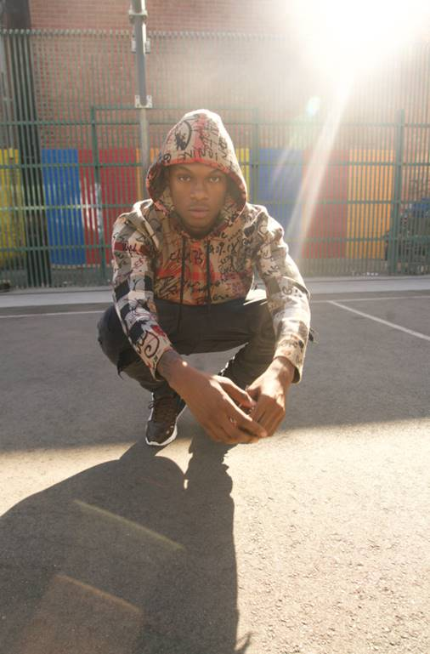

**CONNECT WITH LIL EAZZYY**

[TWITTER](https://nam04.safelinks.protection.outlook.com/?url=https%3A%2F%2Ftwitter.com%2FLileazzyy&data=02%7C01%7CChandler.Owen%40atlanticrecords.com%7C8dbc07475ed0434b67ab08d866ea9e07%7C8367939002ec4ba1ad3d69da3fdd637e%7C0%7C0%7C637372505224870261&sdata=LlWqZNmfQVKN%2BsgD6n2zLLgaC78aVXxhBkwPHsdam2A%3D&reserved=0) | [INSTAGRAM](https://nam04.safelinks.protection.outlook.com/?url=https%3A%2F%2Fwww.instagram.com%2Flileazzyyy%2F&data=02%7C01%7CChandler.Owen%40atlanticrecords.com%7C8dbc07475ed0434b67ab08d866ea9e07%7C8367939002ec4ba1ad3d69da3fdd637e%7C0%7C0%7C637372505224870261&sdata=eDDb4Z%2B6Wmqe2wWZhVDIbFagi0JCTp1s4ELjAOJ3RMU%3D&reserved=0) | [SPOTIFY](https://nam04.safelinks.protection.outlook.com/?url=https%3A%2F%2Fopen.spotify.com%2Fartist%2F0rpUnzu4JIoRkKkGvdcm7b%3Fsi%3D1uNNTgilQoGmeaZKdqrPHA&data=02%7C01%7CChandler.Owen%40atlanticrecords.com%7C8dbc07475ed0434b67ab08d866ea9e07%7C8367939002ec4ba1ad3d69da3fdd637e%7C0%7C0%7C637372505224880250&sdata=J%2BQ7Yy5BxBVKSU76QEqIcZkwzUJ2mhtzDeYljRIrqpE%3D&reserved=0) | [YOUTUBE](https://nam04.safelinks.protection.outlook.com/?url=https%3A%2F%2Fwww.youtube.com%2Fchannel%2FUC-NZcM4AM16ACXPv43IrvsA&data=02%7C01%7CChandler.Owen%40atlanticrecords.com%7C8dbc07475ed0434b67ab08d866ea9e07%7C8367939002ec4ba1ad3d69da3fdd637e%7C0%7C0%7C637372505224880250&sdata=TnqY5w8yb1rrSejiGhPzZ2kwpbM%2Bqhn1JLMidLxw%2FK8%3D&reserved=0) | [SOUNDCLOUD](https://nam04.safelinks.protection.outlook.com/?url=https%3A%2F%2Fsoundcloud.com%2Flileazzyy&data=02%7C01%7CChandler.Owen%40atlanticrecords.com%7C8dbc07475ed0434b67ab08d866ea9e07%7C8367939002ec4ba1ad3d69da3fdd637e%7C0%7C0%7C637372505224890249&sdata=MNSbhxzT2OJ8WptDGz13i9i6q2q8ZSg6Yd8RyVRp8Cc%3D&reserved=0)

**PRESS CONTACT**

BRITTANY BELL | [BRITTANY.BELL@ATLANTICRECORDS.COM](mailto:BRITTANY.BELL@ATLANTICRECORDS.COM)