FOR IMMEDIATE RELEASE
AUGUST 31, 2021

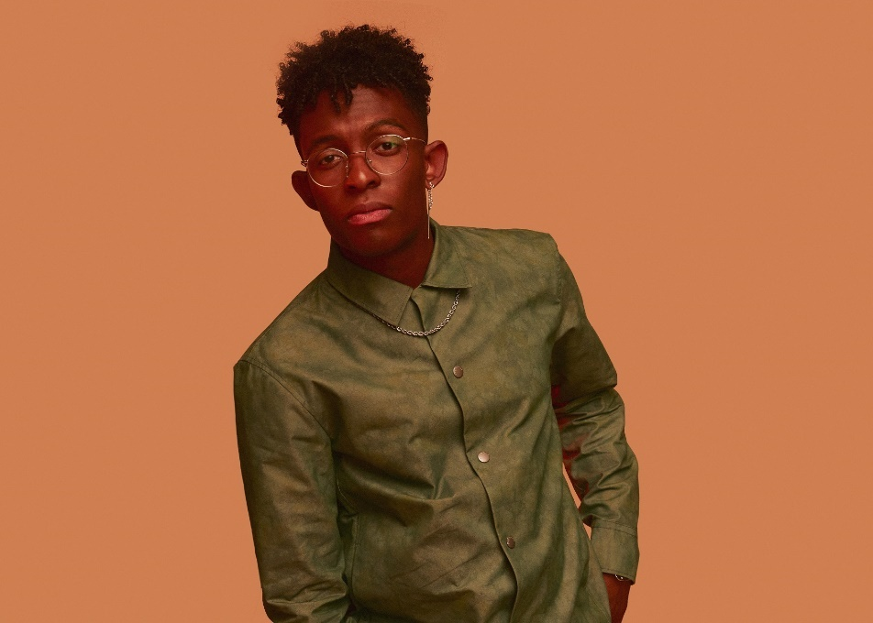
DOWNLOAD PHOTO; CREDIT: NOLAN KNIGHT

TUNE-IN: BRELAND BRINGS THE HEAT TO CMT CROSSROADS WITH NELLY (9/1) & CMA SUMMER JAM (9/2)

DEBUT BONNAROO PERFORMANCE COMING 9/5

BIG LOOKS FOLLOW GMA AND JIMMY KIMMEL LIVE!, HEADLINE CROSS COUNTRY TOUR UP NEXT

NASHVILLE, TENN. (August 31, 2021) - With summer at its absolute hottest, Bad Realm Records / Atlantic Records breakout talent BRELAND continues to bring the heat. He’ll make his presence felt on some of Country’s biggest stages this week, commanding attention with another round of high-profile performances.

On September 1, the genre-blurring “Artist on the Rise” (YouTube) will join Nelly on CMT CROSSROADS, taking center stage at the intersection of Country and Hip-Hop. Appearing alongside Nelly and Blanco Brown on their just-released “High Horse,” CMT Crossroads: Nelly & Friends airs Wednesday, September 1 at 10p/9c on CMT, and this big moment adds to a summer of action.

The next day, September 2, the in-demand collaborator will rock CMA SUMMER JAM with Dierks Bentley and HARDY, toasting their new track “Beers On Me.” Filmed earlier this year at Bentley’s Whiskey Row honky-tonk in downtown Nashville, the performance is part of a star-studded primetime special airing at 8/7c on ABC, and there’s much more.

After releasing his chart-rising track “Throw It Back” (featuring Keith Urban) and the coming-of-age anthem “Cross Country” (featuring Mickey Guyton), BRELAND has continued to stand apart. He teamed up with Nelly and Brown for “High Horse” on the GMA Summer Concert Series in early August, and did the same on Jimmy Kimmel Live! last week.

Looking ahead, BRELAND will be back on stage at the iconic BONNAROO MUSIC FESTIVAL on September 5, which will also serve as kick off to his CROSS COUNTRY TOUR. Marking his first-ever headline tour, the trek will then continue with coast-to-coast dates through October, with more details and tickets available here.

Here are the dates, cities, and venues for BRELAND’s CROSS COUNTRY TOUR:

Sept. 5 – Bonnaroo Music Festival – Manchester, TN
Sept. 10 – The Parish – Austin, TX*
Sept. 11 – House of Blues Bronze Peacock – Houston, TX*
Sept. 12 – House of Blues Cambridge Room – Dallas, TX*
Sept. 16 – Joe’s on Weed Street – Chicago, IL*
Sept. 17 – Fine Line Music Café – Minneapolis, MN*
Sept. 19 – El Club – Detroit, MI*
Sept. 21 – Brighton Music Hall – Boston, MA*
Sept. 23 – Songbyrd DC – Washington, DC*
Sept. 25 – Governor’s Ball Music Festival – New York, NY
Oct. 1 – Aisle 5 – Atlanta, GA^
Oct. 2 – Underground – Charlotte, NC^
Oct. 5 – The High Watt – Nashville, TN^
Oct. 6 – The High Watt – Nashville, TN^
Oct. 8 – Old Rock House – St. Louis, MO^
Oct. 9 – Barnato – Omaha, NE^
Oct. 12 – Kilby Court – Salt Lake City, UT^
Oct. 14 – Larimer Lounge – Denver, CO^
Oct. 17 – Crescent Ballroom – Phoenix, AZ^
Oct. 20 – The Moroccan Lounge – Los Angeles, CA^
Oct. 23 – Great American Music Hall – San Francisco, CA^
Oct. 26 – The Crocodile – Seattle, WA^
Oct. 27 – Lola’s Room – Portland, OR^

* = featured support: Ashley Cooke
^ = featured support: Robyn Ottolini

CONNECT WITH BRELAND
INSTAGRAM | FACEBOOK | TWITTER | YOUTUBE | SOUNDCLOUD

ABOUT BRELAND:
With the arrival of his PLATINUM-certified debut single “My Truck,” singer/songwriter/producer BRELAND emerged as a bold new force on today’s music landscape. Originally from New Jersey, BRELAND moved to Atlanta after graduating from Georgetown University, kicking off his songwriting career by scoring cuts with artists like YK Osiris and Ann Marie. Soon after releasing “My Truck” in late 2019, he saw the Hip-Hop and Country hybrid hit #1 on Spotify’s Global Viral 50, with a remix featuring Country hitmaker Sam Hunt landing on best-of-the-year lists from NPR and The New York Times. The song’s success paved the way for his signing to Bad Realm Records/Atlantic Records, leading to collaborations with heavy-hitters from the Country, Pop, and Hip-Hop worlds (including Gary LeVox of Rascal Flatts, Nelly, Blanco Brown, Lauren Alaina, and Chase Rice). BRELAND’s 2021 single “Cross Country” further reveals his passion for transcending boundaries, continuing his mission of breaking down genre barriers in Country music. The Nashville-based artist made his national TV debut with “Cross Country” on The Kelly Clarkson Show, where she surprised him with a PLATINUM plaque for “My Truck.” Now at work on the follow-up to his 2020 self-titled debut EP, he enlisted superstar Keith Urban for the dynamic collaboration “Throw It Back.” Adding to his list of buzzy collaborations, he is currently featured on Dierks Bentley’s single with HARDY, “Beers On Me.” BRELAND has been praised by Rolling Stone as “1,000 percent the whole package,” featured on Billboard’s “Emerging Artists Spotlight,” and earned acclaim from Genius, Paper, USA TODAY, and more.

PRESS CONTACTS:
FAIRLY MCCASKILL | FAIRLEY.MCCASKILL@ATLANTICRECORDS.COM
JENSEN SUSSMAN | JENSEN@SWEETTALKPR.COM

