AUSTRALIAN POP SENSATION MIA RODRIGUEZ TEAMS UP WITH YUNG BABY TATE
FOR NEW SINGLE “BILLION DOLLAR BITCH”

SINGLE DROPS ALONGSIDE BEJEWELED MUSIC VIDEO

OUT TODAY VIA ATLANTIC RECORDS & CITY POP RECORDS

WATCH/LISTEN HERE

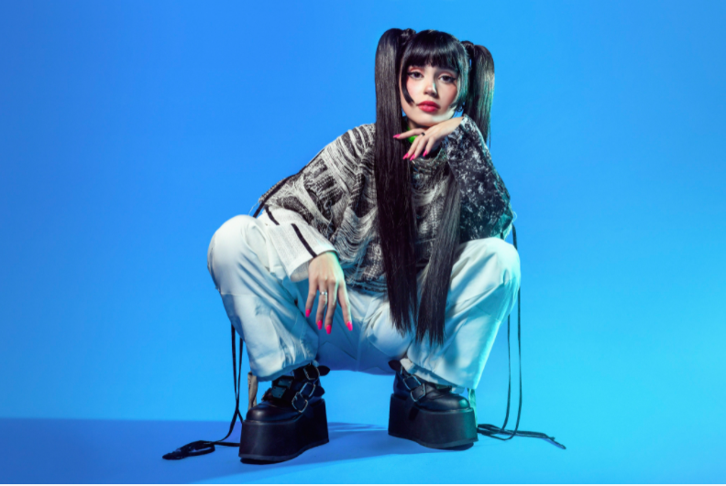

DOWNLOAD PRESS PHOTO HERE

Following the viral success of her song “Psycho” and her official signing to Atlantic Records in partnership with City Pop Records, Mia Rodriguez is back today with the release of her new single “Billion Dollar Bitch” feat. Yung Baby Tate. The single is released alongside a hauntingly playful and visually stunning official music video starring Mia and Yung Baby Tate. WATCH/LISTEN HERE.

“Billion Dollar Bitch is about being self-confident and knowing your worth” said Mia. “But at the same time, being a bit self-indulgent and giving into bad habits. I wrote it to be a hype-up track you can just yell to and feel good. I really love heavy bass, and was super excited to work with Mark Nilan Jr on production, and Salem Ilese with lyrics. When I first started working on the track, I knew I wanted a feature for some contrast, and Yung Baby Tate is such a cool rising star, so it was just a no-brainer to try work with her. Hope you enjoy, always remember your worth; Billions.”
“I knew when I heard this song it was a smash!” said Yung Baby Tate. “I am so excited that Mia asked me to be a part of this record, I know our fans are going to love it!”

Watch out. There’s a new bad bitch in town. 19-year-old Australian singer-songwriter Mia Rodriguez is a force to be reckoned with her unapologetic attitude, unwavering ambition, infectious dark-pop sound, and trendsetting personal style. Recently named “Best New Artist” at the Rolling Stone Australia Awards (where she also took the stage for an immersive, show-stopping performance of “Psycho”), Mia Rodriguez spans the divide between alternative indie and melodic mainstream styles. Inspired by a wide range of musical approaches, from K-pop to hip-hop, the singer-songwriter-musician began posting inventive videos on TikTok, quickly building a fervent fan following now exceeding 2M. Signed as the first artist to the new City Pop Records label (co-founded by legendary Australian concert promoter Michael Chugg and his business partner Andrew Stone), Rodriguez unveiled her captivating debut single, “Emotion,” in late 2019 alongside an official music video streaming now at YouTube HERE. “Psycho” followed and immediately, earning over 9.64 million global streams, and catapulted Rodriguez to the forefront of Australia’s contemporary pop scene. A third single, “Beautiful & Bittersweet” – like both “Emotion” and “Psycho,” – dropped alongside an official video streaming now at Rodriguez’s popular YouTube channel HERE. You can also check out the stripped down version of “Psycho” HERE.

Among the many accolades accrued by Rodriguez in just one short year include being named by Australia’s national radio station as a “triple j Unearthed Feature Artist” as well as a prestigious “Unearthed Artist of the Year” nomination at the Australian Broadcasting Company’s annual J Awards. Rodriguez recently offered a spectacular rendition of Rex Orange County’s “Corduroy Dreams” as part of triple j’s famed “Like A Version” series, streaming HERE; the session also featured a unique live take on “Psycho,” streaming HERE.

Mia’s star power is undeniable but her confidence didn’t come without a fight. Bullied throughout school for her alternative style and open mindset growing up in a straight-edged part of Sydney, Mia found a way to harness the pain as her motivation. “As an artist I get to be the person I’ve always wanted to be but never had the confidence to be. I used to be a loner. And shy,” says Mia. “I wouldn’t let anyone hear me sing for years.”

Spending hours performing karaoke alone in her bedroom, Mia fell in love with the idea of performing by watching videos of acts like Ariana Grande, Britney Spears, and Troye Sivan. “I’d watch Troye Sivan on Youtube before he was famous. I was obsessed with him,” says Mia. “I went to his show when I was 11. I was like ‘wow, I want to do that.’”

Her new single “Billion Dollar Bitch,” featuring Yung Baby Tate solidifies her triumph. It’s a bad bitch calling card, an affirmation mantra of sorts, calling in confidence when you need it most. “It’s for when you’re feeling alone after a break up and need to find yourself again. It’s for the girls and the gays,” says Mia. “It’s my personality and style in a song.” Hell yeah it is. A billion dollar bitch, here to slay. “The people who bullied me are a big part of my motivation. I didn’t let it get to me. I kept pushing,” says Mia. “Life is way too short to be shy or embarrassed. I’ve pushed through that and look at me now.”

CONNECT WITH MIA RODRIGUEZ
INSTAGRAM
TWITTER
FACEBOOK
YOUTUBE
TIKTOK

PRESS ASSETS
press.atlanticrecords.com/mia-rodriguez/
FOR MORE INFORMATION
Paige.Rosoff@atlanticrecords.com

