FOR IMMEDIATE RELEASE
APRIL 7, 2022

ARDEN JONES RELEASES age tape 3

VNCLM_/ATLANTIC RECORDS RISING ARTIST TO RELEASE
A 3 TRACK EP ON THE FIRST THURSDAY OF EVERY MONTH OF 2022

RECENTLY TOURED WITH TAI VERDES AND THOMAS HEADON

age tape 3 INCLUDES “la di da (acoustic),” “serotonin highs (feat. Allen Haley)” and “green eyes”

LISTEN TO age tape 3 HERE
DOWNLOAD ARTWORK + PHOTOS

California artist Arden Jones has released his latest 3-song project, age tape 3. The vnclm_/Atlantic Records artist is releasing a collection of 3 new songs on the first Thursday of every month for the rest of 2022. Today’s release, age tape 3, features “la di da (acoustic),” “serotonin highs (feat. Allen Haley)” and “green eyes.” age tape 3 is streaming now HERE.

On the project, Arden shared, “It’s crazy that we’re only on tape 3 and so much has already happened. The tapes have gone great but this one just feels different after being on the road and things picking up so much over the past month. Thank you so much for rocking with me and following along, I think you’re gonna like this one.”

Just last night, Jones wrapped up a run of live dates opening for breakout stars Tai Verdes and Thomas Headon. At the live shows, Jones played “la di da (acoustic)” and a video of the performance quickly went viral racking up 4 million TikTok views and 300k likes.

Earlier this year, Jones released age tape 1 and age tape 2 sharing consistent new music with his engaged fans. With the new projects, Jones continues to receive over 1 million streams per week and boasts 5 million likes on his TikTok.

After racking up over 15 million streams independently, the 21-year-old Marin County-born singer, songwriter, and multi-instrumentalist bottles the sunshine of an endless California summer into elastic rhymes, radiant hooks, and euphoric piano-laced beats. “either way” followed Jones’ infectious track “SMILE,” his vnclm_/Atlantic Records debut “Rollercoaster” and his viral hit “Parallel Parking.”

Currently boasting over 1 million monthly Spotify listeners, Arden is hard at work on his debut project. Stay tuned for more from this rising star!

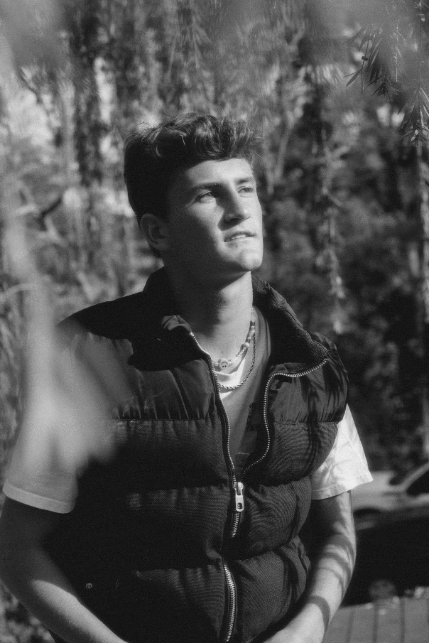
DOWNLOAD PRESS PHOTOS

CONNECT WITH ARDEN JONES
INSTAGRAM | TIKTOK | YOUTUBE | SPOTIFY

For press inquiries, please contact:
Jessica Nall // Jessica.Nall@atlanticrecords.com
Gabrielle Reese // Gabrielle.Reese@atlanticrecords.com

