FOR IMMEDIATE RELEASE
FEBRUARY 3, 2022

ARDEN JONES RELEASES age tape 1

VNCLM_/ATLANTIC RECORDS RISING ARTIST TO RELEASE
A 3 TRACK EP ON THE FIRST THURSDAY OF EVERY MONTH OF 2022

age tape 1 ARRIVES TODAY WITH STANDOUT TRACK “horror story”
+ TWO OTHER SUNNY TRACKS

LISTEN TO age tape 1 HERE
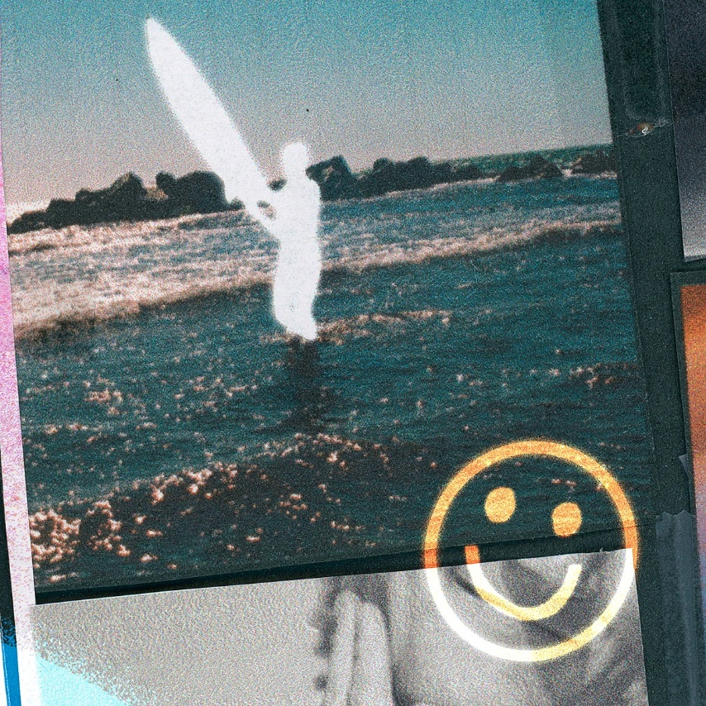
DOWNLOAD ARTWORK PHOTOS

Rising artist Arden Jones has released his first 3-song project of the year, age tape 1. The California native announced that for the rest of 2022, he would be releasing a new collection of 3 songs on the first Thursday of every month. The first one, age tape 1, is highlighted by the standout track “horror story” as well as the two additional tracks “daisy” and “trippin.” age tape 1 is streaming now HERE.

“I’m dropping a new 3-song project on the first Thursday of every month for all of 2022,” Arden shared. “I can’t wait for you to hear them all! I’ve been working on a lot of new music and am excited to share it with all of you.”

Most recently, Jones worked with JakeTheShooter for a visual for his sunny and upbeat track “either way.” The original track arrived last year earning praise from Entertainment Tonight, naming it one of the best releases of the week, The Honey Pop deeming the track “that perfect song to sing out loud with our friends in the car” and Melodic magazine praising “Arden has made the perfect soundtrack to the year, depicting personal highs, lows, and everything in between.”

After racking up over 15 million streams independently, the 20-year-old Marin County-born singer, songwriter, and multi-instrumentalist bottles the sunshine of an endless California summer into elastic rhymes, radiant hooks, and euphoric piano-laced beats. “either way” follows Jones’ infectious track “SMILE,” his vnclm_/Atlantic Records debut “Rollercoaster” and his viral hit “Parallel Parking.”

Currently boasting over 660,000 monthly Spotify listeners, Arden is hard at work on his debut project. Stay tuned for more from this rising star!

DOWNLOAD PRESS PHOTOS

CONNECT WITH ARDEN JONES
INSTAGRAM | TIKTOK | YOUTUBE | SPOTIFY

For press inquiries, please contact:
Jessica Nall // Jessica.Nall@atlanticrecords.com
Gabrielle Reese // Gabrielle.Reese@atlanticrecords.com

