FOR IMMEDIATE RELEASE
NOVEMEBER 5, 2021

ARDEN JONES INSPIRES WITH OPTIMISTIC NEW TRACK “either way”

VNCLM_/ATLANTIC RECORDS RISING ARTIST RELEASES FEEL-GOOD FOLLOW UP TO VIRAL HITS
“SMILE” AND “PARALLEL PARKING”

THE SOUND ALREADY AMASSED OVER 2M VIEWS ON TIKTOK ONE WEEK BEFORE RELEASE

LISTEN TO “EITHER WAY” HERE
WATCH THE VISUALIZER HERE
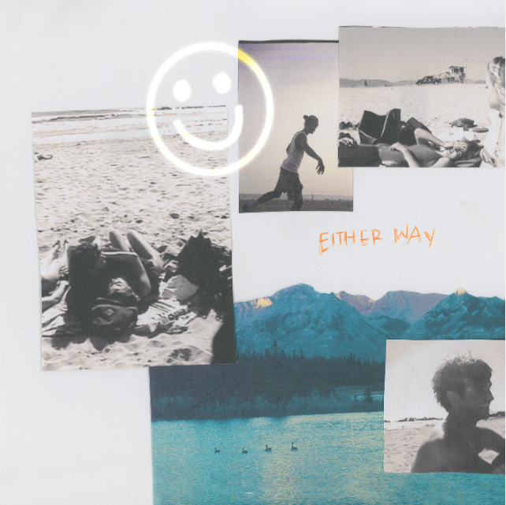
DOWNLOAD ARTWORK

Rising artist Arden Jones has released his latest upbeat track, reminding us all that “either way the sun gonna shine.” “either way” is available now HERE, the song is joined by an official visualizer streaming now HERE.

“’either way’ is a song about perseverance and hope,” Arden says. “No matter what happens, good or bad, one thing you can be sure of is the sun rising the next day. I love thinking of things this way because it makes it feel like we are all alright. Nobody really knows what they’re doing in this life, we are all trying our best.
After racking up over 15 million streams independently, the 20-year-old Marin County-born singer, songwriter, and multi-instrumentalist bottles the sunshine of an endless California summer into elastic rhymes, radiant hooks, and euphoric piano-laced beats. “either way” follows Jones’ infectious track “SMILE,” his vnclm_/Atlantic Records debut “Rollercoaster” and his viral hit “Parallel Parking.”

Currently boasting over 640,000 monthly Spotify listeners, Arden is hard at work on his debut project. Stay tuned for more from this rising star!

DOWNLOAD PRESS PHOTOS (Photo by SJ Spreng)

CONNECT WITH ARDEN JONES
INSTAGRAM | TIKTOK | YOUTUBE | SPOTIFY

For press inquiries, please contact:
Jessica Nall // Jessica.Nall@atlanticrecords.com
Gabrielle Reese // Gabrielle.Reese@atlanticrecords.com

