BRISTON MARONEY TEAMS UP WITH MANCHESTER ORCHESTRA TO RELEASE NEW VERSION OF “BOTTLE ROCKET” OFF CRITICALLY ACCLAIMED DEBUT ALBUM SUNFLOWER

ANNOUNCES SUNFLOWER NORTH AMERICAN, UK + EUROPEAN HEADLINE TOUR DATES

WATCH LIVE PERFORMANCE VIDEO FOR
“BOTTLE ROCKET (FEAT. MANCHESTER ORCHESTRA)” HERE

BUY/STREAM: HERE

SUNFLOWER – BUY/STREAM | WATCH SUNFLOWER: THE VISUAL ALBUM

***
“Briston Maroney has teamed up with veteran producer John Congleton and flaunted a keen understanding of the hooks that will eventually explode in front of festival crowds. ‘Bottle Rocket’ is the project’s most potent firecracker, the drums thwacking as Maroney conveys pure hunger with the line ‘All my life/waiting for a little spark”
– BILLBOARD

“Briston Maroney Is Writing Powerful Rock Songs With Grit And Heart”
– NPR

“Sunflower is a collection of 10 tracks that Maroney got right… an oratory of youth-filled anxieties, growing older, and the awakening of what’s blossoming all around.”
– AMERICAN SONGWRITER

***
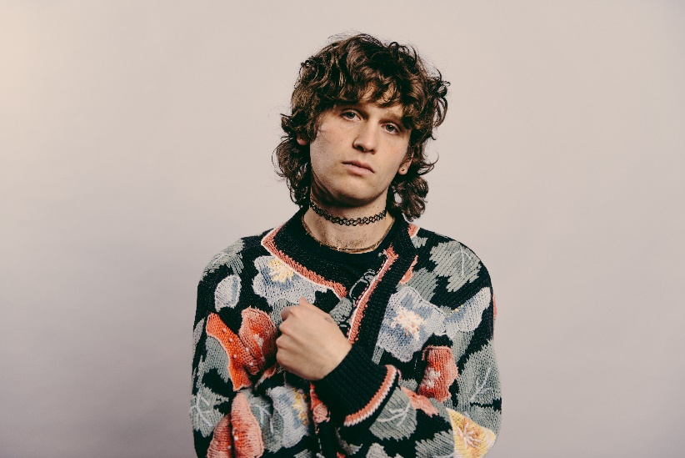
download hi-res press image; photo credit Angelina Castillo

Nashville-based recording artist Briston Maroney has joined forces with Andy Hull and Robert McDowell of Manchester Orchestra to release a new version of “Bottle Rocket” (listen here) – off critically acclaimed debut album Sunflower. The new track arrives alongside a performance video of the trio playing it together, shot in Atlanta (watch here).

The original version of “Bottle Rocket” was written by all three artists and recently was highlighted as the “Pick of the Week” across all of Audacy’s Alternative stations – which including LA’s KROQ and NYC’s Alt 92.3, as well as the alternative stations in 30+ other markets. Briston was also featured on SiriusXM’s Alt Nation as their “Critical Cut” artist of the month.

Also being unveiled today is Briston’s Sunflower North American, UK and Europe headline tour. Maroney’s upcoming live dates kick off at Napa’s Oxbow Riverstage on August 14, include shows at Music Hall Of Williamsburg and LA’s The Troubadour, and culminate with a hometown show next spring at Nashville’s Basement East.

He was also recently announced as support on the southern leg of Mt. Joy’s Fall 2021 tour – starting at Nashville’s Marathon on October 17 and culminating with a two-night stand in Austin on Oct. 23 (ACL Live – Moody Theater) and Oct. 24 (Stubb’s).

Maroney was also included in the long-awaited 2021 lineup announcement for Bonnaroo Music & Arts Festival, to take place in Manchester, TN this September.

Sunflower arrived accompanied by a feature-length companion film envisioned by Maroney and longtime creative collaborator Joey Brodnax – with each song on the album bearing its own cinematic accompaniment. Watch Sunflower: The Visual Album here. The visual album includes the previously released standalone videos “Deep Sea Diver”, “Freeway”, “It’s Still Cool If You Don’t”, “Sinkin”, “Bottle Rocket”, and “Why” – which was just unveiled last week.

The album debuted at #7 on Spotify’s Top 10 US Album Debuts and #8 on Apple Music’s Alternative Albums chart, with Maroney hitting #6 on Billboard’s Alternative New Artists chart, and #16 on the overall Top New Artists chart. With the release of the album, Briston has now amassed over 100K album equivalents, 3 million monthly listeners, and 150 million streams globally.

Sunflower was met with critical acclaim from the likes of Billboard, American Songwriter, The Sunday Times, LADYGUNN, The Line of Best Fit, Rolling Stone France, Dork, Uproxx, and many more.

------------------

REACTIONS TO SUNFLOWER:

“Briston Maroney has teamed up with veteran producer John Congleton and flaunted a keen understanding of the hooks that will eventually explode in front of festival crowds. ‘Bottle Rocket’ is the project’s most potent firecracker, the drums thwacking as Maroney conveys pure hunger with the line ‘All my life/waiting for a little spark.”
– BILLBOARD

“The Nashville-based Briston Maroney is here with a storming set of Raconteurs-ish songs. The opening three – Sinkin’, Bottle Rocket and It’s Still Cool If You Don’t – are as strong a start to an album as you’ll hear this year”
– THE SUNDAY TIMES

“Sunflower is a collection of 10 tracks that Maroney got right, a result of a nearly decade-long journey for the 23-year-old artist, excavating real-life stories and transmitting them into lyrics… Sunflower is an oratory of youth-filled anxieties, growing older, and the awakening of what’s blossoming all around.”
– AMERICAN SONGWRITER

“After his 2018 track ‘Freaking Out On The Interstate’ gained massive traction on TikTok late last year, Nashville-based songwriter Briston Maroney has returned with Sunflower. The ten-track effort serves as a coming of age story for Maroney” – UPROXX: BEST NEW INDIE MUSIC

“‘Sunflower’ is a fantastic debut album… an eclectic Maroney, still full of his signature guitar sound but with some moodier production… In a trippy, aesthetically pleasing, and hypnagogic type way – both Joey Brodnax and Briston capture the beauty of everyday mundanities and make it look incredible.” – LADYGUNN

“Briston Maroney has built a strong reputation as a rising indie-rock artist who can provide rocky sing-alongs as well some more chill acoustic moments; his debut album ‘Sunflower’ balances these two sides and leans into pop production to express a new vibe which is deeply rooted in energetic Americana sounds.” – DORK

“…confessional, feel-good music that gets to the heart of being human…” – THE LINE OF BEST FIT

“The 23-year-old musician sounds his big riffs in the service of cinematic visuals that bring him all the seriousness he deserves.” – ROLLING STONE FRANCE

“Inhabiting an unusual position at the intersection of the indie pop/classic rock Venn diagram, Briston Maroney has already been there and done much of that… ‘Sinkin'’ is a beguiling blend of T.Rex and Pavement, but Maroney isn't a novelty act: there's no doubt the boy can write songs.” – LOUDER

“A whirlwind of tales from breezy adolescence to daunting adulthood, the record packs a lifetime of highs, lows, and lessons into just 34 minutes… a tenacious musical statement, one that solidifies Maroney as an intuitive writer and more-than-capable rocker.” – CULTURE COLLIDE

“Briston Maroney is blossoming with his debut album ‘Sunflower.’” – NO COUNTRY FOR NEW NASHVILLE

“Nashville artist Briston Maroney is having a huge moment… The record serves as a sort of culmination to Maroney’s meteoric rise from his past three EPs and substantial reputation as a live performer. Eclectic and authentic, Maroney’s artistry constantly stands out in the musical landscape” – LIGHTNING 100

“WE LOVE: ‘It’s Still Cool If You Don’t’; ‘Sinkin’’” – WXPN: THE KEY

“Swapping out the synthy, electrified pop-Americana of the original tunes for laid back, somewhat grizzled solo versions, Maroney’s set is full of the longing that make the original versions of the tracks click.” – FLOOD

“On his debut album Sunflower, Briston Maroney showcases his penchant for flourishing atmospheric melodies that frequently pay off in big, impassioned choruses that leave a mark—in a very good way.”
---
“Trying to neatly define the album’s sound is challenging, even for Maroney himself, who has a broad musical palette that ranges from traditional folk to hardcore hip-hop. Instead, it’s probably better to just let the buzzy thump of ‘Bottle Rocket,’ the wistful glimmer of ‘Cinnamon,’ and the melancholic swell of ‘It’s Still Cool If You Don’t’ hit your ear objectively and decide for yourself.” – ALBUMISM

“Musically, Sunflower expands on Maroney's folk and Americana roots, with the subtle sheen that comes naturally with growing up during the 2010s indie pop boom. Sunflower, the movie, is surreal and entrancing, with clever lighting and set design lulling viewers into its dreamlike setting.” – POPDUST

------------------

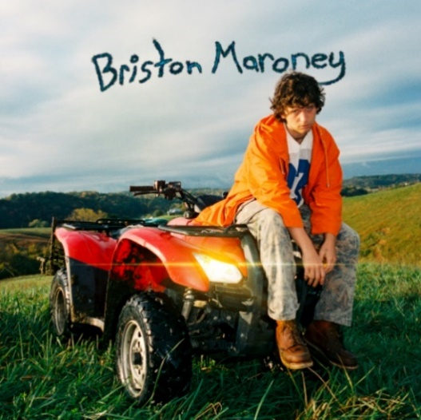
download hi-res album artwork

***

UPCOMING LIVE DATES

Aug 14, 2021 - Napa, CA - Oxbow Riverstage (opening for Trampled By Turtles and Mt. Joy)
Aug 28, 2021 - Lexington, KY - Railbird
Sep 2, 2021 - Manchester, TN - Bonnaroo
Sep 9, 2021 - Oxford, MS - Proud Larry's #
Sep 10, 2021 - Birmingham, AL - Saturn #
Sep 11, 2021 - Athens, GA - 40 Watt Club #
Sep 12, 2021 - Knoxville, TN - New Ground Music Festival
Sep 14, 2021 - Charlottesville, VA - The Southern Cafe & Music Hall #
Sep 15, 2021 - Louisville, KY - Zanzabar #
Sep 16, 2021 - Columbus, OH - A&R Music Bar #
Sep 18, 2021 - Asbury Park, NJ - Sea Hear Now Festival
Oct 17, 2021 - Nashville, TN - Marathon Music Works (opening for Mt. Joy)
Oct 19, 2021 - New Orleans, LA - Joy Theater (opening for Mt. Joy)
Oct 21, 2021 - Houston, TX - House Of Blues (opening for Mt. Joy)
Oct 22, 2021 - Dallas, TX - House Of Blues (opening for Mt. Joy)
Oct 23, 2021 - Austin, TX - ACL Live at the Moody Theater (opening for Mt. Joy) *SOLD OUT*
Oct 24, 2021 - Austin, TX - Stubbs Waller Creek Amphitheater (opening for Mt. Joy)
Jan 11, 2022 - Berlin, Germany - Privatclub
Jan 12, 2022 - Hamburg, Germany - Molotow
Jan 14, 2022 - Amsterdam, Netherlands - Paradiso (Small Hall)
Jan 15, 2022 - Paris, France – Le Hasard Ludique
Jan 17, 2022 - Bristol, UK - Exchange
Jan 19, 2022 - Manchester, UK - Band On The Wall
Jan 20, 2022 - London, UK - The Garage
Jan 22, 2022 - Brighton, UK - Prince Albert
Feb 10, 2022 - Dallas, TX - Club Dada*
Feb 11, 2022 - Austin, TX - Antone's*
Feb 12, 2022 - Houston, TX - White Oak Music Hall Upstairs*
Feb 15, 2022 - Phoenix, AZ – The Rebel Lounge*
Feb 17, 2022 - Los Angeles, CA - Troubadour*
Feb 21, 2022 - Portland, OR – Holocene*
Feb 22, 2022 - Vancouver, BC - Fox Cabaret*
Feb 23, 2022 - Seattle, WA – The Crocodile (Second Stage)*
Feb 25, 2022 - Salt Lake City, UT - Kilby Court*
Feb 26, 2022 - Denver, CO - Bluebird Theater*
Feb 28, 2022 - Madison, WI - High Noon Saloon*
Mar 1, 2022 - Minneapolis, MN - Amsterdam Bar & Hall*
Mar 3, 2022 - Chicago, IL - Lincoln Hall^
Mar 4, 2022 - Indianapolis, IN - HI-FI Indianapolis^
Mar 5, 2022 - Ferndale, MI - The Loving Touch^
Mar 7, 2022 - Toronto, ON - The Horseshoe Tavern^
Mar 9, 2022 - Brooklyn, NY - Music Hall Of Williamsburg^
Mar 10, 2022 - Philadelphia, PA - The Foundry^
Mar 11, 2022 - Boston, MA - The Sinclair^
Mar 12, 2022 - Washington, DC - Union Stage^
Mar 15, 2022 - Pittsburgh, PA - Thunderbird Café & Music Hall^
Mar 16, 2022 - Asheville, NC - The Grey Eagle^
Mar 18, 2022 - Atlanta, GA - The Masquerade Hell Stage^
Mar 19, 2022 - Nashville, TN - The Basement East^

# Special Guest Savannah Conley
* Special Guest Genevieve Stokes
^ Special Guest Jackie Hayes

***

ABOUT BRISTON MARONEY:

After a childhood spent between Tennessee and Florida, 23-year-old recording artist Briston Maroney landed in Nashville and developed a style steeped in the sweat and scrappy sounds of the city's DIY house parties, winning over fans one living room at a time.

Maroney’s 2018 EP Carnival – his take on the modern coming-of-age story and debut for Canvasback Music/Atlantic Records – amassed millions of streams and opened the door to tours with Wallows and Liz Cooper.

The following year saw the release of Indiana, highlighted by such tracks as “Fool’s Gold” (later featured on fellow Nashvillian Taylor Swift’s hugely popular Apple Music “Playlist by ME!”). Indiana was met with wide-ranging critical acclaim, with PAPER praising the EP for its “mixture of absolute tension and mounting significance” and NPR applauding his “buoyant guitar-pop” and “taut, hooky romanticism.” Indiana was ultimately cited on a number of 2019 “Best Of” lists, including Consequence of Sound, Vulture, and PAPER.

At the top of 2020, Maroney released his third EP Miracle, heralded by “Chattanooga” and “The Garden” which Consequence of Sound declared “refreshingly raw.”

An energetic live performer with a craft honed in basements, living rooms, and jam-packed clubs, Maroney spent much of 2019 on the road, including sold out headline shows both here and around the world, dates alongside Cold War Kids, and international festival performances spanning Austin City Limits Music Festival to Pitchfork Paris.

CONNECT WITH BRISTON MARONEY:
OFFICIAL I INSTAGRAM I YOUTUBE I FACEBOOK I TWITTER

FOR ALL PRESS INQUIRIES, PLEASE CONTACT:
Libby Kober (National) | Libby.Kober@AtlanticRecords.com
Trish Mollo (Tour/Online) | Trish.Mollo@AtlanticRecords.com

