BRISTON MARONEY DEBUTS “FREEWAY”

SECOND SINGLE TO BE RELEASED OFF FORTHCOMING 2021 ALBUM

“FREAKIN’ OUT ON THE INTERSTATE” CONTINUES ASCENT; SURPASSING 1 MILLION WEEKLY STREAMS

“FREEWAY” ARRIVES WITH OFFICIAL MUSIC VIDEO – STREAMING NOW HERE

***
“Briston Maroney Is Writing Powerful Rock Songs With Grit And Heart” – NPR

“refreshingly raw” – Consequence of Sound

“…deceptively breezy Americana that’s somewhere on the continuum between John Prine and Kacey Musgraves…” – Talkhouse

***

WATCH: LINK
BUY/STREAM: HERE

download hi-res press photo; photo credit Joey Brodnax

Canvasback Music recording artist Briston Maroney announces the release of his new single “Freeway” – available now at all DSPs and streaming services. Produced by John Congleton (St. Vincent, Angel Olsen), the song is joined by a cinematic official music video shot along the Maine coastline and directed by the Nashville-based singer-songwriter’s longtime visual collaborator, Joey Brodnax – watch HERE.

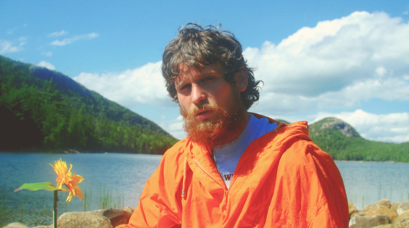

Today’s release marks the second off Maroney’s forthcoming 2021 debut LP. Released in August, the album’s first single – “Deep Sea Diver” – was met with critical acclaim including from Consequence of Sound (“a freewheeling number”) and Paste, who declared the track “reminiscent of an uplifting roadtrip soundtrack with meaningful lyricism blended beneath the surface.”

Produced by Congleton and co-written with Dan Wilson (Leon Bridges, Adele, The Chicks), “Deep Sea Diver” also arrived with a Brodnax-directed companion video – watch HERE. Upon release, LADYGUNN praised the visual for the way in which it “plays on the surreal serenity of our natural world.” The magazine continued, “In a trippy, aesthetically pleasing, and hypnagogic type way – both Joey Brodnax and Briston capture the beauty of everyday mundanities and make it look incredible.”

“Deep Sea Diver” was the first new release from Briston since his acclaimed third EP Miracle, released at the top of 2020. Produced by Jim Abbiss (Arctic Monkeys), that project was highlighted by tracks “Chattanooga” and “The Garden” – praised as “refreshingly raw” by Consequence of Sound.

This year has also seen the extraordinary resurgence of Maroney’s “Freakin’ Out On the Interstate.” First released via Maroney’s Carnival EP (2018), the song has gained serious traction as of late, garnering more than a million streams a week and bringing the Knoxville-native’s catalog up over 50 million global streams – all prior to the release of his debut album.

In July, Maroney released an acoustic rendition of the track, as well as a full-band performance – both recorded live at Nashville’s Alex the Great recording studio and directed by Brodnax. The song had previously been recorded for a performance for World Café – watch here – live at WXPN Studios in Philadelphia, leading NPR to declare “Briston Maroney is writing powerful rock songs with grit and heart.”

In 2019, Maroney was named to various critics’ year-end “Best Of” lists – including PAPER, Vulture, and Consequence of Sound. Off the back of his sophomore EP Indiana, he rose from playing house shows to sold-out clubs in the US, as well as an international headline tour and slots at marquee festivals including Austin City Limits and Pitchfork Paris.

ABOUT BRISTON MARONEY:
After a childhood spent between Tennessee and Florida, 22-year-old recording artist Briston Maroney landed in Nashville and developed a style steeped in the sweat and scrappy sounds of the city's DIY house parties, winning over fans one living room at a time.

Maroney’s 2018 EP Carnival – his take on the modern coming-of-age story and debut for Canvasback Music/Atlantic Records – amassed millions of streams and opened the door to tours with Wallows and Liz Cooper.

The following year saw the release of Indiana, highlighted by such tracks as “Fool’s Gold” (later featured on fellow Nashvillian Taylor Swift’s hugely popular Apple Music “Playlist by ME!”). Indiana was met with wide-ranging critical acclaim, with PAPER praising the EP for its “mixture of absolute tension and mounting significance” and NPR applauding his “buoyant guitar-pop” and “taut, hooky romanticism.” Indiana was ultimately cited on a number of 2019 “Best Of” lists, including Consequence of Sound, Vulture, and PAPER.

At the top of 2020, Maroney released his third EP Miracle, heralded by “Chattanooga” and “The Garden” which Consequence of Sound declared “refreshingly raw.”

An energetic live performer with a craft honed in basements, living rooms, and jam-packed clubs, Maroney spent much of 2019 on the road, including sold out headline shows both here and around the world, dates alongside Cold War Kids, and international festival performances spanning Austin City Limits Music Festival to Pitchfork Paris.

CONNECT WITH BRISTON MARONEY:
OFFICIAL I INSTAGRAM I YOUTUBE I FACEBOOK I TWITTER

FOR ALL PRESS INQUIRIES, PLEASE CONTACT:
Libby Kober | Libby.Kober@AtlanticRecords.com

