BRISTON MARONEY RELEASES SUNFLOWER: LIVE AT THIRD MAN RECORDS

EPISODE 7 OF ‘THE BOTTLE ROCKET COMPANY PODCAST’ OUT NOW WITH SPECIAL GUEST PRODUCER JOHN CONGLETON

BUY/STREAM SUNFLOWER: LIVE AT THIRD MAN RECORDS HERE
WATCH THE LIVE PERFORMANCE HERE
LISTEN TO ‘THE BOTTLE ROCKET COMPANY PODCAST’ HERE

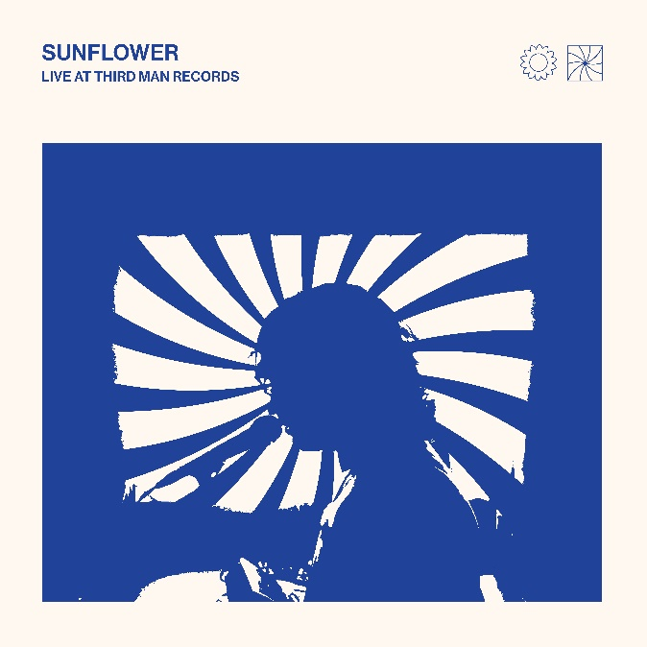

SUNFLOWER – BUY/STREAM | WATCH SUNFLOWER: THE VISUAL ALBUM

Briston Maroney has today unveiled his live album Sunflower: Live From Third Man Records – available now on all platforms (here). Captured earlier this year at Jack White’s Nashville recording studios, the album arrives with a full-length live performance visual showcasing Briston performing his debut full-length Sunflower in its entirety. Watch the live performance (here).

Also out this week is the seventh and final episode of ‘The Bottle Rocket Company Podcast,’ featuring special guest and Sunflower producer John Congleton (listen here). Past installments of the podcast have featured interviews with Maroney and the other artists and collaborators who helped create the album – including Dan Wilson and Andy Hull (Manchester Orchestra).

Briston recently wrapped the sold-out first leg of his Sunflower headline tour, which included a performance at Sea.Hear.Now. festival in Asbury Park.

His 2022 headline touring includes already sold-out shows at LA’s The Troubadour (Feb 16-17), New York’s Music Hall of Williamsburg (March 9) + Bowery Ballroom (March 14), and a 2-night hometown stand at Nashville’s Basement East (March 19-20).

Prior to that, Briston will perform as main support on the southern leg of Mt. Joy’s Fall 2021 tour – starting at Marathon in Nashville on October 17 and culminating with a two-night stand in Austin on Oct. 23 (ACL Live – Moody Theater) and Oct. 24 (Stubb’s).

***

Sunflower arrived in April of this year accompanied by a feature-length companion film envisioned by Maroney and Joey Brodnax – with each song on the album bearing its own cinematic accompaniment. Watch Sunflower: The Visual Album here. It includes the previously released standalone videos “Deep Sea Diver”, “Freeway”, “It’s Still Cool If You Don’t”, “Sinkin”, “Bottle Rocket”, and “Why”.

With the release of Sunflower, Briston has now amassed over 125K album equivalents, 3 million monthly listeners, and 200 million streams globally.

Sunflower was met with critical acclaim from the likes of Billboard, American Songwriter, The Sunday Times, LADYGUNN, The Line of Best Fit, Rolling Stone France, Dork, Uproxx, and many more.

------------------

PRESS REACTIONS:

“Briston Maroney has teamed up with veteran producer John Congleton and flaunted a keen understanding of the hooks that will eventually explode in front of festival crowds. ‘Bottle Rocket’ is the project’s most potent firecracker, the drums thwacking as Maroney conveys pure hunger with the line ‘All my life/waiting for a little spark.”
– BILLBOARD

“Sunflower is a collection of 10 tracks that Maroney got right, a result of a nearly decade-long journey for the 23-year-old artist, excavating real-life stories and transmitting them into lyrics… Sunflower is an oratory of youth-filled anxieties, growing older, and the awakening of what’s blossoming all around.” – AMERICAN SONGWRITER

“Swapping out the synthy, electrified pop-Americana of the original tunes for laid back, somewhat grizzled solo versions, Maroney’s set is full of the longing that make the original versions of the tracks click.” – FLOOD

“After his 2018 track ‘Freaking Out On The Interstate’ gained massive traction on TikTok late last year, Nashville-based songwriter Briston Maroney has returned with Sunflower. The ten-track effort serves as a coming of age story for Maroney” – UPROXX: BEST NEW INDIE MUSIC

“‘Sunflower’ is a fantastic debut album… an eclectic Maroney, still full of his signature guitar sound but with some moodier production… In a trippy, aesthetically pleasing, and hypnagogic type way – both Joey Brodnax and Briston capture the beauty of everyday mundanities and make it look incredible.” – LADYGUNN

“Briston Maroney has built a strong reputation as a rising indie-rock artist who can provide rocky sing-alongs as well some more chill acoustic moments; his debut album ‘Sunflower’ balances these two sides and leans into pop production to express a new vibe which is deeply rooted in energetic Americana sounds.” – DORK

“…confessional, feel-good music that gets to the heart of being human…” – THE LINE OF BEST FIT

------------------

UPCOMING LIVE DATES
Oct 17, 2021 - Nashville, TN - Marathon Music Works (opening for Mt. Joy)
Oct 19, 2021 - New Orleans, LA - Joy Theater (opening for Mt. Joy)
Oct 21, 2021 - Houston, TX - House Of Blues (opening for Mt. Joy)
Oct 22, 2021 - Dallas, TX - House Of Blues (opening for Mt. Joy)
Oct 23, 2021 - Austin, TX - ACL Live at the Moody Theater (opening for Mt. Joy) SOLD OUT
Oct 24, 2021 - Austin, TX - Stubbs Waller Creek Amphitheater (opening for Mt. Joy)
Jan 11, 2022 - Berlin, Germany - Privatclub
Jan 12, 2022 - Hamburg, Germany - Molotow
Jan 14, 2022 - Amsterdam, Netherlands - Paradiso (Small Hall)
Jan 15, 2022 - Paris, France – Le Hasard Ludique
Jan 17, 2022 - Bristol, UK - Exchange
Jan 19, 2022 - Manchester, UK - Band On The Wall
Jan 20, 2022 - London, UK - The Garage
Jan 22, 2022 - Brighton, UK - Prince Albert
Feb 10, 2022 - Dallas, TX - Club Dada*
Feb 11, 2022 - Austin, TX - Antone's*
Feb 12, 2022 - Houston, TX - White Oak Music Hall Upstairs*
Feb 15, 2022 - Phoenix, AZ – The Rebel Lounge* SOLD OUT
Feb 16, 2022 - Los Angeles, CA – Troubadour* SECOND NIGHT ADDED SOLD OUT
Feb 17, 2022 - Los Angeles, CA – Troubadour* SOLD OUT
Feb 21, 2022 - Portland, OR – Holocene* SOLD OUT
Feb 22, 2022 - Vancouver, BC - Fox Cabaret*
Feb 23, 2022 - Seattle, WA – The Crocodile (Second Stage)*
Feb 25, 2022 - Salt Lake City, UT - Kilby Court* SOLD OUT
Feb 26, 2022 - Denver, CO - Bluebird Theater* SOLD OUT
Feb 28, 2022 - Madison, WI - High Noon Saloon* SOLD OUT
Mar 1, 2022 - Minneapolis, MN - Amsterdam Bar & Hall*
Mar 3, 2022 - Chicago, IL - Lincoln Hall^
Mar 4, 2022 - Indianapolis, IN - HI-FI Indianapolis^
Mar 5, 2022 - Ferndale, MI - The Loving Touch^
Mar 7, 2022 - Toronto, ON - The Horseshoe Tavern^ SOLD OUT
Mar 9, 2022 - Brooklyn, NY - Music Hall Of Williamsburg^ SOLD OUT
Mar 10, 2022 - Philadelphia, PA - The Foundry^ SOLD OUT
Mar 11, 2022 - Boston, MA - The Sinclair^ SOLD OUT
Mar 12, 2022 - Washington, DC - Union Stage^ SOLD OUT
Mar 14, 2022 - New York, NY - Bowery Ballroom^ SOLD OUT
Mar 15, 2022 - Pittsburgh, PA - Thunderbird Café & Music Hall^
Mar 16, 2022 - Asheville, NC - The Grey Eagle^
Mar 18, 2022 - Atlanta, GA - The Masquerade Hell Stage^
Mar 19, 2022 - Nashville, TN - The Basement East^ SOLD OUT
Mar 20, 2022 - Nashville, TN - The Basement East^ SECOND NIGHT ADDED

# Special Guest Savannah Conley
* Special Guest Genevieve Stokes
^ Special Guest Jackie Hayes

***

ABOUT BRISTON MARONEY:
After a childhood spent between Tennessee and Florida, 23-year-old recording artist Briston Maroney landed in Nashville and developed a style steeped in the sweat and scrappy sounds of the city's DIY house parties, winning over fans one living room at a time.

Maroney’s 2018 EP Carnival – his take on the modern coming-of-age story and debut for Canvasback Music/Atlantic Records – amassed millions of streams and opened the door to tours with Wallows and Liz Cooper. The following year saw the release of Indiana, highlighted by such tracks as “Fool’s Gold” (later featured on fellow Nashvillian Taylor Swift’s hugely popular Apple Music “Playlist by ME!”). Indiana was met with wide-ranging critical acclaim, with PAPER praising the EP for its “mixture of absolute tension and mounting significance” and NPR applauding his “buoyant guitar-pop” and “taut, hooky romanticism.” Indiana was ultimately cited on a number of 2019 “Best Of” lists, including Consequence of Sound, Vulture, and PAPER. At the top of 2020, Maroney released his third EP Miracle, heralded by “Chattanooga” and “The Garden” which Consequence of Sound declared “refreshingly raw.”

An energetic live performer with a craft honed in basements, living rooms, and jam-packed clubs, Maroney’s live touring includes sold out headline shows around the world, dates alongside Cold War Kids, and international festival performances spanning Austin City Limits Music Festival to Pitchfork Paris.

His critically acclaimed debut album Sunflower is out now.

CONNECT WITH BRISTON MARONEY:
OFFICIAL I INSTAGRAM I YOUTUBE I FACEBOOK I TWITTER

FOR ALL PRESS INQUIRIES, PLEASE CONTACT:
Libby Kober (National) | Libby.Kober@AtlanticRecords.com
Trish Mollo (Tour/Online) | Trish.Mollo@AtlanticRecords.com

