BRISTON MARONEY RELEASES MUSIC VIDEO FOR “WHY” ON THE HEELS OF DEBUT ALBUM SUNFLOWER

ALBUM MET WITH CRITICAL ACCLAIM FROM PRESS, RADIO, DSPs + FANS AROUND THE WORLD

MARONEY HITS #6 ON BILLBOARD’S ALTERNATIVE NEW ARTISTS CHART WHILE
SUNFLOWER DEBUTS AT #7 ON SPOTIFY’S TOP 10 US ALBUM DEBUTS;
#8 ON APPLE MUSIC’S ALTERNATIVE ALBUMS CHART

SET TO PERFORM AT BONNAROO MUSIC FESTIVAL + JOIN MT. JOY ON TOUR LATER THIS YEAR

WATCH OFFICIAL VIDEO FOR “WHY” HERE
SUNFLOWER – BUY/STREAM | WATCH SUNFLOWER: THE VISUAL ALBUM

***
“Briston Maroney has teamed up with veteran producer John Congleton and flaunted a keen understanding of the hooks that will eventually explode in front of festival crowds. ‘Bottle Rocket’ is the project’s most potent firecracker, the drums thwacking as Maroney conveys pure hunger with the line ‘All my life/waiting for a little spark”
– BILLBOARD

“The Nashville based Briston Maroney is here with a storming set of Raconteurs-ish songs. The opening three – Sinkin’, Bottle Rocket and It’s Still Cool If You Don’t – are as strong a start to an album as you’ll hear this year”
– THE SUNDAY TIMES

“Briston Maroney Is Writing Powerful Rock Songs With Grit And Heart”
– NPR

“Sunflower is a collection of 10 tracks that Maroney got right… an oratory of youth-filled anxieties, growing older, and the awakening of what’s blossoming all around.”
– AMERICAN SONGWRITER

***
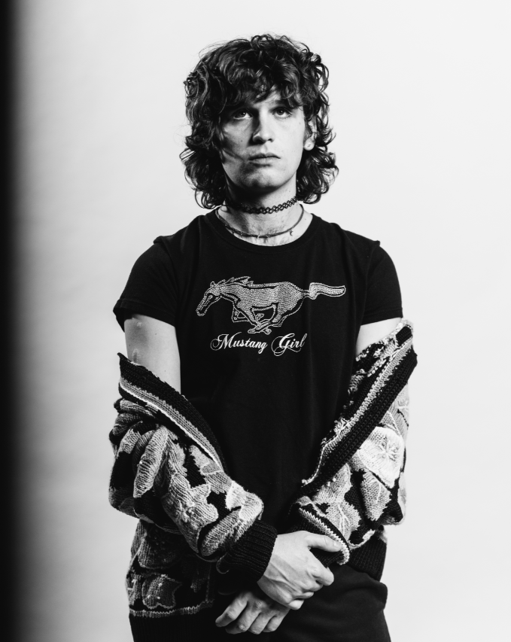
download hi-res press image; photo credit Angelina Castillo

Nashville-based recording artist Briston Maroney has today unveiled the official standalone music video for his track “Why” (watch here). Today’s news comes on the heels of the Knoxville-native’s debut album Sunflower – released earlier this month via Canvasback Music (listen here) – which has now amassed 4 million global streams, with 1.3 million streams last week alone.

The album was accompanied by a feature-length companion film envisioned by Maroney and longtime creative collaborator Joey Brodnax – with each song on the album bearing its own cinematic accompaniment. Watch Sunflower: The Visual Album here.

Sunflower debuted at #7 on Spotify’s Top 10 US Album Debuts and #8 on Apple Music’s Alternative Albums chart, with Maroney hitting #6 on Billboard’s Alternative New Artists chart, and #16 on the overall Top New Artists chart. With the release of the album, Briston has now amassed over 100K album equivalents, 3 million monthly listeners, and 150 million streams globally.

Sunflower was met with critical acclaim from the likes of Billboard, American Songwriter, The Sunday Times, LADYGUNN, The Line of Best Fit, Rolling Stone France, Dork, Uproxx, and many more.

------------------

REACTIONS TO SUNFLOWER:

“Briston Maroney has teamed up with veteran producer John Congleton and flaunted a keen understanding of the hooks that will eventually explode in front of festival crowds. ‘Bottle Rocket’ is the project’s most potent firecracker, the drums thwacking as Maroney conveys pure hunger with the line ‘All my life/waiting for a little spark.”
– BILLBOARD

“The Nashville-based Briston Maroney is here with a storming set of Raconteurs-ish songs. The opening three – Sinkin’, Bottle Rocket and It’s Still Cool If You Don’t – are as strong a start to an album as you’ll hear this year”
– THE SUNDAY TIMES

“Sunflower is a collection of 10 tracks that Maroney got right, a result of a nearly decade-long journey for the 23-year-old artist, excavating real-life stories and transmitting them into lyrics… Sunflower is an oratory of youth-filled anxieties, growing older, and the awakening of what’s blossoming all around.”
– AMERICAN SONGWRITER

“After his 2018 track ‘Freaking Out On The Interstate’ gained massive traction on TikTok late last year, Nashville-based songwriter Briston Maroney has returned with Sunflower. The ten-track effort serves as a coming of age story for Maroney” – UPROXX: BEST NEW INDIE MUSIC

“‘Sunflower’ is a fantastic debut album… an eclectic Maroney, still full of his signature guitar sound but with some moodier production… In a trippy, aesthetically pleasing, and hypnagogic type way – both Joey Brodnax and Briston capture the beauty of everyday mundanities and make it look incredible.” – LADYGUNN

“Briston Maroney has built a strong reputation as a rising indie-rock artist who can provide rocky sing-alongs as well some more chill acoustic moments; his debut album ‘Sunflower’ balances these two sides and leans into pop production to express a new vibe which is deeply rooted in energetic Americana sounds.” – DORK

“…confessional, feel-good music that gets to the heart of being human…” – THE LINE OF BEST FIT

“The 23-year-old musician sounds his big riffs in the service of cinematic visuals that bring him all the seriousness he deserves.” – ROLLING STONE FRANCE

“Inhabiting an unusual position at the intersection of the indie pop/classic rock Venn diagram, Briston Maroney has already been there and done much of that… ‘Sinkin'’ is a beguiling blend of T.Rex and Pavement, but Maroney isn't a novelty act: there's no doubt the boy can write songs.” – LOUDER

“A whirlwind of tales from breezy adolescence to daunting adulthood, the record packs a lifetime of highs, lows, and lessons into just 34 minutes… a tenacious musical statement, one that solidifies Maroney as an intuitive writer and more-than-capable rocker.” – CULTURE COLLIDE

“Briston Maroney is blossoming with his debut album ‘Sunflower.’” – NO COUNTRY FOR NEW NASHVILLE

“Nashville artist Briston Maroney is having a huge moment… The record serves as a sort of culmination to Maroney’s meteoric rise from his past three EPs and substantial reputation as a live performer. Eclectic and authentic, Maroney’s artistry constantly stands out in the musical landscape” – LIGHTNING 100

“WE LOVE: ‘It’s Still Cool If You Don’t’; ‘Sinkin’’” – WXPN: THE KEY

------------------

Sunflower was produced by John Congleton (St. Vincent, Angel Olsen). In addition to the acclaimed producer, Maroney also co-wrote with the likes of Jenny Owen Youngs, Manchester Orchestra’s Andy Hull + Robert McDowell, and venerated songwriter Dan Wilson (Adele, The Chicks). Recorded between the summer of 2019 and early 2020 in Los Angeles, the album is a culmination of the past decade of the now-23-year old’s life.

Of the album, Maroney shares: “Coming to terms with the full scope of who the hell I am has been the most difficult thing I have ever had to do. It’s also the only thing that has allowed me to fully experience true joy in my life. Sometimes processing everything emotionally the way I do, has kept me from understanding things logically, the way other people seem to so effortlessly. This has allowed me to see so much beauty and has at times also made me feel so far away from reality.

'Sunflower' is my attempt at a record about all of those moments, terrifying and serene alike. The times when I’ve felt connected to people and the world, the times I’ve loved, the times I have felt despair, the times I’ve been sure that I’ll never understand and am proved wrong. I am so thankful for the chance to let anyone kind enough to listen know that I love the hell out of life, for better or for worse. I hope it can be a friend to anyone who feels the same way!

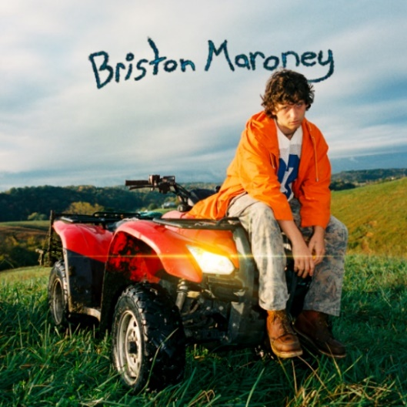
download hi-res album artwork

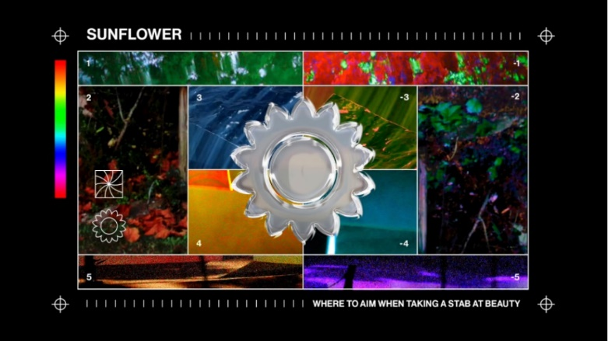
download hi-res film graphic here

Briston was recently announced as support on the southern leg of Mt. Joy’s Fall 2021 tour – kicking off at Nashville’s Marathon on October 17 and culminating with a two-night stand in Austin on Oct. 23 (ACL Live – Moody Theater) and Oct. 24 (venue TBA). This joins the previously announced, socially-distanced shows he’ll be opening for them throughout the Southeast in May (full tour itinerary enclosed; tickets available here).

Maroney was also included in the long-awaited 2021 lineup announcement for Bonnaroo Music & Arts Festival, to take place in Manchester, TN this September.

Ahead of the album’s release, Maroney unveiled “Sinkin’”, “It’s Still Cool If You Don’t”, “Deep Sea Diver” and “Freeway,” which were celebrated by the likes of Paste, Talkhouse, Consequence of Sound, Line of Best Fit, LADYGUNN, and more. Released in February alongside the initial album announcement, current single “It’s Still Cool If You Don’t” hit #1 at alternative specialty radio in its first week out of the gate and brought Briston his highest ever streaming week.

“Deep Sea Diver” was the first new release from Briston since his acclaimed third EP Miracle, released at the top of 2020. Produced by Jim Abbiss (Arctic Monkeys), that project was highlighted by tracks “Chattanooga” and “The Garden” – praised as “refreshingly raw” by Consequence of Sound.

Maroney’s “Freakin’ Out On the Interstate” also experienced a resurgence of late. First released via his Carnival EP (2018), the song gained serious traction last year, garnering more than 2 million streams a week. The song had previously been recorded for a performance for World Café – watch here – live at WXPN Studios in Philadelphia, leading NPR to declare “Briston Maroney is writing powerful rock songs with grit and heart.”

In 2019, Maroney was named to various critics’ year-end “Best Of” lists – including PAPER, Vulture, and Consequence of Sound. Off the back of his sophomore EP Indiana, he rose from playing house shows to sold-out clubs in the US, as well as an international headline tour and slots at marquee festivals including Austin City Limits and Pitchfork Paris.

***

UPCOMING LIVE DATES

Mt. Joy “Socially Distanced” Shows
Mon, May 10 – Avondale Brewing Company – Birmingham, AL *SOLD OUT*
Tues, May 11 – Historic Rural Hill – Huntersville, NC
Thu, May 13 – Orange County Speedway – Durham, NC
Fri, May 14 – Devil’s Backbone Basecamp Brewpub – Roseland, VA *SOLD OUT*
Sat, May 15 – Columbia Speedway Entertainment Center – Cayce, SC
Sun, May 16 – Windjammer – Isle of Palms, SC *SOLD OUT*
Tues, May 18 – Windjammer – Isle of Palms, SC *SOLD OUT*
Wed, May 19 – Windjammer – Isle of Palms, SC *SOLD OUT*

Thu, Sep 2 – Bonnaroo Music Festival – Manchester, TN
Sat, Sep 18 – Sun, Sep 19 – Sea.Hear.Now. Festival – Asbury Park, NJ

Mt. Joy Fall Tour
Sun, Oct 17 – Marathon Music Works – Nashville, TN
Tues, Oct 19 – Joy Theater – New Orleans, LA
Thu, Oct 21 – House of Blues Houston – Houston, TX
Fri, Oct 22 – House of Blues Dallas – Dallas, TX
Sat, Oct 23 – ACL Live At The Moody Theater – Austin, TX
Sun, Oct 24 – Venue TBA – Austin, TX

***

ABOUT BRISTON MARONEY:

After a childhood spent between Tennessee and Florida, 23-year-old recording artist Briston Maroney landed in Nashville and developed a style steeped in the sweat and scrappy sounds of the city's DIY house parties, winning over fans one living room at a time.

Maroney’s 2018 EP Carnival – his take on the modern coming-of-age story and debut for Canvasback Music/Atlantic Records – amassed millions of streams and opened the door to tours with Wallows and Liz Cooper.

The following year saw the release of Indiana, highlighted by such tracks as “Fool’s Gold” (later featured on fellow Nashvillian Taylor Swift’s hugely popular Apple Music “Playlist by ME!”). Indiana was met with wide-ranging critical acclaim, with PAPER praising the EP for its “mixture of absolute tension and mounting significance” and NPR applauding his “buoyant guitar-pop” and “taut, hooky romanticism.” Indiana was ultimately cited on a number of 2019 “Best Of” lists, including Consequence of Sound, Vulture, and PAPER.

At the top of 2020, Maroney released his third EP Miracle, heralded by “Chattanooga” and “The Garden” which Consequence of Sound declared “refreshingly raw.”

An energetic live performer with a craft honed in basements, living rooms, and jam-packed clubs, Maroney spent much of 2019 on the road, including sold out headline shows both here and around the world, dates alongside Cold War Kids, and international festival performances spanning Austin City Limits Music Festival to Pitchfork Paris.

CONNECT WITH BRISTON MARONEY:
OFFICIAL I INSTAGRAM I YOUTUBE I FACEBOOK I TWITTER

FOR ALL PRESS INQUIRIES, PLEASE CONTACT:
Libby Kober (National) | Libby.Kober@AtlanticRecords.com
Trish Mollo (Tour/Online) | Trish.Mollo@AtlanticRecords.com

