**CASPR RELEASES NEW SONG “COKE NOSE” ALONGSIDE POLARIZING MUSIC VIDEO**

**PRODUCED BY TRAVIS BARKER & OMER FEDI**

**VIDEO DIRECTED BY RICHARD QUINTERO**

[**WATCH: “Coke Nose” Official Music Video**](https://nam04.safelinks.protection.outlook.com/?url=https%3A%2F%2Fyoutu.be%2FOZlbI6qSRK8&data=04%7C01%7CBrian.Sommer%40atlanticrecords.com%7C8ef3cea17c5d42c04baa08d91b3d5c7d%7C8367939002ec4ba1ad3d69da3fdd637e%7C0%7C0%7C637570772637901581%7CUnknown%7CTWFpbGZsb3d8eyJWIjoiMC4wLjAwMDAiLCJQIjoiV2luMzIiLCJBTiI6Ik1haWwiLCJXVCI6Mn0%3D%7C1000&sdata=LmKoLgnR3AGjTxDnZSOeubN3nBNin%2BJXGJ9ayu%2BTSYc%3D&reserved=0)

[**DOWNLOAD/STREAM: “Coke Nose”**](https://nam04.safelinks.protection.outlook.com/?url=https%3A%2F%2Fcaspr.lnk.to%2FCokeNose&data=04%7C01%7CBrian.Sommer%40atlanticrecords.com%7C8ef3cea17c5d42c04baa08d91b3d5c7d%7C8367939002ec4ba1ad3d69da3fdd637e%7C0%7C0%7C637570772637911575%7CUnknown%7CTWFpbGZsb3d8eyJWIjoiMC4wLjAwMDAiLCJQIjoiV2luMzIiLCJBTiI6Ik1haWwiLCJXVCI6Mn0%3D%7C1000&sdata=tr1aeFbEwHXsfo1KzyGaagXIQI81LVE2%2BaBEz6IRr1g%3D&reserved=0)

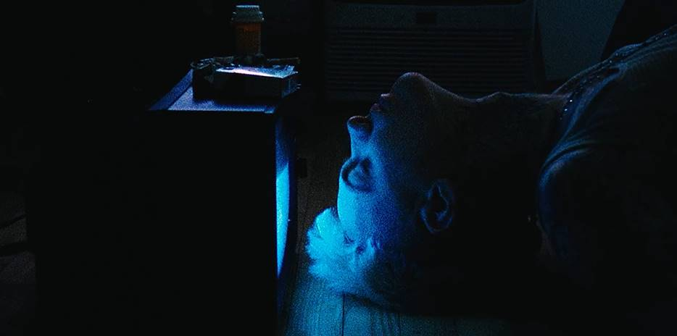

**New York, NY – May 21st, 2021 –** New York-based alternative songwriter and recording artist, **Caspr**, has unveiled his new single, **“Coke Nose,”** – [LISTEN HERE](https://nam04.safelinks.protection.outlook.com/?url=https%3A%2F%2Fcaspr.lnk.to%2FCokeNose&data=04%7C01%7CBrian.Sommer%40atlanticrecords.com%7C8ef3cea17c5d42c04baa08d91b3d5c7d%7C8367939002ec4ba1ad3d69da3fdd637e%7C0%7C0%7C637570772637911575%7CUnknown%7CTWFpbGZsb3d8eyJWIjoiMC4wLjAwMDAiLCJQIjoiV2luMzIiLCJBTiI6Ik1haWwiLCJXVCI6Mn0%3D%7C1000&sdata=tr1aeFbEwHXsfo1KzyGaagXIQI81LVE2%2BaBEz6IRr1g%3D&reserved=0). Produced by **Travis Barker *(blink-182, Machine Gun Kelly, Trippie Redd)*** and **Omer Fedi *(Lil Nas X, 24kGoldn, The Kid Laroi)***,the infectiously energetic single arrives today alongside a Richard Quintero-directed visual: [WATCH HERE](https://nam04.safelinks.protection.outlook.com/?url=https%3A%2F%2Fyoutu.be%2FOZlbI6qSRK8&data=04%7C01%7CBrian.Sommer%40atlanticrecords.com%7C8ef3cea17c5d42c04baa08d91b3d5c7d%7C8367939002ec4ba1ad3d69da3fdd637e%7C0%7C0%7C637570772637921568%7CUnknown%7CTWFpbGZsb3d8eyJWIjoiMC4wLjAwMDAiLCJQIjoiV2luMzIiLCJBTiI6Ik1haWwiLCJXVCI6Mn0%3D%7C1000&sdata=TIgsaZKGQjQMfOaI87JRPNkwXYZOZEJOst%2BkKtOmKfA%3D&reserved=0).

[**DOWNLOAD/STREAM: “COKE NOSE”**](https://nam04.safelinks.protection.outlook.com/?url=https%3A%2F%2Fcaspr.lnk.to%2FCokeNose&data=04%7C01%7CBrian.Sommer%40atlanticrecords.com%7C8ef3cea17c5d42c04baa08d91b3d5c7d%7C8367939002ec4ba1ad3d69da3fdd637e%7C0%7C0%7C637570772637921568%7CUnknown%7CTWFpbGZsb3d8eyJWIjoiMC4wLjAwMDAiLCJQIjoiV2luMzIiLCJBTiI6Ik1haWwiLCJXVCI6Mn0%3D%7C1000&sdata=w3jOJssMkTk5d50BjP%2BlZGL%2Fv7qD9qdqLxbiqphCLbc%3D&reserved=0)

Produced by Travis Barker & Omer Fedi

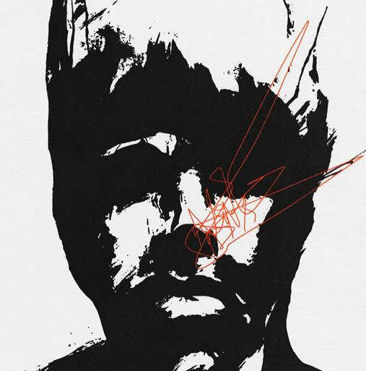

**ABOUT CASPR:**

Over the past few years, New York artist Caspr (formerly known as PPG Casper) has been building a cult-like fanbase via Soundcloud drops, music videos and underground shows. It was only a matter of time before Travis Barker and Andrew Watt caught wind and helped shape Caspr’s vision and sound to what you hear now. A unique songwriter, artist and vocalist, Caspr draws inspiration from his experiences and environment which he formulates into intricate stories of heartache, love, loss, late nights, long days and the struggles of everyday life.

**Press Contact:** Jason Davis – [jason.davis@atlanticrecords.com](mailto:jason.davis@atlanticrecords.com)

* * *

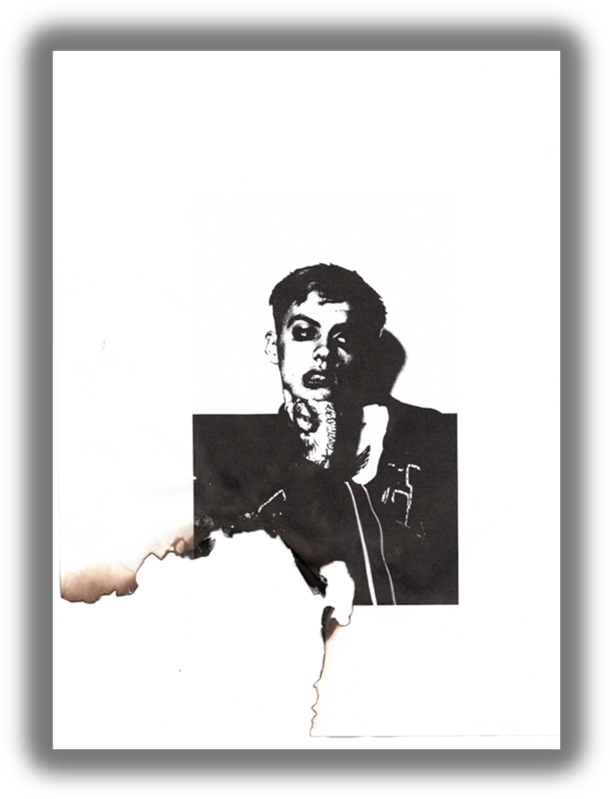

**CONNECT WITH CASPR:**

[INSTAGRAM](https://nam04.safelinks.protection.outlook.com/?url=https%3A%2F%2Fwww.instagram.com%2Fiamcaspr%2F%3Fhl%3Den&data=04%7C01%7CBrian.Sommer%40atlanticrecords.com%7C8ef3cea17c5d42c04baa08d91b3d5c7d%7C8367939002ec4ba1ad3d69da3fdd637e%7C0%7C0%7C637570772637931563%7CUnknown%7CTWFpbGZsb3d8eyJWIjoiMC4wLjAwMDAiLCJQIjoiV2luMzIiLCJBTiI6Ik1haWwiLCJXVCI6Mn0%3D%7C1000&sdata=p7%2B2toQsTQrMuFNF3wDqYSSK7YJTBroJcbPyTV4b9r8%3D&reserved=0) | [TWITTER](https://nam04.safelinks.protection.outlook.com/?url=https%3A%2F%2Ftwitter.com%2FIamcaspr%3Fref_src%3Dtwsrc%255Egoogle%257Ctwcamp%255Eserp%257Ctwgr%255Eauthor&data=04%7C01%7CBrian.Sommer%40atlanticrecords.com%7C8ef3cea17c5d42c04baa08d91b3d5c7d%7C8367939002ec4ba1ad3d69da3fdd637e%7C0%7C0%7C637570772637931563%7CUnknown%7CTWFpbGZsb3d8eyJWIjoiMC4wLjAwMDAiLCJQIjoiV2luMzIiLCJBTiI6Ik1haWwiLCJXVCI6Mn0%3D%7C1000&sdata=wxysSxEOzeWS1NVKDhM5W79kgoB2z6qx4C4%2B21HgvHs%3D&reserved=0) | [FACEBOOK](https://nam04.safelinks.protection.outlook.com/?url=https%3A%2F%2Fwww.facebook.com%2Fiamcaspr%2F&data=04%7C01%7CBrian.Sommer%40atlanticrecords.com%7C8ef3cea17c5d42c04baa08d91b3d5c7d%7C8367939002ec4ba1ad3d69da3fdd637e%7C0%7C0%7C637570772637941557%7CUnknown%7CTWFpbGZsb3d8eyJWIjoiMC4wLjAwMDAiLCJQIjoiV2luMzIiLCJBTiI6Ik1haWwiLCJXVCI6Mn0%3D%7C1000&sdata=Z5tIwthw%2FzHrMTUx6%2FiDFgNHiSkMFK4Cabok1%2BsB%2FgE%3D&reserved=0) | [YOUTUBE](https://nam04.safelinks.protection.outlook.com/?url=https%3A%2F%2Fwww.youtube.com%2Fchannel%2FUCbdpzIKJo_a5q9v0GyU_bnw&data=04%7C01%7CBrian.Sommer%40atlanticrecords.com%7C8ef3cea17c5d42c04baa08d91b3d5c7d%7C8367939002ec4ba1ad3d69da3fdd637e%7C0%7C0%7C637570772637951551%7CUnknown%7CTWFpbGZsb3d8eyJWIjoiMC4wLjAwMDAiLCJQIjoiV2luMzIiLCJBTiI6Ik1haWwiLCJXVCI6Mn0%3D%7C1000&sdata=39X8Q%2BxG34DDAXwueaY4lHdwl30pIyBk0qSSZzq%2Fyy8%3D&reserved=0) | [PRESS SITE](https://nam04.safelinks.protection.outlook.com/?url=http%3A%2F%2Fpress.atlanticrecords.com%2Fcaspr&data=04%7C01%7CBrian.Sommer%40atlanticrecords.com%7C8ef3cea17c5d42c04baa08d91b3d5c7d%7C8367939002ec4ba1ad3d69da3fdd637e%7C0%7C0%7C637570772637951551%7CUnknown%7CTWFpbGZsb3d8eyJWIjoiMC4wLjAwMDAiLCJQIjoiV2luMzIiLCJBTiI6Ik1haWwiLCJXVCI6Mn0%3D%7C1000&sdata=3lWGdgx9bzkNgABRQ%2BTfaAziDj6lbn37JUrABvy2RAk%3D&reserved=0)

# # #