CASPR RELEASES “DON’T MAKE SENSE”

RISING ARTIST UNVEILS NEW SONG ALONGSIDE RICHARD QUINTERO-DIRECTED MUSIC VIDEO

RECENT LIVE PERFORMANCES INCLUDE 2 SOLD-OUT SHOWS AT NYC’S BABY’S ALL RIGHT & LA’S MOROCCAN LOUNGE

WATCH: “Don’t Make Sense”
Directed by Richard Quintero

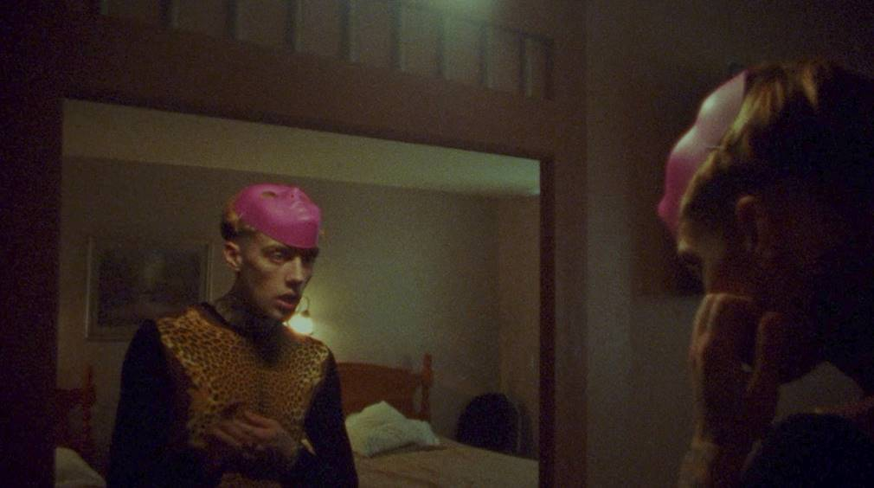

DOWNLOAD/STREAM: “Don’t Make Sense”
Written by Caspr
Produced by Travis Barker & Omer Fedi

New York, NY – October 29, 2021 – Alternative songwriter & recording artist Caspr has released his latest single, “Don’t Make Sense,” an acoustic guitar-driven track written by Caspr and co-produced by Travis Barker (Machine Gun Kelly, jxdn, WILLOW) and Omer Fedi (The Kid Laroi, Machine Gun Kelly, 24KGoldn) – LISTEN HERE.

Arriving today alongside a Richard Quintero-directed visual – WATCH HERE – “Don’t Make Sense” is the fourth track in a string of singles from the New York-based artist. His major label debut, “Coke Nose,” was praised by Office Magazine for its, “seamless blend of emo sentimentality, post-punk guitar lines and a bouncy pop-rap rhythm.”

The energetic single was followed by “Duct Taped Lips,” produced by Andrew Watt (Justin Bieber, Post Malone, Miley Cyrus, JuiceWRLD) and megastar Omar Apollo, as well as “Play Pretend,” which featured legendary blink-182 drummer and frequent collaborator, Travis Barker.

The new music also arrives fresh off the heels of Caspr’s first sold-out headlining shows this month at Los Angeles’ Moroccan Lounge and Brooklyn’s Baby’s All Right.

Caspr’s new single, “Don’t Make Sense,” is available now and will appear alongside his previously released songs on his upcoming project arriving soon.

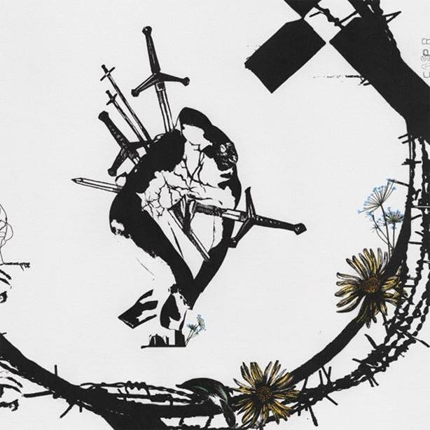
DOWNLOAD HIGH-RES ARTWORK

ABOUT CASPR:
Over the past few years, New York artist Caspr (formerly known as PPG Casper) has been building a cult-like fanbase via Soundcloud drops, music videos, underground shows and his work with the meteorically rising Surf Gang collective. It was only a matter of time before Travis Barker and Andrew Watt caught wind and helped shape Caspr’s vision and sound to what you hear now. A unique songwriter, artist and vocalist, Caspr draws inspiration from his experiences and environment which he formulates into intricate stories of heartache, love, loss, late nights, long days and the struggles of everyday life.

Press Contact: Jason Davis – jason.davis@atlanticrecords.com

* * *

DOWNLOAD PRESS PHOTOS HERE
[Photo Credit: Yulissa Benitez]
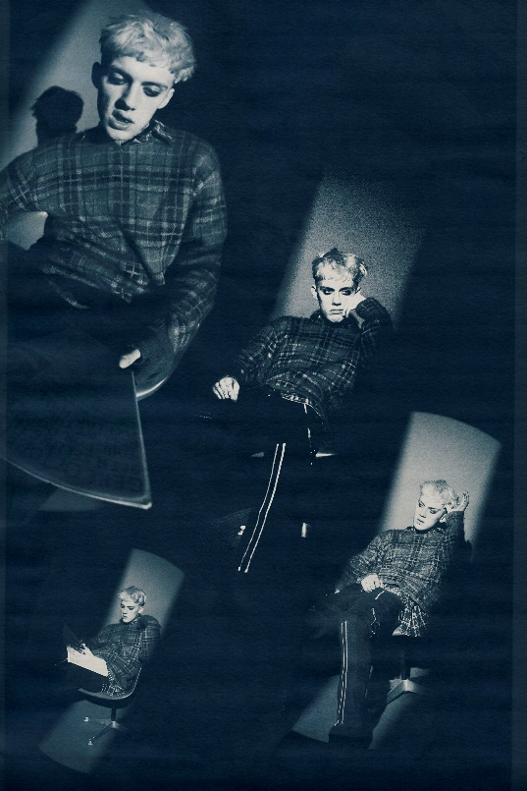

CONNECT WITH CASPR:
INSTAGRAM | TWITTER | FACEBOOK | YOUTUBE | PRESS SITE

# # #

