**CASPR LETS IT “SNOW”**

**[WATCH: “Snow” Music Video](https://nam04.safelinks.protection.outlook.com/?url=https%3A%2F%2Fcaspr.lnk.to%2FSnowOfficialVideo&data=04%7C01%7CBrian.Sommer%40atlanticrecords.com%7Cf49a552ab6bd4dcb075d08d9bb037175%7C8367939002ec4ba1ad3d69da3fdd637e%7C0%7C0%7C637746445721681900%7CUnknown%7CTWFpbGZsb3d8eyJWIjoiMC4wLjAwMDAiLCJQIjoiV2luMzIiLCJBTiI6Ik1haWwiLCJXVCI6Mn0%3D%7C3000&sdata=PR9FJ1krQjUwAO%2FCWYL0kBYcdePeVNlVtFxa92FST%2FM%3D&reserved=0)**

*Directed by Lake Hills*

[**DOWNLOAD/STREAM**](https://nam04.safelinks.protection.outlook.com/?url=https%3A%2F%2Fcaspr.lnk.to%2FSnow&data=04%7C01%7CBrian.Sommer%40atlanticrecords.com%7Cf49a552ab6bd4dcb075d08d9bb037175%7C8367939002ec4ba1ad3d69da3fdd637e%7C0%7C0%7C637746445721691891%7CUnknown%7CTWFpbGZsb3d8eyJWIjoiMC4wLjAwMDAiLCJQIjoiV2luMzIiLCJBTiI6Ik1haWwiLCJXVCI6Mn0%3D%7C3000&sdata=UXdXpjgvehaXzljJAlTXJzZqy7BQYvx6Nc9zV4rkwbw%3D&reserved=0)

*Written by Caspr, Andrew Watt, Carter Lang, Billy Walsh & Ali Tamposi*

*Produced by Andrew Watt & Carter Lang*

***RECENT LIVE PERFORMANCES INCLUDE SOLD-OUT SHOWS AT NYC’S BABY’S ALL RIGHT & LA’S MOROCCAN LOUNGE***

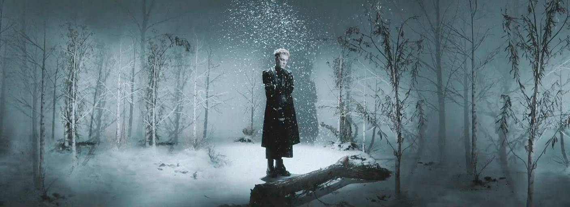

[**DOWNLOAD/STREAM: “Snow”**](https://nam04.safelinks.protection.outlook.com/?url=https%3A%2F%2Fcaspr.lnk.to%2FSnow&data=04%7C01%7CBrian.Sommer%40atlanticrecords.com%7Cf49a552ab6bd4dcb075d08d9bb037175%7C8367939002ec4ba1ad3d69da3fdd637e%7C0%7C0%7C637746445721691891%7CUnknown%7CTWFpbGZsb3d8eyJWIjoiMC4wLjAwMDAiLCJQIjoiV2luMzIiLCJBTiI6Ik1haWwiLCJXVCI6Mn0%3D%7C3000&sdata=UXdXpjgvehaXzljJAlTXJzZqy7BQYvx6Nc9zV4rkwbw%3D&reserved=0)

**New York, NY – December 10, 2021 –** Alternative songwriter & recording artist **Caspr** is embracing the cold weather with his new single, **“Snow”** – [LISTEN HERE](https://nam04.safelinks.protection.outlook.com/?url=https%3A%2F%2Fcaspr.lnk.to%2FSnow&data=04%7C01%7CBrian.Sommer%40atlanticrecords.com%7Cf49a552ab6bd4dcb075d08d9bb037175%7C8367939002ec4ba1ad3d69da3fdd637e%7C0%7C0%7C637746445721691891%7CUnknown%7CTWFpbGZsb3d8eyJWIjoiMC4wLjAwMDAiLCJQIjoiV2luMzIiLCJBTiI6Ik1haWwiLCJXVCI6Mn0%3D%7C3000&sdata=UXdXpjgvehaXzljJAlTXJzZqy7BQYvx6Nc9zV4rkwbw%3D&reserved=0). Arriving today alongside a chilling visual directed by **Lake Hills** – [WATCH HERE](https://nam04.safelinks.protection.outlook.com/?url=https%3A%2F%2Fcaspr.lnk.to%2FSnowOfficialVideo&data=04%7C01%7CBrian.Sommer%40atlanticrecords.com%7Cf49a552ab6bd4dcb075d08d9bb037175%7C8367939002ec4ba1ad3d69da3fdd637e%7C0%7C0%7C637746445721701888%7CUnknown%7CTWFpbGZsb3d8eyJWIjoiMC4wLjAwMDAiLCJQIjoiV2luMzIiLCJBTiI6Ik1haWwiLCJXVCI6Mn0%3D%7C3000&sdata=gk8WZLIaYEPFCfk5dq52PIGp9Za1lYst4myooeUkW04%3D&reserved=0) – **“Snow”** was co-written by Caspr, **Billy Walsh *(Justin Bieber, The Weeknd, Post Malone)*** and **Ali Tamposi *(Dua Lipa, Miley Cyrus & Camila Cabello)*** as well as  **Andrew Watt** ***(*Justin *Bieber, Post Malone, Miley Cyrus, JuiceWRLD)*** & **Carter Lang *(Post Malone, Doja Cat, SZA)***, both of whom also produced the track.

**“Snow”** is the fifth track in a string of singles from the New York-based artist, succeeding his previous release, [**“Don’t Make Sense,”**](https://nam04.safelinks.protection.outlook.com/?url=https%3A%2F%2Fwww.youtube.com%2Fwatch%3Fv%3DxMbhqyAP5_0&data=04%7C01%7CBrian.Sommer%40atlanticrecords.com%7Cf49a552ab6bd4dcb075d08d9bb037175%7C8367939002ec4ba1ad3d69da3fdd637e%7C0%7C0%7C637746445721701888%7CUnknown%7CTWFpbGZsb3d8eyJWIjoiMC4wLjAwMDAiLCJQIjoiV2luMzIiLCJBTiI6Ik1haWwiLCJXVCI6Mn0%3D%7C3000&sdata=PsOtig8M92mGpBbcEN%2FuwPRf%2BxokVWKdftq9w6eiZ5I%3D&reserved=0) an acoustic guitar-driven track written by Caspr and co-produced by **Travis Barker** (***Machine Gun Kelly, jxdn, WILLOW)*** and **Omer Fedi** ***(The Kid Laroi, Machine Gun Kelly, 24KGoldn)***.

Caspr made his major label debut in May this year with [**“Coke Nose,”**](https://nam04.safelinks.protection.outlook.com/?url=https%3A%2F%2Fwww.youtube.com%2Fwatch%3Fv%3DOZlbI6qSRK8&data=04%7C01%7CBrian.Sommer%40atlanticrecords.com%7Cf49a552ab6bd4dcb075d08d9bb037175%7C8367939002ec4ba1ad3d69da3fdd637e%7C0%7C0%7C637746445721711880%7CUnknown%7CTWFpbGZsb3d8eyJWIjoiMC4wLjAwMDAiLCJQIjoiV2luMzIiLCJBTiI6Ik1haWwiLCJXVCI6Mn0%3D%7C3000&sdata=IrEXimHmZ6bg5ocgtkQaVc9uVUisSFU08d4RVcjdTY8%3D&reserved=0)whichwas praised by **Office Magazine** for its, *“seamless blend of emo sentimentality, post-punk guitar lines and a bouncy pop-rap rhythm.”*

The energetic single was followed by [**“Duct Taped Lips,”**](https://nam04.safelinks.protection.outlook.com/?url=https%3A%2F%2Fwww.youtube.com%2Fwatch%3Fv%3DzIXFUh5qIOI&data=04%7C01%7CBrian.Sommer%40atlanticrecords.com%7Cf49a552ab6bd4dcb075d08d9bb037175%7C8367939002ec4ba1ad3d69da3fdd637e%7C0%7C0%7C637746445721711880%7CUnknown%7CTWFpbGZsb3d8eyJWIjoiMC4wLjAwMDAiLCJQIjoiV2luMzIiLCJBTiI6Ik1haWwiLCJXVCI6Mn0%3D%7C3000&sdata=Q7PiYK3cMw%2FW9imCSaNl2Bty8JRb8vpcj5HY7FvG%2BBc%3D&reserved=0)produced by **Andrew Watt**and megastar **Omar Apollo**, as well as [**“Play Pretend,”**](https://nam04.safelinks.protection.outlook.com/?url=https%3A%2F%2Fwww.youtube.com%2Fwatch%3Fv%3DAONcGwviq2A&data=04%7C01%7CBrian.Sommer%40atlanticrecords.com%7Cf49a552ab6bd4dcb075d08d9bb037175%7C8367939002ec4ba1ad3d69da3fdd637e%7C0%7C0%7C637746445721721875%7CUnknown%7CTWFpbGZsb3d8eyJWIjoiMC4wLjAwMDAiLCJQIjoiV2luMzIiLCJBTiI6Ik1haWwiLCJXVCI6Mn0%3D%7C3000&sdata=4bFW9OXCk0hJRs7b7Kfy6g92tysgbklWMruDSw0kshU%3D&reserved=0)which featured legendary blink-182 drummer and frequent collaborator, **Travis Barker**.

**“Snow”** also arrives fresh off the heels of Caspr’s first **sold-out** headlining shows in October at **Los Angeles’ Moroccan Lounge** and **Brooklyn’s Baby’s All Right**.

Caspr’s new single, **“Snow,”** is available now and will appear alongside his previously released tracks on his upcoming project arriving soon.

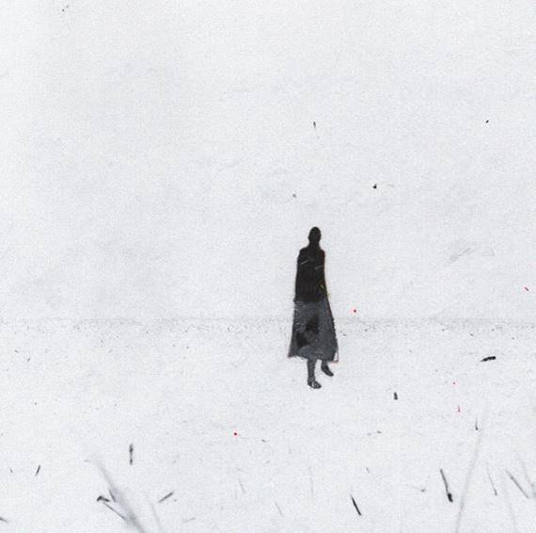

[DOWNLOAD HIGH-RES ARTWORK](https://nam04.safelinks.protection.outlook.com/?url=http%3A%2F%2Fpress.atlanticrecords.com%2Fcaspr%2F&data=04%7C01%7CBrian.Sommer%40atlanticrecords.com%7Cf49a552ab6bd4dcb075d08d9bb037175%7C8367939002ec4ba1ad3d69da3fdd637e%7C0%7C0%7C637746445721721875%7CUnknown%7CTWFpbGZsb3d8eyJWIjoiMC4wLjAwMDAiLCJQIjoiV2luMzIiLCJBTiI6Ik1haWwiLCJXVCI6Mn0%3D%7C3000&sdata=45GpuKDyoJovrim4zSElOza3hosMeaJSJlbktXTvX2w%3D&reserved=0)

**ABOUT CASPR:**

Over the past few years, New York artist Caspr (formerly known as PPG Casper) has been building a cult-like fanbase via Soundcloud drops, music videos, underground shows and his work with the meteorically rising Surf Gang collective. It was only a matter of time before Travis Barker and Andrew Watt caught wind and helped shape Caspr’s vision and sound to what you hear now. A unique songwriter, artist and vocalist, Caspr draws inspiration from his experiences and environment which he formulates into intricate stories of heartache, love, loss, late nights, long days and the struggles of everyday life.

**Press Contact:** Jason Davis – [jason.davis@atlanticrecords.com](mailto:jason.davis@atlanticrecords.com)

* * *

[**DOWNLOAD PRESS PHOTOS HERE**](https://nam04.safelinks.protection.outlook.com/?url=http%3A%2F%2Fpress.atlanticrecords.com%2Fcaspr%2F&data=04%7C01%7CBrian.Sommer%40atlanticrecords.com%7Cf49a552ab6bd4dcb075d08d9bb037175%7C8367939002ec4ba1ad3d69da3fdd637e%7C0%7C0%7C637746445721721875%7CUnknown%7CTWFpbGZsb3d8eyJWIjoiMC4wLjAwMDAiLCJQIjoiV2luMzIiLCJBTiI6Ik1haWwiLCJXVCI6Mn0%3D%7C3000&sdata=45GpuKDyoJovrim4zSElOza3hosMeaJSJlbktXTvX2w%3D&reserved=0)

[Photo Credit: Lake Hills]



**CONNECT WITH CASPR:**

[INSTAGRAM](https://nam04.safelinks.protection.outlook.com/?url=https%3A%2F%2Fwww.instagram.com%2Fiamcaspr%2F%3Fhl%3Den&data=04%7C01%7CBrian.Sommer%40atlanticrecords.com%7Cf49a552ab6bd4dcb075d08d9bb037175%7C8367939002ec4ba1ad3d69da3fdd637e%7C0%7C0%7C637746445721731867%7CUnknown%7CTWFpbGZsb3d8eyJWIjoiMC4wLjAwMDAiLCJQIjoiV2luMzIiLCJBTiI6Ik1haWwiLCJXVCI6Mn0%3D%7C3000&sdata=pJuMnKYHY4MxgiZcHtdX8%2ByGuIEREZi9cO4hMPe%2Fhgc%3D&reserved=0) | [TWITTER](https://nam04.safelinks.protection.outlook.com/?url=https%3A%2F%2Ftwitter.com%2FIamcaspr%3Fref_src%3Dtwsrc%255Egoogle%257Ctwcamp%255Eserp%257Ctwgr%255Eauthor&data=04%7C01%7CBrian.Sommer%40atlanticrecords.com%7Cf49a552ab6bd4dcb075d08d9bb037175%7C8367939002ec4ba1ad3d69da3fdd637e%7C0%7C0%7C637746445721731867%7CUnknown%7CTWFpbGZsb3d8eyJWIjoiMC4wLjAwMDAiLCJQIjoiV2luMzIiLCJBTiI6Ik1haWwiLCJXVCI6Mn0%3D%7C3000&sdata=JNgwgfLDdsYEjIYN9WuSfhQ6MgftJ070khBXuDjFSSs%3D&reserved=0) | [FACEBOOK](https://nam04.safelinks.protection.outlook.com/?url=https%3A%2F%2Fwww.facebook.com%2Fiamcaspr%2F&data=04%7C01%7CBrian.Sommer%40atlanticrecords.com%7Cf49a552ab6bd4dcb075d08d9bb037175%7C8367939002ec4ba1ad3d69da3fdd637e%7C0%7C0%7C637746445721741862%7CUnknown%7CTWFpbGZsb3d8eyJWIjoiMC4wLjAwMDAiLCJQIjoiV2luMzIiLCJBTiI6Ik1haWwiLCJXVCI6Mn0%3D%7C3000&sdata=y6c%2BLM9yW8SBvZNkOH7ffGosSDRJl8uhVCpqLGin3ws%3D&reserved=0) | [YOUTUBE](https://nam04.safelinks.protection.outlook.com/?url=https%3A%2F%2Fwww.youtube.com%2Fchannel%2FUCbdpzIKJo_a5q9v0GyU_bnw&data=04%7C01%7CBrian.Sommer%40atlanticrecords.com%7Cf49a552ab6bd4dcb075d08d9bb037175%7C8367939002ec4ba1ad3d69da3fdd637e%7C0%7C0%7C637746445721741862%7CUnknown%7CTWFpbGZsb3d8eyJWIjoiMC4wLjAwMDAiLCJQIjoiV2luMzIiLCJBTiI6Ik1haWwiLCJXVCI6Mn0%3D%7C3000&sdata=4YT7qoZKj9wnGjlj3uWAj%2FWq49nWauZWlWkN2hj1y7M%3D&reserved=0) | [PRESS SITE](https://nam04.safelinks.protection.outlook.com/?url=http%3A%2F%2Fpress.atlanticrecords.com%2Fcaspr&data=04%7C01%7CBrian.Sommer%40atlanticrecords.com%7Cf49a552ab6bd4dcb075d08d9bb037175%7C8367939002ec4ba1ad3d69da3fdd637e%7C0%7C0%7C637746445721751857%7CUnknown%7CTWFpbGZsb3d8eyJWIjoiMC4wLjAwMDAiLCJQIjoiV2luMzIiLCJBTiI6Ik1haWwiLCJXVCI6Mn0%3D%7C3000&sdata=TorV0DJngkHHDmdktOQgjXHIsC%2BqS1pmOmmI0nH1XhI%3D&reserved=0)

# # #