FOR IMMEDIATE RELEASE

DECEMBER 16, 2021

CATIE TURNER GIVES STUNNING PERFORMANCE OF “GOD MUST HATE ME”

ACCLAIMED SINGER-SONGWRITER GIVES POWERFUL PERFORMANCE OF CURRENT SINGLE

RISING SINGLE HAS RACKED UP 10 MILLION STREAMS + OVER 40,000 TIKTOK CREATES
WITHIN LESS THAN A MONTH OF RELEASE

WATCH THE VIDEO NOW HERE
DOWNLOAD ASSETS HERE

Rising singer-songwriter Catie Turner has released a stunning performance video of her recent single “God Must Hate Me.” Sitting on the floor of the beautiful St. Ann's church, Turner delivers a powerful and
emotional live performance of the honest track. Watch the video now HERE.

Catie first teased the confessional track on her TikTok, quickly racking up over 1 million views within 24 hours of posting the video. The honest track has gone on to rack up over 10 million streams in the 3 weeks since it’s November release and continues to stream over 2 million times a week in the US alone. The sound on TikTok currently boats over 40,000 individual creates and Catie has gained over 1.5 million monthly Spotify on listeners in the past 2 weeks. The track also landed Catie on the cover Spotify’s Next Gen Singer Songwriters playlist.

“’God must hate me’ may be, in my opinion, the most vulnerable song ive released yet - which is scary yet exhilarating all at the same time,” Catie shared about the track. “Some may roll their eyes at the melodramatic title, and believe me, when I’m in a good headspace I can laugh at myself too, but ‘God Must Hate Me’ is about those times where the feelings are so omnipotent, you really start to believe it. That you were made wrong. That you’re not good enough. And, that maybe, a higher power being angry with you is a pill easier to swallow than personal responsibility.”

Catie recently toured with rising pop artist JORDY where they performed their moving duet “(Wish I Didn’t Have To) Lie.” The track was co-written by Turner and JORDY and landed the pair on the cover of Spotify’s Sad Hour playlist upon release.

Catie is currently working on her next project – for all updates please visit: https://www.catieturner.com/.

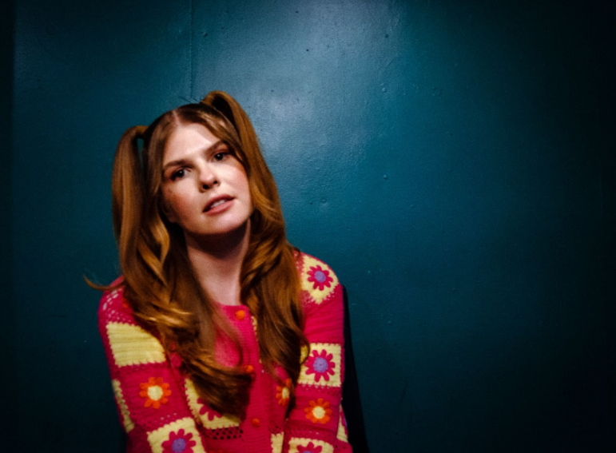
DOWNLOAD PRESS PHOTOS HERE

ABOUT CATIE TURNER:
Beloved for her potent, personal lyricism and soulful vocals, Catie Turner is a uniquely gifted singer and writer whose offbeat charm and tongue-in-cheek songcraft has now drawn over 117 million global streams and counting.

Catie first began writing songs and playing guitar in her hometown of Langhorne, PA, providing her a means to cope with the myriad pressures placed upon young women. The 20-year-old artist captured national attention in 2018 as one of the standout stars of ABC's American Idol, kicking off the season with a stunning audition performance of her own extraordinary composition, “21st Century Machine,” immediately winning over judges Lionel Richie, Luke Bryan, and Katy Perry, who applauded her a “genius songwriter.” 2019 brought her remarkable solo debut EP, THE SAD VEGAN, highlighted by the moving pop anthem “Prom Queen.” The track, which exploded across all platforms, was named one of TIME’s “5 Songs You Need To Listen To This Week,” and landed Catie a spot on Idolator’s “On The Verge: 40 Artists To Watch In 2020.”

Most recently, Catie released her Atlantic Records debut EP Heartbroken and Milking It. The project included widely praised tracks such as “Play God,” named by Billboard as one of “10 Cool New Pop Songs to Get You Through the Week” and hailed by Hollywood Life as an “enchanting new song…with a dreamy production capturing the cloudy haze one feels when struggling with the affairs of the heart, Catie captures the turmoil of someone who knows it’s time to let go but can’t just yet.”

The project saw further acclaim from American Songwriter which stated, “Turner’s ethereal pop-shere aims toward an arrival of sorts, while her stripped-down lyricism suggests a pinnacled confidence,” and Ones to Watch praising, “Catie Turner's music moves through the world with an infectious sincerity, invisible to the passerby but deeply affective to those it happens to grace. It's a testament to her gift for immaculate pop-minded songwriting that carries with it an empathy well beyond her age, and it is a gift she is more than happy to share on her major label debut EP, Heartbroken and Milking It.”

Perhaps TIME said it best, “There is a universal message that resonates well into adulthood in Catie Turner's aching, existential honesty… The intimate directness of her voice, over a supple acoustic melody, suggests wisdom beyond her years.”

Catie is hard at work on her next project. Stay tuned for more from this rising star!

# # #

CONNECT WITH CATIE TURNER
OFFICIAL | INSTAGRAM |TIK TOK | FACEBOOK | TWITTER | YOUTUBE

For Catie press inquiries, please contact:
Kelly McWilliam, Kelly.McWilliam@atlanticrecords.com
Paige Rosoff, Paige.Rosoff@atlanticrecords.com

