FOR IMMEDIATE RELEASE

OCTOBER 13, 2021

CATIE TURNER AND JORDY RELEASE VERSION 2 OF
“(WISH I DIDN’T HAVE TO) LIE”

THE ORIGINAL PROVED TO BE A FAN FAVORITE FROM TURNER’S ATLANTIC LABEL DEBUT EP HEARTBROKEN AND MILKING IT

TRACK ARRIVES TODAY WITH A PERFORMANCE VIDEO
STREAMING NOW HERE

LISTEN TO “(WISH I DIDN’T HAVE TO) LIE [FEAT JORDY]” HERE
WATCH THE PERFORMANCE VIDEO HERE
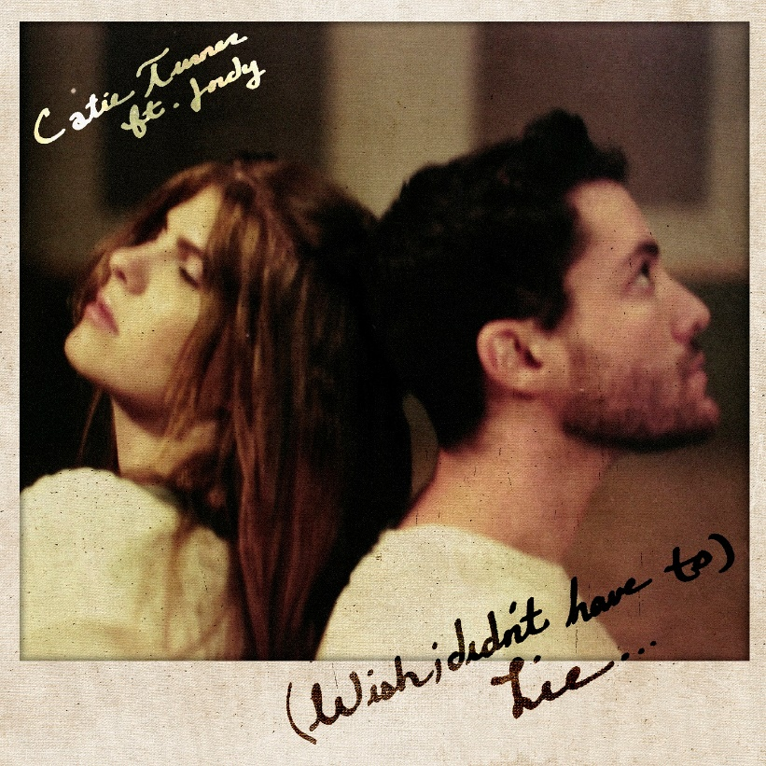
DOWNLOAD ARTWORK HERE

Acclaimed singer-songwriter Catie Turner and rising pop artist JORDY have released a new version of their song “(Wish I Didn’t Have To) Lie” – available now HERE. The new version of this honest track arrives today alongside a performance video, streaming now HERE.

Co-written by Turner and JORDY, “(Wish I Didn’t Have To) Lie” originally appeared on Turner’s Atlantic Records debut EP, Heartbroken and Milking it. Upon release, Entertainment Tonight named it one of the best releases of the week. The duo first performed the new version together at Catie’s live show at Los Angeles’ legendary venue, The Troubadour, earlier this month.

“I wrote this song with JORDY over Zoom during 2020 and it was the type of song where we both knew it was special right away,” Catie shared. “It only felt right to put out a new version with him actually singing on it, because without him the song wouldn’t exist. I hope people think it’s as special as we do!”

“Catie Turner is a force to be reckoned with and I am immensely honored to be a part of her project,” JORDY added. “During the pandemic we had many a “FaceTime sessions” where Catie would video call me with her guitar and we would talk for hours about what we were going through at the time. When we wrote “lie” we were talking breakups and hardships, leaving people in our past but acknowledging the impact they had on us. Ruining daily activities that we associated with them, the feeling of hating that you miss them; that you still love them. “Lie” is a true diary of our real experiences and it means the world to me to be on a song with someone I care so much about.”

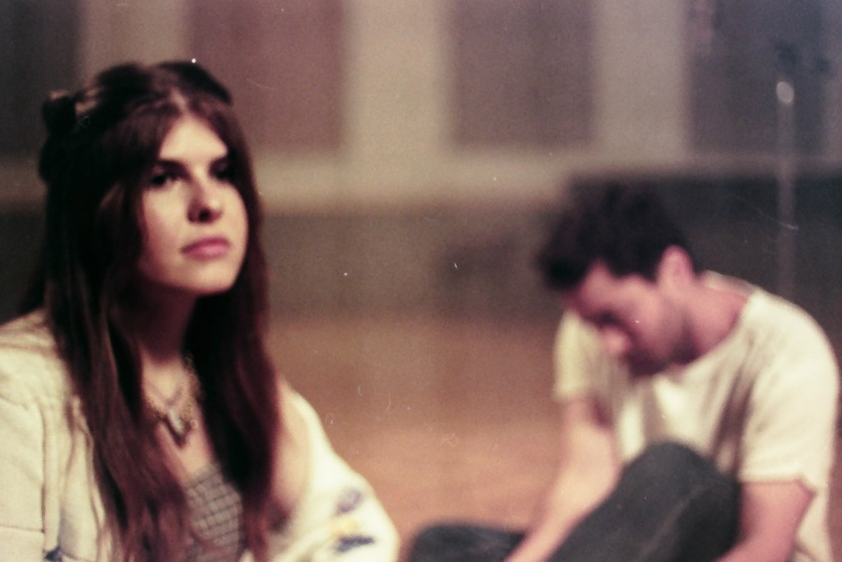
DOWNLOAD PRESS PHOTOS HERE

ABOUT CATIE TURNER:
Beloved for her potent, personal lyricism and soulful vocals, Catie Turner is a uniquely gifted singer and writer whose offbeat charm and tongue-in-cheek songcraft has now drawn over 70 million global streams and counting.

Catie first began writing songs and playing guitar in her hometown of Langhorne, PA, providing her a means to cope with the myriad pressures placed upon young women. The 20-year-old artist captured national attention in 2018 as one of the standout stars of ABC's American Idol, kicking off the season with a stunning audition performance of her own extraordinary composition, “21st Century Machine,” immediately winning over judges Lionel Richie, Luke Bryan, and Katy Perry, who applauded her a “genius songwriter.” 2019 brought her remarkable solo debut EP, THE SAD VEGAN, highlighted by the moving pop anthem “Prom Queen.” The track, which exploded across all platforms, was named one of TIME’s “5 Songs You Need To Listen To This Week,” and landed Catie a spot on Idolator’s “On The Verge: 40 Artists To Watch In 2020.”

Most recently, Catie released her Atlantic Records debut EP Heartbroken and Milking It. The project included widely praised tracks such as “Play God,” named by Billboard as one of “10 Cool New Pop Songs to Get You Through the Week” and hailed by Hollywood Life as an “enchanting new song…with a dreamy production capturing the cloudy haze one feels when struggling with the affairs of the heart, Catie captures the turmoil of someone who knows it’s time to let go but can’t just yet.”

The project saw further acclaim from American Songwriter which stated, “Turner’s ethereal pop-shere aims toward an arrival of sorts, while her stripped-down lyricism suggests a pinnacled confidence,” and Ones to Watch praising, “Catie Turner's music moves through the world with an infectious sincerity, invisible to the passerby but deeply affective to those it happens to grace. It's a testament to her gift for immaculate pop-minded songwriting that carries with it an empathy well beyond her age, and it is a gift she is more than happy to share on her major label debut EP, Heartbroken and Milking It.”

Perhaps TIME said it best, “There is a universal message that resonates well into adulthood in Catie Turner's aching, existential honesty… The intimate directness of her voice, over a supple acoustic melody, suggests wisdom beyond her years.”

Catie is hard at work on her next project. Stay tuned for more from this rising star!

ABOUT JORDY:
Born in the suburbs of Chicago, JORDY is an up-and-coming singer-songwriter now based in Los Angeles. Drawing influences from Lauv and Troye Sivan with catchy melodies and unforgettable hooks, JORDY has been releasing a steady supply of pop hits and features. He has been taking over media, first as one of Radio Disney’s featured artists with the release of his song “Tomorrow feat. OSTON,” and most recently on the Tonight Show with Jimmy Fallon where he participated in and won the Songwriter’s Challenge.
With a heart-on-sleeve approach to modern pop music, JORDY’s music explores themes of rejection and loneliness through the lens of hope and empowerment, such as in “Is It Love?” which asks the question “Is it love if it’s not f*cked up?”

After his debut single “Just Friends” gained rave reviews from Billboard and OUT Magazine, he released his EP Welcome to the Friend Zone, a collection of songs themed around the popular phrase.

To support his second EP, PSYCHO, JORDY completed his first headline tour, playing sold out shows across the country, including in his hometown of Chicago at Schubas Tavern. With this EP, JORDY was written about in TIME Magazine as one of the Top Things to Hear This Week, alongside notable acts like Billie Eillish, Sam Smith and Monsta X.

With major support from streaming services like SoundCloud (Artist to Watch) Apple Music , TIDAL, and Spotify (garnering 800K+ monthly listeners) the independent artist has developed a global fan-base that has fallen in love with his vulnerable, relatable, and catchy lyricism.

His recently released track ‘Long Distance’ blew up the TikTok charts and had Meghan Trainor proclaiming “This is my JAMMMM.” The song quickly grew a global fan base and was #4 on Apple Music’s New Releases, adjacent to Dua Lipa and Ariana Grande.

JORDY has written for other notable artists such as Betty Who, VINCINT and Rob Resnick. His next body of work will come out the top of November 2021.

# # #

CONNECT WITH CATIE TURNER
OFFICIAL | INSTAGRAM | FACEBOOK | TWITTER | YOUTUBE

For Catie press inquiries, please contact:
Kelly McWilliam, Kelly.McWilliam@atlanticrecords.com
Paige Rosoff, Paige.Rosoff@atlanticrecords.com

For JORDY press inquiries, please contact:
Bobbie Gale, bobbie@mixedmediaworks.com
Lily Golightly, lily@threehundred.biz

