FOR IMMEDIATE RELEASE
MARCH 25, 2022

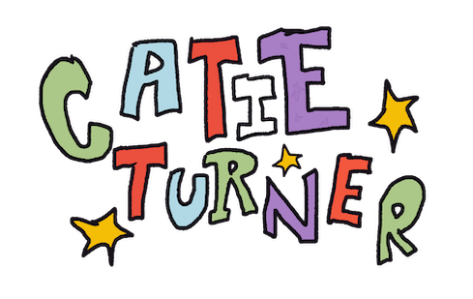
CATIE TURNER SHARES “NOTHING”

MULTI-MILLION STREAMING SINGER-SONGWRITER RETURNS WITH SELF DEPRECATING POP SMASH

NORTH AMERICAN TOUR SUPPORTING LÉON BEGINS MAY 30 IN TORONTO

LISTEN TO “NOTHING” HERE
WACH THE VISULIZER HERE
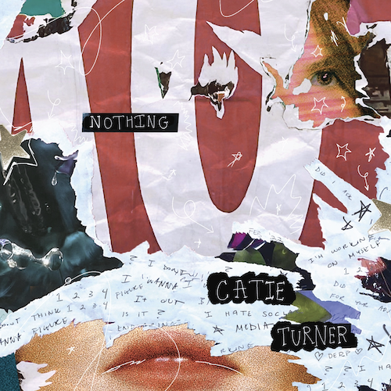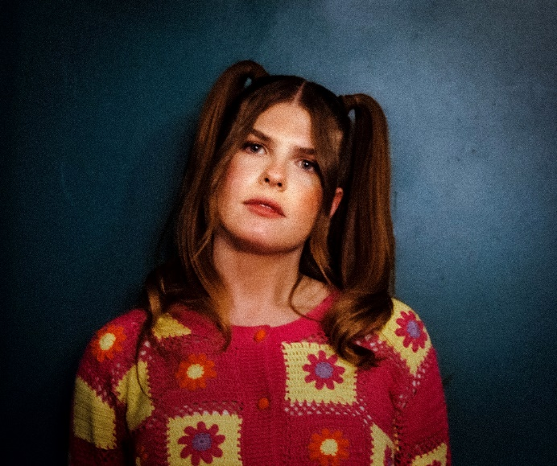
DOWNLOAD HI-RES ARTWORK

“There is a universal message that resonates well into adulthood in Catie Turner's aching, existential honesty… The intimate directness of her voice, over a supple acoustic melody, suggests wisdom beyond her years.” – TIME

Critically acclaimed, multi-million streaming singer-songwriter Catie Turner is back with her latest single, “Nothing.” A self-proclaimed “bullshitter” who “drives self-help books into the ground,” Turner is back with her profound and poignant lyricism, this time in the form of a high energy, pop smash. “Nothing” is available now HERE and an official visualizer is streaming now HERE.

On the new track, Catie shared:

“Ok

I am an overthinking, overwhelmed musician with a talent in overcomplicating situations. I wrote “Nothing” after a very ordinary conversation with a friend, where they were telling me how they started a running regime. I started going on about how I wish I could run, and how I wish I could wake up at 6 am, and they replied, straight to the point: “you know, you always could do that”. And just like that, I realized that my love language is complaining and doing everything I can to make life harder for myself comes like a breeze to my brain. I hope you like it, and that if you, too, are a procrastinator/bullshitter like I am, this can be your anthem.”

Turner – who only just wrapped a major US run supporting Canadian pop band Valley – will kick off her summer as special guest on Léon’s upcoming Fade Into A Dream: The North American Tour, beginning May 30 at Toronto, ON’s Phoenix Concert Center and then touring North America through late June. For complete details and ticket information, please visit www.catieturner.com.

“Nothing” follows Catie’s heart-wrenching breakthrough hit single, “God Must Hate Me,” which proved a viral phenomenon upon its November 2021 release. Applauded by American Songwriter as “a platform for all sorts of reflections and interpretations…one of (Turner’s) most successful songs to date,” the track landed Catie on the cover Spotify’s “Next Gen Singer Songwriters” playlist and has since earned over 38 million streams. A powerful performance video, filed live at the historic St. Ann’s Church in Brooklyn, NY, is streaming now at Catie’s official YouTube channel HERE.

In addition, after hearing 16-year-old rising artist Javier Bennett’s TikTok of him covering the viral track, Catie reached out and together the two artists came up with “god must hate me (lofi),” a stunning lo-fi version which includes captivating new production and an original verse from Bennett.

Last fall also saw Catie team up with new pop artist JORDY for a moving, co-written duet, “(Wish I Didn’t Have To) Lie,” landing the pair on the cover of Spotify’s “Sad Hour” playlist upon release and followed by a series of US tour dates that saw the two artists further collaborating by performing their song together onstage.

CATIE TURNER NORTH AMERICAN TOUR 2022
* All Dates w/ Léon Fade Into A Dream: The North American Tour

MAY
30 - Toronto, ON - Phoenix Music Hall
31 - Chicago, IL - Vic Theater

JUNE
1 - Minneapolis, MN - Varsity Theater
3 - Denver, CO - Summit
4 - Salt Lake City, UT - Complex
6 - Vancouver, BC - Commodore Ballroom
7 - Seattle, WA - Showbox SoDo
9 - San Francisco, CA - Regency Ballroom
10 - Los Angeles, CA - Wiltern
11 - San Diego, CA - House of Blues
15 - Phoenix, AZ – The Van Buren
17 - Austin, TX - Scoot Inn
18 - Dallas, TX - Echo Lounge & Music Hall
19 - Houston, TX - White Oak
21 - Orlando, FL - Plaza Live
22 - Atlanta, GA - Buckhead Theater
24 - Nashville, TN - Brooklyn Bowl
25 - Charlotte, NC - Underground
26 - Silver Springs, MD – The Fillmore
28 - Philadelphia, PA – Theater of Living Arts (TLA)
29 - Brooklyn, NY - Brooklyn Steel
30 - Boston, MA - House of Blues

# # #

ABOUT CATIE TURNER:
You don’t ever have to worry about what Catie Turner is thinking. She’ll tell you within seconds. Besides being a singer and songwriter, she fancies herself as “an overly emotional and anxious attachment-style musician with a lot of over-sharing to do.” However, that over-sharing continues to click with listeners. The Langhorne, PA native went from placing 7th on American Idol in 2018 to releasing teenage crisis anthems such as “Prom Queen” and “i luv him.” in 2019. Beyond piling up over 30 million streams, she reeled in critical acclaim from TIME, Billboard, American Songwriter, Idolator, The Honey Pop, Euphoria., and more. She took all of her heartbreak from a breakup and turned it into the bops, ballads, and confessions on her 2021 EP, Heartbroken and Milking It, introduced by the single “Therapy.” She describes her ex’s response to these bops as “not appreciative.” She just hopes you think she’s pretty cool, because she doesn’t have a Plan B.

# # #

CONNECT WITH CATIE TURNER
OFFICIAL | INSTAGRAM |TIK TOK | FACEBOOK | TWITTER | YOUTUBE

For press inquiries, please contact:
Kelly McWilliam, Kelly.McWilliam@atlanticrecords.com
Paige Rosoff, Paige.Rosoff@atlanticrecords.com

