HOLLYWOOD LIFE PREMIERES EXCLUSIVE PIANO VIDEO OF COLTON DIXON'S HIT SINGLE 'MIRACLES'

WATCH “MIRACLES (PIANO VERSION)”:
https://www.youtube.com/watch?v=pPdJOR79pxg&feature=youtu.be

BUY/STREAM:
https://coltondixon.lnk.to/MiraclesPianoPR

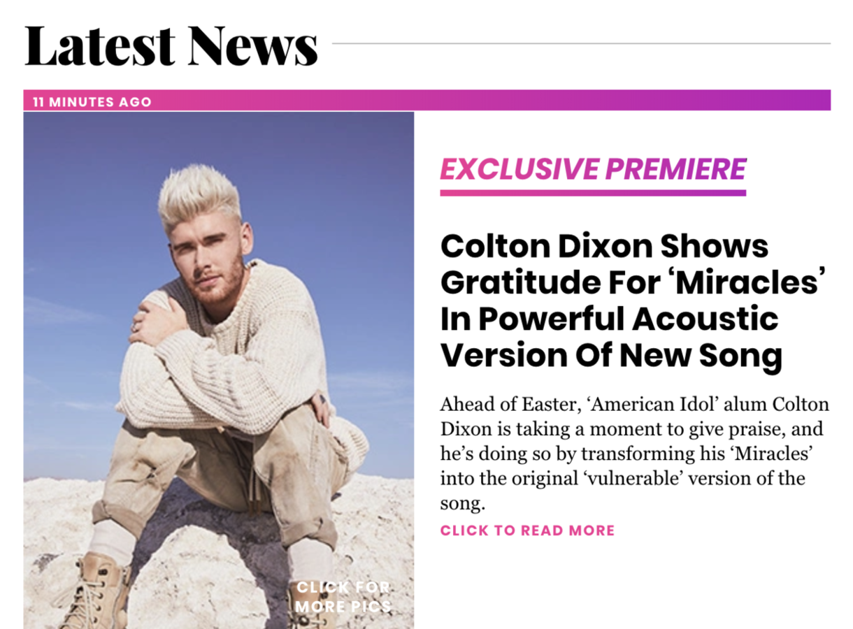

Nashville, TN.... April 10, 2020 - Colton Dixon's hit track "Miracles" is making its way up the radio charts with more adds each week, and today, Hollywood Life is exclusively premiering a special piano video of the song.

“This is how we initially wrote the song,” Dixon said to Hollywood Life. “Stripping a song back to its original form feels vulnerable, but I’m excited for listeners to get a glimpse into what it was like at the studio that day." Talking about life amidst the COVID-19 pandemic and how they're spending their time at home, Dixon also commented that he and wife Annie have been making the most of our time at home, "Trying new things in the kitchen, legos, puzzles, home projects, and preparing the nursery for our twins has kept the time flying by.”
"Miracles," is Dixon's first new music in over three years. Already Top 10 on Billboard Hot AC/CHR and Top 30 AC, the track is airing in major markets such as Spirit 105.3/Seattle, WA; SOS Radio/Las Vegas, NV; Spirit FM 90.5/Tampa, FL; JoyFM/St. Louis, MO; 94.1 KXOJ/Tulsa, OK; 89.7 KSGN/Riverside, CA; Shine.fm/Chicago, IL; and 98.5 KTIS/Minneapolis, MN.

The American Idol finalist and fan favorite will release his self-titled EP with Atlantic Records/Hear It Loud later this spring/summer.

###
ABOUT COLTON DIXON:
Colton Dixon quickly became a household name in 2012 when he was voted a fan favorite and made it to the top seven on Season 11 of Fox's hit show AMERICAN IDOL. His career has been on the fast track ever since, now boasting over 100 million streams across all platforms. Dixon's 2013 debut, A Messenger, set the record for biggest first-week sales by a new solo Christian act, becoming the No. 1 selling album by a new Christian artist. Dixon is also a Steinway & Sons artist, following in the footsteps of legendary artists such as Harry Connick, Jr. and Billy Joel. Dixon's sophomore effort Anchor included the most played Hot AC single of 2014, “More Of You," which spent three weeks at No. 1, as well as "Through All of It," his fourth consecutive No. 1 at Hot AC Radio. In 2013, Dixon won a Dove Award for Best Rock/Contemporary Album Of The Year, along with two additional nominations. In 2015, Anchor was honored with the Dove Award for Rock/Contemporary Album of the Year. Dixon received back-to-back K-LOVE Fan Award nominations for Male Artist of the Year in 2014 and 2015, followed by the release of his third studio album Identity, which included the top 5 single “All That Matters,” whose video was premiered by PEOPLE magazine.

Get Connected with Colton Dixon:
Twitter: https://twitter.com/coltondixon
Facebook: https://www.facebook.com/coltondixonmusic?fref=ts
YouTube: https://www.youtube.com/user/ColtonDixonMusicVEVO
Instagram: https://instagram.com/coltondixonmusic/
Media Contact:
the media collective
Velvet Kelm
velvet@themcollective.com
615-591-7989
www.themcollective.com

