FOR IMMEDIATE RELEASE

NOVEMBER 12, 2O20

CROOKED COLOURS RETURN WITH “FALLING”

AUSTRALIAN INDIE-DANCE TRIO RETURN WITH INTOXICATING NEW SINGLE

THE BAND’S THIRD FULL LENGTH ALBUM SET TO ARRIVE NEXT YEAR

LISTEN TO “FALLING” HERE
WATCH THE VIDEO HERE
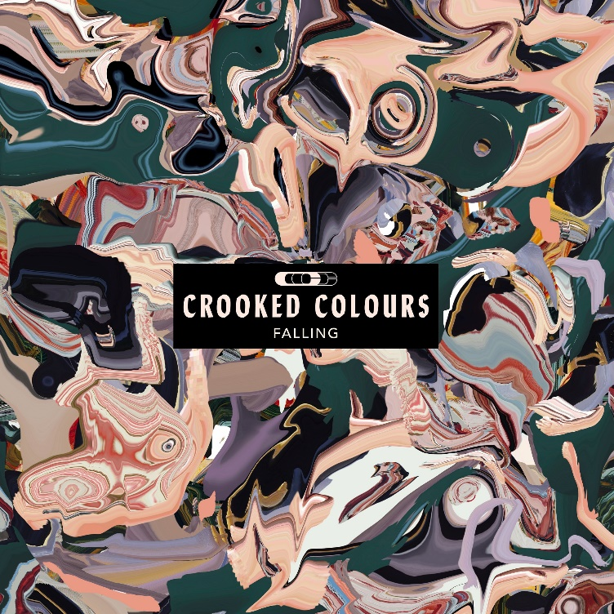
DOWNLOAD ART HERE

Acclaimed Australian indie-dance trio Crooked Colours have released their latest brilliant single “Falling” – available now HERE. The euphoric new track combines elements of indie, house, and pop that is amplified by lead singer Phil Slabber’s dynamic vocals alongside seductive indietronica production. “Falling” arrives today alongside a captivating official video, streaming now HERE.

“Having the chance to focus on making music while we can't tour has been a lifesaver,” shares drummer Liam Merrett-Park. “It feels like we were all flailing at one point and being able to direct our energy into a creative channel helped.”

Producer and keyboard player Leon Debaughn said, “This was a representation of how we felt, literally falling with no sense of direction, trying to move forward and accepting the impermanence of life.”

“This will be a first for us as we don't have the chance to play ‘Falling’ live, so it will be a special moment to play it to an audience that has been sitting on it” added vocalist Phil Slabber.

“Falling” follows the trio’s euphoric track “Love Language” which was immediately met with widespread critical acclaim with FLAUNT calling the track “the summer romantic ballad we’ve been waiting for all year,” This Song Is Sick raving, “this uplifting new track carries you through a euphoric reminiscence of summer love,…the overall groovy and boppy vibe that ‘Love Language’ emulates is the perfect way to close out these final summer nights,” and Acid Stag praising the song as “an elevating new single full of lively movement and groove that depicts a tale of romance and connection.”

Last month, Crooked Colours tapped acclaimed deep house DJ SNBRN for an incredible remix of “Love Language” which received praise across the board with Billboard stating “the edit adds thickness, depth and serious vibe to the formerly indie leaning track” and Out Now saying the remix “takes the fans into a magical adventure with some hot dance vibes.” As if that weren’t enough, the remix reached #1 on Hype Machine’s popular chart days after its release.

Crooked Colours have quickly earned applause as one of Australia’s hottest new electronic acts, scoring over 200 million worldwide streams thus far with a series of increasingly popular tracks – including the breakthrough single, “Flow” – and show-stealing festival performances around the globe. Acclaimed by triple J for “expanding their spellbinding sonic world,” LANGATA, the band’s 2019 sophomore album, hit #1 on the Dance Albums Chart as well as top 10 on the overall ARIA Albums Chart, fueled in part by tracks like “Do It Like You,” “I’ll Be There,” and “Never Dance Alone (Feat. Ladyhawke).”

Recently, the band spent over a year touring around the world and playing massive sold-out shows throughout North America as well as breakout performances at festivals such as Bonnaroo, Firefly, Electric Forest, Life Is Beautiful, CRSSD and more. This past March, while on the road with fellow Australian band RÜFÜS DU SOL, the band put their touring on pause in order to ensure the safety of their fans and crew. The band is looking forward to touring again and playing rescheduled dates at Brooklyn Mirage in New York, Red Rocks Amphitheatre in Denver and festivals such as Outside Lands and Lightning In A Bottle.

WHAT CRITICS ARE SAYING ABOUT CROOKED COLOURS

“a steamy deep house heater that would surely get bodies together on the dancefloor, if such a thing were currently possible.” – BILLBOARD

“From pensive lyrics to pleasure-evoking sounds, Crooked Colours definitely know how to hit their fans in the feels.” – EDM IDENTITY

“Crooked Colours’ latest single ‘Love Language’ is the summer romantic ballad we’ve been waiting for all year.”
– FLAUNT

“The single is everything you’d expect from the guys between the ease of cymbals and the all too real self-reflecting lyrics” – POPULAR TV

“[‘Love Language’] is an emotional track with tropical layers and textures filled with warmth. It has the classic Crooked Colours sound, it’s an intricate example of the indie tropica sub-genre and fans of their previous works will be in love with this new track.” – CULTR

“The track opens with vulnerable, almost pleading, lyricism from Phil Slabber, which meets the juxtaposition of a seductive & dance-able indietronic production courtesy of Leon Debaughn on keys and Liam Merrett-Park on drums. "Love Language" encompasses the signature style of Crooked Colours' discography; emotive and evocative...” – INDIE SHUFFLE

“’Love Language’ has a slow-burning, steady build that comes alive and turns into an electronic dance gem.”
– RIFF MAGAZINE

“ ‘Love Language‘ is a euphoric new track that exemplifies an evolution for the trailblazing band.”
– OUT NOW MAGAZINE

ABOUT CROOKED COLOURS:
Extracting harmony from the union of seemingly disparate elements, Crooked Colours exist at an elusive crossroads between delicate acoustic instrumentation, evocative vocals, and dancefloor-ready synth transmissions. The Australian trio—Phil Slabber [vocals, guitar, production], Leon Debaughn [keys, production], and Liam Merrett-Park [drums]—could just as easily soothe a quaint coffeehouse or a chaotic club. Generating over 100 million streams, selling out shows on multiple continents, and garnering looks from Billboard, NME, YourEDM, This Song Is Sick, and more, the group further sharpen this shape-shifting sound on a series of singles and their forthcoming debut for Atlantic Records.

Crooked Colours have spent quarantine back in Fremantle, Western Australia to focus on creating new music. Stay tuned for more exciting releases from the rising band, “Love Language” is the first taste of what’s to come!

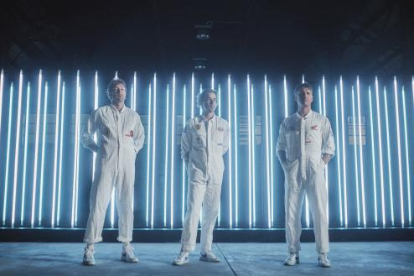
DOWNLOAD PRESS PHOTOS

CONNECT WITH CROOKED COLOURS
FACEBOOK I YOUTUBE I TWITTER I INSTAGRAM

# # #

FOR PRESS INQUIRIES, PLEASE CONTACT:
Jessica Nall // Jessica.Nall@atlanticrecords.com

