DARKOO X BLANCO RELEASE NEW SINGLE ‘SHE LIKE’

LISTEN HERE
WATCH THE ACCOMPANYING VIDEO HERE

ANNOUNCES EP 2 IN 1 OUT JULY 16TH VIA ATLANTIC RECORDS

PRE-ORDER EP HERE

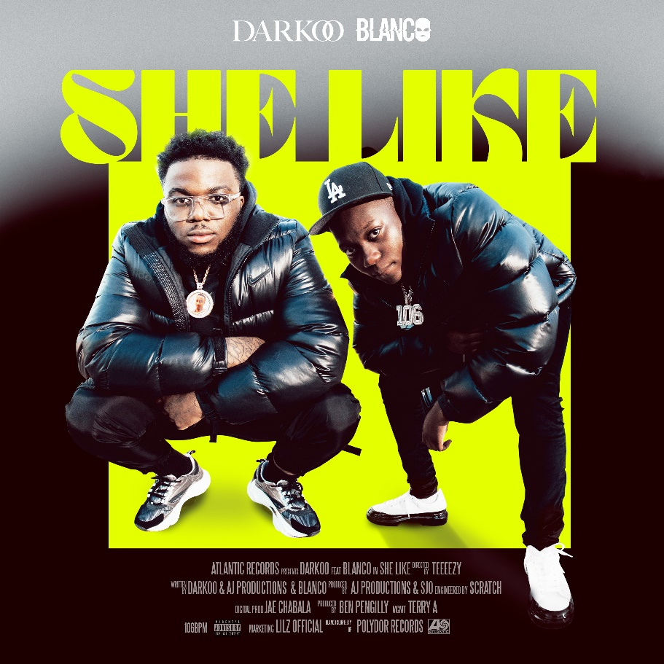

“Boxes are just about the only thing that Darkoo doesn’t do”- The FACE
“The musician smashing stereotypes with her style and sound”- British Vogue
“An artist whose fluid approach to Afrobeats puts her in her own lane” – The FADER

Nigerian born, London raised sensation Darkoo releases her new single ‘She Like’, featuring the buzz-worthy young rapper Blanco. The track is available to stream/purchase here.

Lifted off her debut EP 2 In 1, via Atlantic Records, this body of work is an intimate look into the artist and pays homage to her African roots with her recognizable afro wave sound. With features from Tion Wayne, Unknown T and Blanco, the EP allows us to delve into the sound that has defined her. Available to pre-order HERE.

Speaking on the EP she states, “This is a body of work that truly represents who I am. I’ve merged my two cultures, where I came from and where I am now encompassing my journey from Lagos to London. It’s literally 2 In 1”.

The latest track from the captivating Afrobeat artist is the follow up to her last single ‘Pick Up’. ‘She Like,’ directed by Teeeezy C [Potter Payper, Central C, M1LLIONZ], is set in a jet hangar and features slick and lively visuals of the pair. The track showcases her distinct vocals blended with an undeniable rap flow, while still maintaining her signature afro sound. Watch it here.

Speaking on ‘She Like’ Darkoo explains; “It’s just a feel good track about letting the boys know what a girl likes. Today everybody wants the finer things in life, they want to live the high life. You can be a rapper, a hustler or a banker but all a girl really wants is to be treated nice regardless of the guy’s background, she knows what she likes.”

With dreams of becoming a footballer before signing up to study engineering at university, Darkoo’s path took an unexpected turn after exploding onto the scene with the anthemic track ‘Gangsta’ featuring One Acen — a track that gave Darkoo her first UK top 40 at the back end of 2019 and was crowned by the Official Charts Company as the Afrobeat track of 2020. She added another first by featuring on Tion Wayne and Russ Million’s number 1 single ‘Body Remix’, alongside Fivio Foreign and Bugzy Malone to name a few and surprising fans with her formidable drill verse.

Still only 19 years old and with over 11 million monthly listeners on Spotify, Darkoo is one of the most talked about breakout UK artists around right now, with co-signs from the likes of Wretch 32, Tion Wayne, Ms Banks and NSG. Her imaginative, genre-blurring music blends her love of international sounds with the UK underground, helping create a unique form of AfroSwing that she’s firmly made her own.

2 In 1 Pre-Order available now: https://lnk.to/2in1EP-PreSave

TrackList:
- Oti Bere
- She Like feat. Blanco
- Drunk Texting
- Pick Up
- Slow Down ft Tion Wayne
- Outro voice note
- Come Up ft Unknown T

Connect with Darkoo:
Instagram|Twitter |Spotify |Website

Press contact: corey.brewer@atlanticrecords.com

