DAINE EXPLORES HER LOVE OF HYPERPOP ON THE INFECTIOUS ‘BOYS WANNA TXT’ FT. ERICDOA

TRACK CO-PRODUCED BY DYLAN BRADY OF 100 GECS

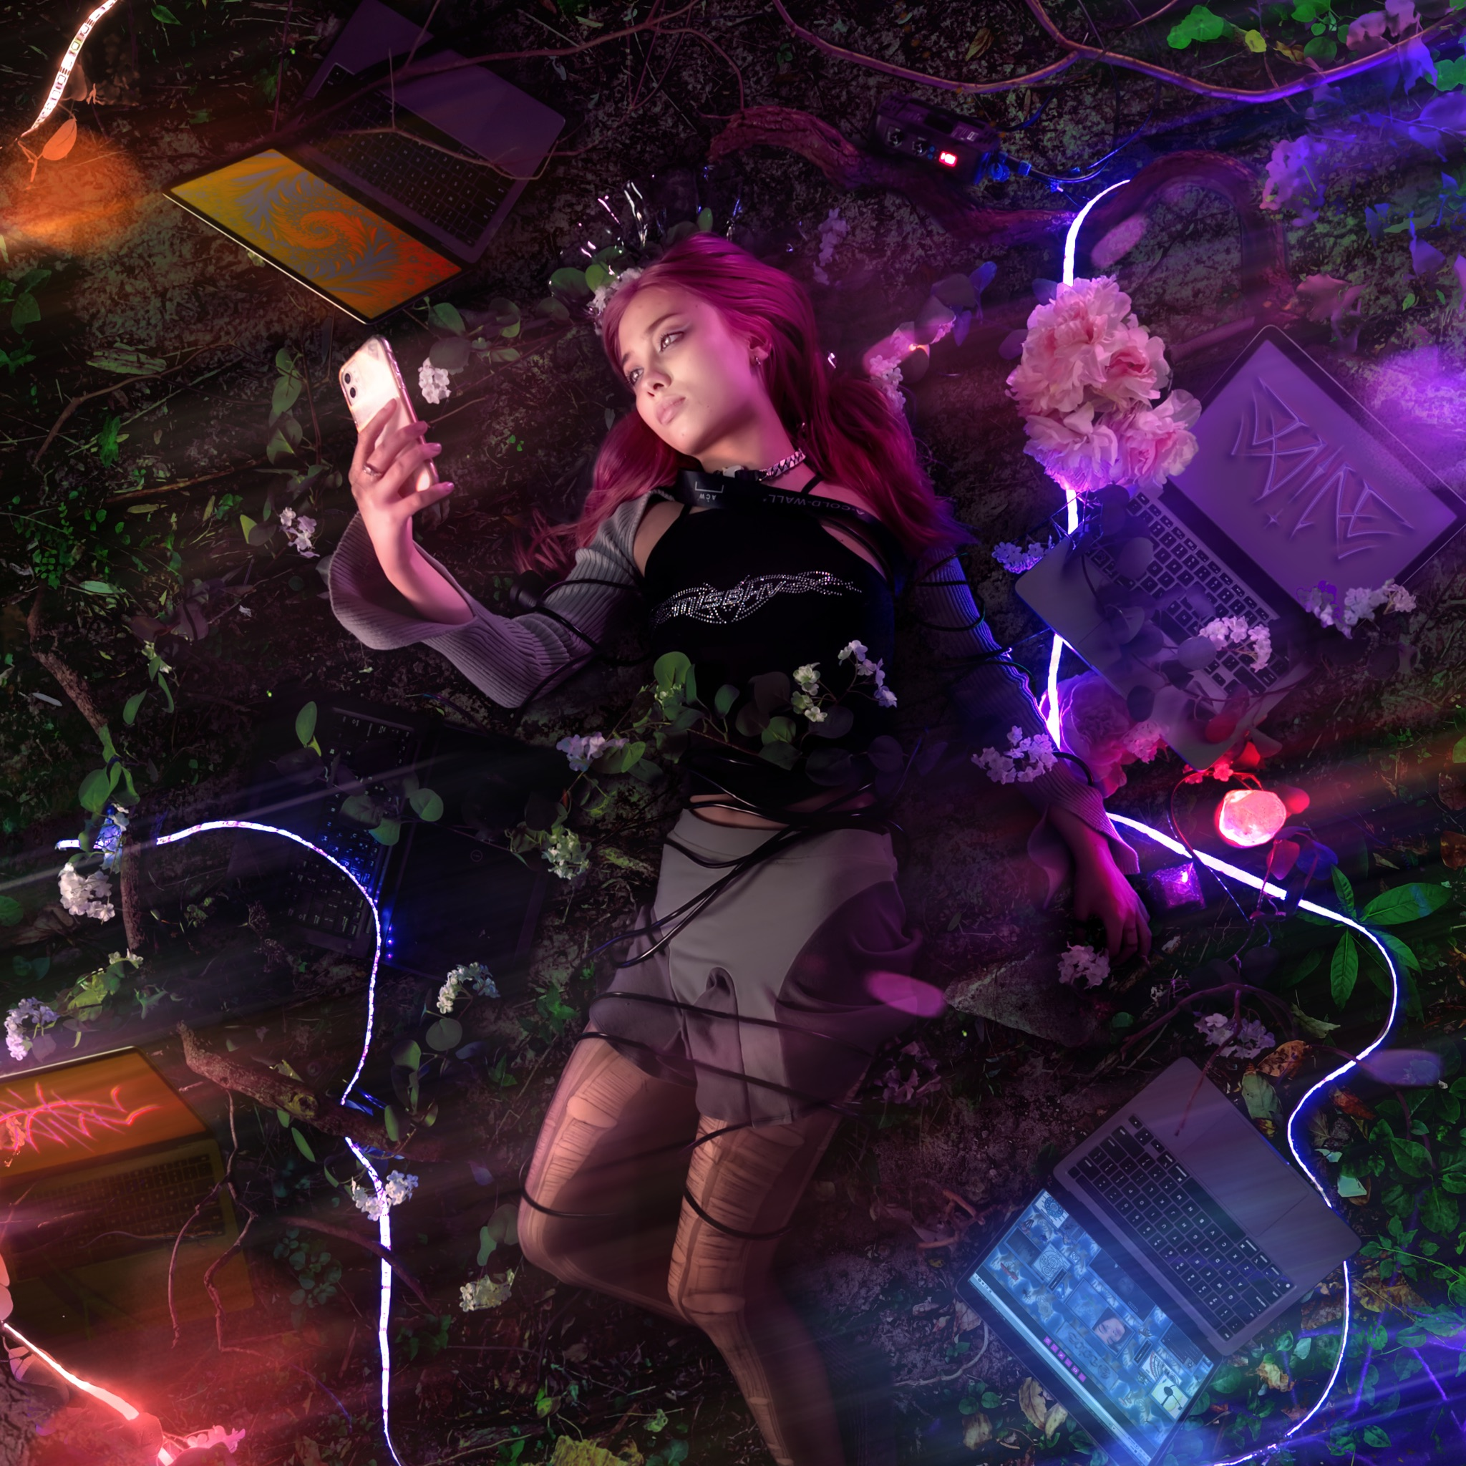

Watch the video HERE
Buy/Stream the track HERE

“Teen angst’s freshest voice” - V Magazine
“It feels healing and painful; like looking directly at a solar flare.” - The Guardian
“daine's tracks echo Midwestern emo greats like American Football, while simultaneously providing a dark-pop twist.” - PAPER
“A nihilistically detached voice” - The FADER
“daine’s creative spin on such a distinctive sound evokes an irresistible nostalgia” - Pigeons & Planes

With a slew of rapturously received singles under her belt released throughout 2020, Filipino-Australian artist daine has, within the space of 12 months, carved a unique niche within the modern pop landscape. On tracks such as ‘Ascension’ and ‘Angel Numbers’ she has consolidated a reputation as emotionally-driven pop’s next great hope; drawing on her love of the rich sounds of the glory days of midwest emo. Today, daine presents her own take on another burgeoning online sound; taking to hyperpop with her brand new single, ‘boys wanna txt’.

Featuring scene stalwart ericdoa and produced by Dylan Brady of the pioneering duo 100 gecs and Ryan Jacob, ‘boys wanna txt’ takes daine’s traditional formula and forces it into warp speed. Set to a frantic cacophony of digitised bleep tones and crushed 808 hits, the track’s production adds new colour to daine’s usually soaring sonic palette; a hyperactive moment of madness amongst the serenity that proves daine’s artistic versatility. Elements of her nostalgia-rendering songwriting remain throughout the song; exploring romantic apathy and a love of material things in a style that recalls the golden era of pop punk alongside her most infectious hook to date, before ericdoa delivers a freeform verse of lovelorn flows that act as the perfect counterpoint to daine’s melodic disinterest.

The track’s Oliver van der Lugt (aka Air Max 97) directed visual is a hyperreal, internet art indebted look into text-based exhaustion, with daine's romantic indifference reflected within the video's performance as she's seemingly overwhelmed with overstimulating digital imagery. Beaming in from her own room set in outer space, the visual focuses in on online interaction throughout isolation in a fantasy hybrid IRL/URL space.

A loving tribute to the hyperpop community that she has forged among emo-rap loving supporters thanks to her bi-monthly Nocturne online party series, ‘boys wanna txt’ places daine’s future-facing talents in a new context. Her first single of 2021, the track is more than an example of simple genre experimentation, it’s evidence of daine’s willingness to tear up her own rulebook to push her sound to its furthest reaches and in turn, consolidate one of the scene’s most defining burgeoning voices.

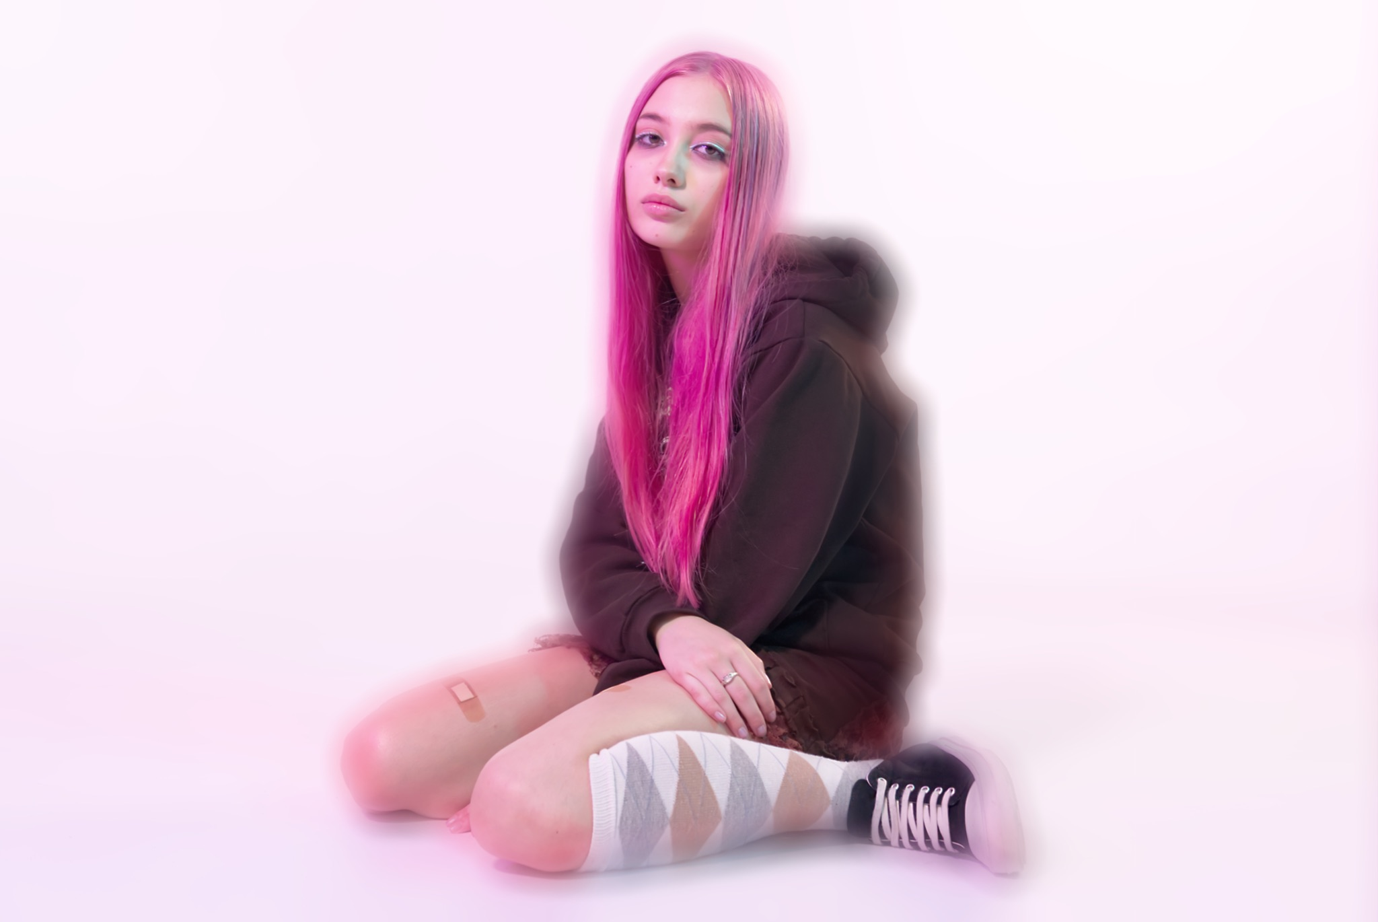

daine: Website | Twitter | Instagram

For more information contact mitch@revenant.earth

