DARKOO RELEASES DEBUT EP 2 IN 1
SHARES NEW SINGLE ‘SLOW DOWN’ FEATURING TION WAYNE
LISTEN TO ‘SLOW DOWN’ HERE
STREAM EP HERE
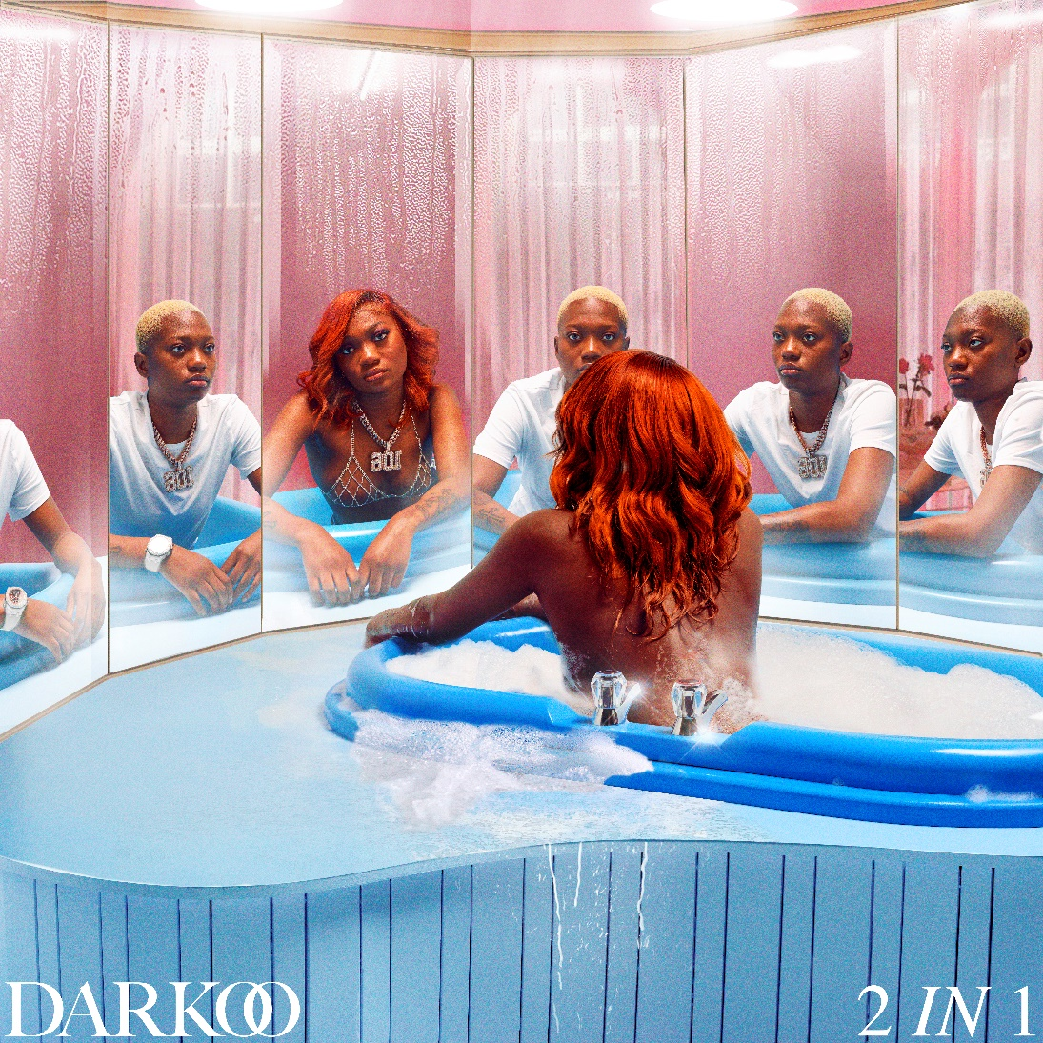
Press site
“Boxes are just about the only thing that Darkoo doesn’t do”- The FACE
“The musician smashing stereotypes with her style and sound”- British Vogue
“An artist who’s fluid approach to Afrobeats put her in her own lane” -The FADER

Afrobeat sensation Darkoo today releases her hotly anticipated debut EP 2 In 1 via Atlantic records and shares her new single ‘Slow Down’ featuring Tion Wayne. The EP is available to stream/purchase HERE.
Darkoo’s debut EP 2 In 1 pays homage to her African and UK roots and allows us to delve into the sound that has defined her. The EP is a blend of her distinct afro sound and vocals paired alongside her unequivocal rap flow. 2 In 1 gives us a fearless and passionate insight into her emotions with tracks like ‘Drunk Texting’ and ‘Pick Up’, revealing a more vulnerable side to Darkoo while also showcasing her many facets via ‘Come up’ featuring Unknown T.

Speaking on the project she shares:
“This EP explores my feelings and presents a more emotional side of me with tracks like ‘Oti Bere’, ‘Pick Up’ and ‘Slow Down’ featuring Tion Wayne. 2 in 1 is a collection of tracks that you can chill to and vibe with, it showcases my two cultures which evolved from my journey to London from Lagos. It also gives you a sneak peek to another side of me with the track ‘Come up’ which has a drill edge to it and features Unknown T, it represents my London side. 2 In 1 is a body of work that truly represents who I am.”
‘Slow Down’ featuring Tion Wayne is the follow up to her last single 'She Like' featuring Blanco. It’s a mid-tempo track that highlights the tone of the EP and sees Darkoo in pursuit of her dream partner. Listen HERE.
Darkoo’s style fluidity also plays a huge part in her music and demonstrates her versatility and confidence in wearing what best represents her she explains:

“I do want I want to do. I could wear a wig and make-up and still wear a tracksuit, today I want to do this, tomorrow I want to do that my music reflects my style and vice versa. Everything I do has an element of 2 in 1 in it.”

After exploding onto the scene with the infectious track ‘Gangsta’ featuring One Acen, which gave Darkoo her first UK top 40 at the back end of 2019, the track was later crowned by the Official Charts Company as the Afrobeat track of 2020. She added another first by featuring on Tion Wayne and Russ Million’s number 1 UK single ‘Body Remix’, surprising fans with her formidable drill verse.
With over 9 million monthly listeners on Spotify, the 19 year old is one of the most talked about breakout UK artists around right now. A self-confessed ‘Afro-head’, Nigerian superstars such as Wande Coal and Wizkid left a lasting impact on Darkoo particularly after moving to London at the age of seven, cementing her connection to the sounds that defined her childhood.

With co-signs from the likes of Wretch 32, Tion Wayne, Ms Banks and NSG Darkoo’s imaginative, genre-blurring music blends her love of international sounds with the UK underground, helping create a unique form of AfroSwing that she’s firmly made her own.

TrackList:
- Oti Bere
- She Like feat. Blanco
- Drunk Texting
- Pick Up
- Slow Down feat. Tion Wayne
- Interlude (feat. Gabzy)
- Come Up feat. Unknown T

Connect with Darkoo:
Instagram|Twitter |Spotify |Website
Press contact: corey.brewer@atlanticrecords.com

