**NIGERIAN-BORN, LONDON-BASED SENSATION *DARKOO***

**SHARES NEW SINGLE “PICK UP”**

**WATCH THE 19-YEAR-OLD AFROSWING STAR PLAY HER OWN LOVE INTEREST IN THE OFFICIAL VIDEO** [**HERE**](https://nam04.safelinks.protection.outlook.com/?url=https%3A%2F%2Fwww.youtube.com%2Fwatch%3Fv%3Dde-wW36PnLQ&data=04%7C01%7CGabrielle.Reese%40atlanticrecords.com%7Cc65b915951eb4195092b08d8dfed7973%7C8367939002ec4ba1ad3d69da3fdd637e%7C0%7C0%7C637505558320274950%7CUnknown%7CTWFpbGZsb3d8eyJWIjoiMC4wLjAwMDAiLCJQIjoiV2luMzIiLCJBTiI6Ik1haWwiLCJXVCI6Mn0%3D%7C1000&sdata=qcYxWvm0Zd%2F8Sk%2BXWHDLdTdlRiwLz%2FHUAQb4Elzp%2FYM%3D&reserved=0)

**BREAKTHROUGH SONG** [**“GANGSTA”**](https://nam04.safelinks.protection.outlook.com/?url=https%3A%2F%2Fwww.youtube.com%2Fwatch%3Fv%3DhRrMo8DzvW4&data=04%7C01%7CGabrielle.Reese%40atlanticrecords.com%7Cc65b915951eb4195092b08d8dfed7973%7C8367939002ec4ba1ad3d69da3fdd637e%7C0%7C0%7C637505558320284902%7CUnknown%7CTWFpbGZsb3d8eyJWIjoiMC4wLjAwMDAiLCJQIjoiV2luMzIiLCJBTiI6Ik1haWwiLCJXVCI6Mn0%3D%7C1000&sdata=RcxhkH1%2FPJzg4Epyt%2FbBmPLVg7HazYcKl72bkZgIfzk%3D&reserved=0) **CROWNED *OFFICIAL CHARTS’* TOP “AFROBEAT TRACK OF 2020”**

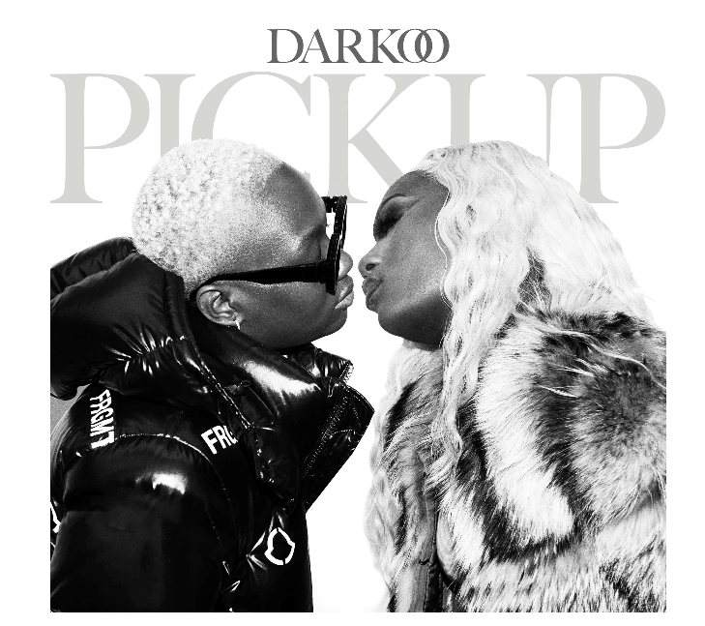

**Darkoo bio** [**here**](https://isaacportal.wmg.com/#/share-item/603e33896095db7113c25a51/4nrsPtxgq_EAR-yuMCRnUh?token=WcklWprt8qlFNFNzkouEu)

**Press photos** [**here**](https://isaacportal.wmg.com/#/shares/private/WcklWprt8qlFNFNzkouEu?activeFolder=Shared%20Assets%2FWMUK%20Intl%2FAtlantic%20UK%2FDarkoo%2FPick%20Up%2FPress%20Shots)

*“Darkoo is not the kind of artist to conform with the rules. Her 2019 breakout hit ‘Gangsta’ showcased both her feminine and masculine qualities, positioning her as an artist whose fluid approach to afrobeats put her in her own lane.” –* ***The FADER***

*“Boxes are just about the only thing that Darkoo doesn’t do”-* ***The FACE***

*“The musician smashing stereotypes with her style and sound”-* ***British Vogue***

Nigerian-born, London-raised sensation **Darkoo** is back with her new single “[Pick Up](https://nam04.safelinks.protection.outlook.com/?url=https%3A%2F%2Fwww.youtube.com%2Fwatch%3Fv%3Dde-wW36PnLQ&data=04%7C01%7CGabrielle.Reese%40atlanticrecords.com%7Cc65b915951eb4195092b08d8dfed7973%7C8367939002ec4ba1ad3d69da3fdd637e%7C0%7C0%7C637505558320274950%7CUnknown%7CTWFpbGZsb3d8eyJWIjoiMC4wLjAwMDAiLCJQIjoiV2luMzIiLCJBTiI6Ik1haWwiLCJXVCI6Mn0%3D%7C1000&sdata=qcYxWvm0Zd%2F8Sk%2BXWHDLdTdlRiwLz%2FHUAQb4Elzp%2FYM%3D&reserved=0).” Produced by ATG (Kelly Rowland, Dave East, Ms Banks), the track is available [HERE.](https://lnk.to/Darkoo-PickUp)

“Pick Up” follows Darkoo’s her previous hit [“Cinderella"](https://nam04.safelinks.protection.outlook.com/?url=https%3A%2F%2Fwww.youtube.com%2Fwatch%3Fv%3D3RiWNhOPCnU&data=04%7C01%7CGabrielle.Reese%40atlanticrecords.com%7Cc65b915951eb4195092b08d8dfed7973%7C8367939002ec4ba1ad3d69da3fdd637e%7C0%7C0%7C637505558320284902%7CUnknown%7CTWFpbGZsb3d8eyJWIjoiMC4wLjAwMDAiLCJQIjoiV2luMzIiLCJBTiI6Ik1haWwiLCJXVCI6Mn0%3D%7C1000&sdata=1WUoDMUiG2M8IDr%2FzhM2GaIjl50KngXuO4MMCWhS1gc%3D&reserved=0) and comes complete with a dextrous official video, directed by Kelvin Jones (AJ Tracey, KSI, Aitch) where she plays her own love interest. The track showcases her distinct vocals along with her signature afro sound. Watch it [HERE.](https://nam04.safelinks.protection.outlook.com/?url=https%3A%2F%2Fwww.youtube.com%2Fwatch%3Fv%3Dde-wW36PnLQ&data=04%7C01%7CGabrielle.Reese%40atlanticrecords.com%7Cc65b915951eb4195092b08d8dfed7973%7C8367939002ec4ba1ad3d69da3fdd637e%7C0%7C0%7C637505558320274950%7CUnknown%7CTWFpbGZsb3d8eyJWIjoiMC4wLjAwMDAiLCJQIjoiV2luMzIiLCJBTiI6Ik1haWwiLCJXVCI6Mn0%3D%7C1000&sdata=qcYxWvm0Zd%2F8Sk%2BXWHDLdTdlRiwLz%2FHUAQb4Elzp%2FYM%3D&reserved=0)

With dreams of becoming a footballer before signing up to study engineering at university, Darkoo’s path took an unexpected turn after exploding onto the scene with the anthemic track ["Gangsta"](https://nam04.safelinks.protection.outlook.com/?url=https%3A%2F%2Fwww.youtube.com%2Fwatch%3Fv%3DhRrMo8DzvW4&data=04%7C01%7CGabrielle.Reese%40atlanticrecords.com%7Cc65b915951eb4195092b08d8dfed7973%7C8367939002ec4ba1ad3d69da3fdd637e%7C0%7C0%7C637505558320284902%7CUnknown%7CTWFpbGZsb3d8eyJWIjoiMC4wLjAwMDAiLCJQIjoiV2luMzIiLCJBTiI6Ik1haWwiLCJXVCI6Mn0%3D%7C1000&sdata=RcxhkH1%2FPJzg4Epyt%2FbBmPLVg7HazYcKl72bkZgIfzk%3D&reserved=0) featuring One Acen — a track that gave Darkoo her first UK top 40 at the back end of 2019 and was crowned by the Official Charts Company as the top Afrobeat Track of 2020.

Still only 19-years-old and with over 1.5 million monthly listeners on Spotify, Darkoo is one of the most talked about breakout UK artists around right now, with co-signs from the likes of Wretch 32, Tion Wayne, Ms Banks and NSG. Her imaginative, genre-blurring music blends her love of international sounds with the UK underground, helping create a unique form of AfroSwing that she’s firmly made her own.

**CONNECT WITH DARKOO**

[Instagram](https://www.instagram.com/darkoo/?hl=en) | [Twitter](https://twitter.com/darkoo?lang=en)

US press contact: [corey.brewer@atlanticrecords.com](mailto:corey.brewer@atlanticrecords.com)