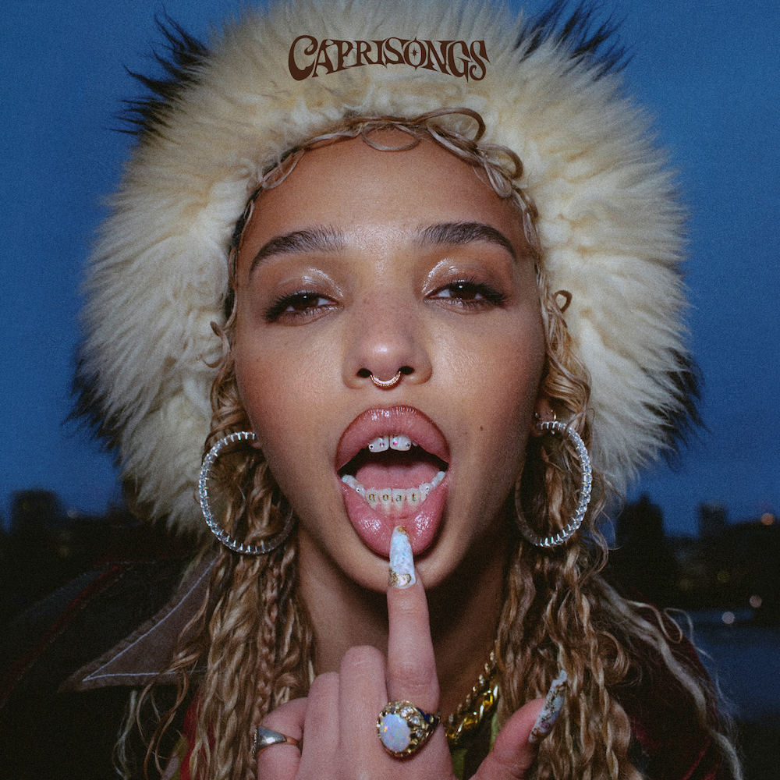

When FKA twigs released her groundbreaking debut “LP1” in 2014, she learned how to produce songs, direct music videos and vogue. With her powerful and heavy “MAGDALENE” album five years later, she learned how to pole dance and her operatic vocals stretched to new heights.

On her latest project, the mixtape “CAPRISONGS,” she directly explains: “I learned how to write a hook!”

“It just goes back to you never, as an artist, stop learning. You're always improving, always learning, and always stretching in different directions.”

“CAPRISONGS” showcases a new side of FKA twigs – one that’s always been present but not in public. The songs are fun, carefree, upbeat and bold, brimming with messages of confidence and independence. Along with the bangers and bops are vulnerable, honest, eerie and soft songs that highlight FKA twigs’ lyrical prowess and vocal acrobatics.

“CAPRISONGS,” her first release on Atlantic Records, is a departure for the Grammy-nominated visual icon’s previous works but it’s also a reflection of where she is today. The 17-track mixtape documents her personal growth.

“It's weird because, in some ways, this is my most fun project. But in other ways, it's my most honest and the deepest. It's a very fine line of how to describe it because, to me, it's not just like throwaway bangers. I think, if you really listen to the lyrics, maybe I'm really telling the truth as well,” she says. “It was a bigger challenge because I don't really think I've ever channeled my art, particularly, through happiness before.”
“If people found out about me with songs like ‘Cellophane’ or ‘Home With You,’ for example, this is going to be quite a big listening experience for them to see me push myself so much and go in such a different direction, but for me, it is about learning and it is about getting better,” she continues. “I don't want to be constricted by the things that I'm already good at. I can't keep on making the same songs over and over again. I need to explore and I need to move forward and I need to challenge myself and those around me to keep up.”

“CAPRISONGS” is a vibe. It’s also genre-less. There are tunes based in island sounds, reggae and Afrobeats, while other tracks blend dance with electronic, pop, R&B and alternative feels.

FKA twigs kicks off the mixtape with the sexy mid-tempo tune “ride the dragon,” where she is daring and assertive. She’ll keep you on the dance floor with a number of songs, including addictive tracks like “honda,” “oh my love” and “papi bones”; “pamplemousse” is fast-paced and adventurous; “jealousy” is full of cool R&B swagger; and “darjeeling” is an anthemic hip-hop-flavored jam exuding British pride.

Then there’s first single “tears in the club,” an edgy dance track where FKA twigs and The Weeknd’s vocals blend to perfection. The song – and music video featuring signature slick FKA twigs choreography – has been praised by critics, including The New York Times, Rolling Stone, Billboard, Forbes, Paper and Fader, who called the song “a high-quality entry into the canon of weepy euphoria.”

“I wanted to make something really fun and something that shows people a different side of my personality, because people, I think, assume that I'm very serious and that I take myself very seriously and it's kind of the opposite. I'm very funny and have definitely always been a clown at school and amongst my friends,” says FKA twigs. “I wanted to show people that lighthearted side of me, that I'm really one of the girls, I love going out and I love my friends and I live a very fun and full social life, usually. Essentially, I came up being a club kid.”

But listen to “CAPRISONGS” carefully, even in the upbeat songs, and you’ll find real lyrics about an artist on her path to self-confidence and acceptance. To accompany the dance floor anthems are tracks like “lightbeamers,” a beautiful, hopeful song for the dreamers that features the refrain: “Ain’t nobody die from a no.”

“That song really helped me, in terms of just reminding me to stay positive and be my best self and go to work and shine. ‘Be a lightbeamer, no matter what you're going through.’ So I think I was encouraging myself, as well, in a very difficult time, to be alive. I was encouraging myself to remain hopeful and connect with my friends and just fall in love with the more simple things in life that we've taken for granted at times,” she says. “Usually, I'm either sexy, in distress, or just straight up traumatized, but this time, I was able to channel everything I've been going through into more of a vibey place. It still feels just as deep to me.”

Ethereal and slower songs like “meta angel,” “careless,” “minds of men” and “thank you song” give the album its balance. “I want people to be able to send the songs to someone – to send ‘lightbeamers’ to somebody when they're feeling down, or ‘thank you song’ or ‘meta angel.’ You know, those songs that your friends send you to cheer you up or to make you feel a certain way or to make you laugh, to play in an Uber or to get ready to. I want to bring people together with my music on this project.”

On “thank you song,” which closes the mixtape, FKA twigs digs deep and the track drips with emotion. It starts with the powerful line: “I wanted to die, just being honest/No longer afraid to say it out loud.”

“That was at the beginning of lockdown, and it's funny because I guess the journey of the mixtape ends where, I guess, I began. ‘Thank you song’ was the emotional space that I was in when I started it. I just wanted to be brutally honest, to be honest with you. It's been a hard couple years for everyone in their own ways. And for me, being surrounded by people that love me, I feel like it's saved me. I feel the power of connection. When I sing, ‘Loving emotion seems to save me now’ – that's how I feel. Having people to love and having them love you back is just the best feeling in the whole world,” she says.

What pulls the album’s message of connectedness together is FKA twigs’ conversations with friends woven into the songs. Over lockdown, she recorded some of her talks with close mates, pulling encouraging soundbites and putting them on the project. She even pulled audio from some of her friends’ Instagram stories and to pay tribute to her dog that passed, she includes the sound of her bark in one of the interludes.

“If you're lonely or if you feel like you don't have a good friend that day or whatever it is, literally, don't sweat. You can just put on ‘CAPRISONGS’ and you can borrow mine,” she says. “It's just about these little soundbites of quite, I guess, innocuous conversations that, for me, have given a lot of comfort. If I felt lonely in the last two years, to think about my friends getting ready and to make a record that reminds me of getting dressed up or reminds me of hanging out with people that I love, the pregame to go into the club, all of these really fun times that you share with people that you care about, I hope that this is a soundtrack to that.”

“CAPRISONGS” is all about community. It’s why the mixtape is heavy on features – a first for FKA twigs. Guests include The Weeknd, Jorja Smith, Daniel Caesar, Unknown T, Pa Salieu, Rema, Shygirl, Dystopia and Solo.

In a collaborative state of mind, FKA twigs even slid into peoples’ DMs to see if they’d want to work with her.

“Just me sliding into people's DMs, literally just being like, ‘Yo, I've got this song. I really love your work. I think you'd sound great on it,’” FKA twigs explains.

Not everyone responded, but those who needed to did, and that’s why ‘CAPRISONGS’ feels complete and whole. “You send people a message on Instagram and they just don't read it or things don't align the way you want it to, but I was just like, ‘You know what? It doesn't really matter. Whatever.’ Just reach out to people that you love and see what happens and don't be shy, which is my main thing. I can be very shy, so I was just trying to be confident and believe in myself.”

Boldness is a color FKA twigs wears well. It’s also how she got The Weeknd to appear on “tears in the club.”

She began creating the song with a piano sample and later wrote the hook, and her co-producer, El Guincho aka Pablo Díaz-Reixa, was in love with what she came up with. His suggestion for guest vocals: The Weeknd.

“And I was like, ‘How am I going to get The Weeknd on a song?’ Obviously, I've known Abel for years. He's very sweet and I have his number and we've definitely checked in with each other every now again and shown respect for each other's work, but I was like, ‘The Weeknd is not going to want to be on a song with me. That's crazy.’ And then Pablo was just like, ‘You're FKA twigs.’ He was like, ‘You can get anyone on a song.’”

“I was just like, ‘Yeah, I can.’” And she did.

“CAPRISONGS” marks the first album FKA twigs worked with Grammy winner El Guincho, who co-executive produced the entire mixtape. They first started working together before the lockdown, but as the world shut down, they traded vocals, lyrics and beats over Zoom and virtual sessions. Later, they got back into the studio to finish the project, and FKA twigs says working with the Spanish hitmaker was a life-changing experience.

“Pablo's been incredible throughout the whole process. I feel very supported by him and he's really instilled a lot of confidence back in me because, to be honest, I completely lost my confidence over the past couple years and he just made me feel like a superstar. And it's been invaluable. I didn't know somebody could champion you that much. He just really made me believe in myself and made me fall back in love with why I started doing this in the first place and having fun and just being the best artist that I can be,” she says.

“CAPRISONGS” features production from FKA twigs, El Guincho, Koreless, P2J, Mike Dean, Marius de Vries, Jasper Harris, Teo Halm, Arca, FRED, Psymun, Cirkut, BKay, Reaper, Sega Bodega, Fake Guido, Pau, Felix Joseph, AoD, Jeff Kleinman, Warren Ellis, Jonathan Coffer and BAK.

“I think that this project has definitely been an amazing vehicle to the next phase of my career that I didn't know was in my reach,” she says. “That's how I feel. I feel like it's been an incredible learning experience.”

