**RISING POP SINGER-SONGWRITER GAYLE UNVEILS ATLANTIC RECORDS DEBUT SINGLE**

**“abcdefu” PREMIERES TODAY WITH OFFICIAL MUSIC VIDEO**

**Tickets on sale for headline “FU TOUR” in NYC, NASHVILLE, AND LOS ANGELES**

**LISTEN** [**HERE**](https://GAYLE.lnk.to/abcdefuPR) **/ WATCH** [**HERE**](https://GAYLE.lnk.to/abcdefu-Video)

***“I wrote ‘abcdefu’ when I was trying really hard to be nice and considerate to my ex. Then I heard through some mutual friends that my ex wasn’t saying the nicest things about me and all bets were off.”***

***– GAYLE***

**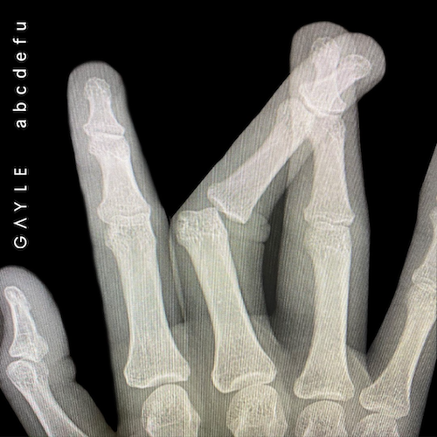    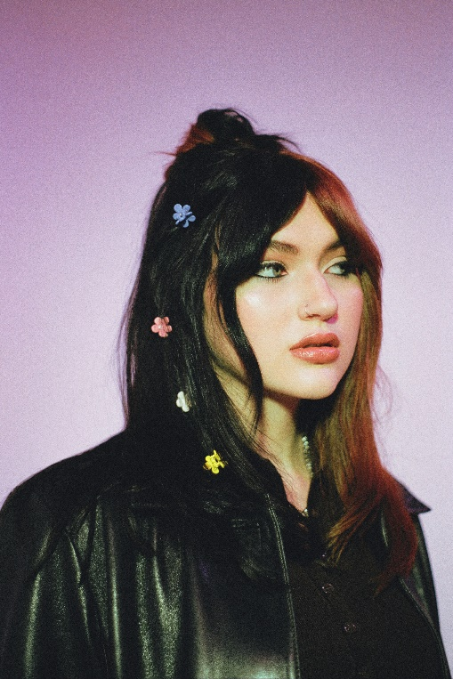**

**(**[**DOWNLOAD**](https://warnermusicgroup.app.box.com/s/yp3vtoouq7vyb6t7jzsiumr5lolnneh8/file/833808131764) **HI-RES ARTWORK)**

**(DOWNLOAD PRESS PHOTOS** [**HERE**](https://nam04.safelinks.protection.outlook.com/?url=https%3A%2F%2Fwarnermusicgroup.box.com%2Fs%2Fvp33fztgslzorzqy4ixd2zxnqc44lm34&data=04%7C01%7CTiana.Timmerberg%40atlanticrecords.com%7Cacb8d16bc82340efc27308d951160365%7C8367939002ec4ba1ad3d69da3fdd637e%7C0%7C0%7C637629977289087961%7CUnknown%7CTWFpbGZsb3d8eyJWIjoiMC4wLjAwMDAiLCJQIjoiV2luMzIiLCJBTiI6Ik1haWwiLCJXVCI6Mn0%3D%7C1000&sdata=HQ7M%2BC1OtX2UYUKomXXqXX96JsioLtm5Q2iK2YgkyzY%3D&reserved=0)**)**

Atlantic Records is very proud to announce the signing of 17-year old rising pop singer-songwriter GAYLE with today’s premiere of her single “**abcdefu**.” “**abcdefu**” is available now at all DSPs and streaming services [HERE](https://gayle.lnk.to/abcdefuPR); an official music video is streaming now via YouTube [HERE](https://GAYLE.lnk.to/abcdefu-Video).

Produced by Pete Nappi (Kesha, Anne Marie, Madison Beer, Illenium), “abcdefu” arrives as a glowing example of GAYLE’s gift for fusing raw sincerity with an idiosyncratic and sometimes irreverent perspective. With its minimalist backdrop of jagged guitar work, the tongue-in-cheek breakup song explodes into a glorious free-for-all at its gang-vocal-fueled chorus. But “abcdefu” also telegraphs the Nashville-based artist’s refusal to compromise her own needs.

“*That song came from a place of trying so hard to be the nice, respectful ex-girlfriend, to the point where it was negatively affecting me,*” GAYLE says. “*It’s about asking, ‘Why am I being so nice to this person who completely took advantage of me? and allowing myself to express my anger about that.*”

The official music video shows GAYLE further expressing her pent-up anger with a visit to her ex’s house. She takes her friends along for the ride, baking an “FU” cake in her ex’s honor before leaving him a recording documenting their adventure.

GAYLE will celebrate “abcdefu” with a series of major market headline performances on *The FU Tour*, set for Brooklyn, NY’s Baby’s All Right (November 3rd), Nashville, TN’s The High Watt (November 10th), and Los Angeles, CA’s The Echo (November 17th). In addition, GAYLE will be among the rising stars performing at Bonnaroo’s SheRoo x She Is The Music Showcase on September 2. For more details and tickets, please visit [www.gayleofficial.com](https://nam04.safelinks.protection.outlook.com/?url=http%3A%2F%2Fwww.gayleofficial.com%2F&data=04%7C01%7CTiana.Timmerberg%40atlanticrecords.com%7Cacb8d16bc82340efc27308d951160365%7C8367939002ec4ba1ad3d69da3fdd637e%7C0%7C0%7C637629977289097955%7CUnknown%7CTWFpbGZsb3d8eyJWIjoiMC4wLjAwMDAiLCJQIjoiV2luMzIiLCJBTiI6Ik1haWwiLCJXVCI6Mn0%3D%7C1000&sdata=bkROmlZOJPnRNY3ruyu%2BuxcFTSgjBpN7v1phJyCiuJk%3D&reserved=0).

­

Fearlessly honest and undeniably magnetic, GAYLE has already earned more than **5M** worldwide streams by creating self-possessed modern pop music that’s empowering for both artist and audience. Growing up outside Dallas, she first started singing at the age of seven and before long had had taken up piano and guitar as well writing songs on her own. By the time she was 14 she’d crossed paths with GRAMMY® Award-nominated songwriter, former *American Idol* judge, producer, and music publisher **Kara DioGuardi**, who promptly took on the role of mentor.

*"GAYLE grabbed my attention with her vulnerable yet strong, sexy lyrics and powerhouse voice.”* says Kara DioGuardi. *“I was blown away by her ability to translate her life into her songs and I’m excited to be a part of her introduction to the world."*

GAYLE made a remarkable debut in early 2020 with the boldly confessional “[dumbass](https://nam04.safelinks.protection.outlook.com/?url=https%3A%2F%2Fgayle.lnk.to%2FdumbassAW&data=04%7C01%7CTiana.Timmerberg%40atlanticrecords.com%7Cacb8d16bc82340efc27308d951160365%7C8367939002ec4ba1ad3d69da3fdd637e%7C0%7C0%7C637629977289107944%7CUnknown%7CTWFpbGZsb3d8eyJWIjoiMC4wLjAwMDAiLCJQIjoiV2luMzIiLCJBTiI6Ik1haWwiLCJXVCI6Mn0%3D%7C1000&sdata=xFFhuaVboqFccMN%2Bv1qZiqYC2FzWhIW2ejc5Vrx%2FFAU%3D&reserved=0)” and immediately scored placement on some of pop’s most influential playlists. A string of releases followed throughout last year, including a pair of inspired “dumbass” remixes by [The Him](https://nam04.safelinks.protection.outlook.com/?url=https%3A%2F%2Fgayle.lnk.to%2FdumbasshimrmxAW&data=04%7C01%7CTiana.Timmerberg%40atlanticrecords.com%7Cacb8d16bc82340efc27308d951160365%7C8367939002ec4ba1ad3d69da3fdd637e%7C0%7C0%7C637629977289107944%7CUnknown%7CTWFpbGZsb3d8eyJWIjoiMC4wLjAwMDAiLCJQIjoiV2luMzIiLCJBTiI6Ik1haWwiLCJXVCI6Mn0%3D%7C1000&sdata=rzbQjVdVMh4z9wDavFMtjw4EKaiFUqQkL63aijWVNbo%3D&reserved=0) and [Ashworth](https://nam04.safelinks.protection.outlook.com/?url=https%3A%2F%2Fgayle.lnk.to%2FdumbassAshworthRmxAW&data=04%7C01%7CTiana.Timmerberg%40atlanticrecords.com%7Cacb8d16bc82340efc27308d951160365%7C8367939002ec4ba1ad3d69da3fdd637e%7C0%7C0%7C637629977289117938%7CUnknown%7CTWFpbGZsb3d8eyJWIjoiMC4wLjAwMDAiLCJQIjoiV2luMzIiLCJBTiI6Ik1haWwiLCJXVCI6Mn0%3D%7C1000&sdata=A5OWlKFqoOgwNnglIiHmmfPK8d9eayiPtbPIQ1uOicc%3D&reserved=0), as well as such uniquely original tracks as the sardonic Gen Z anthem, “[z](https://nam04.safelinks.protection.outlook.com/?url=https%3A%2F%2Fgayle.lnk.to%2Fz-musicAW&data=04%7C01%7CTiana.Timmerberg%40atlanticrecords.com%7Cacb8d16bc82340efc27308d951160365%7C8367939002ec4ba1ad3d69da3fdd637e%7C0%7C0%7C637629977289127938%7CUnknown%7CTWFpbGZsb3d8eyJWIjoiMC4wLjAwMDAiLCJQIjoiV2luMzIiLCJBTiI6Ik1haWwiLCJXVCI6Mn0%3D%7C1000&sdata=WZNWKnwhDkE1kxD6wz0Vc7nDstuzbdDEcLw6iVOZv3o%3D&reserved=0),” the more contemplative and soulful “[happy for you](https://nam04.safelinks.protection.outlook.com/?url=https%3A%2F%2Fgayle.lnk.to%2FhappyforyouAW&data=04%7C01%7CTiana.Timmerberg%40atlanticrecords.com%7Cacb8d16bc82340efc27308d951160365%7C8367939002ec4ba1ad3d69da3fdd637e%7C0%7C0%7C637629977289127938%7CUnknown%7CTWFpbGZsb3d8eyJWIjoiMC4wLjAwMDAiLCJQIjoiV2luMzIiLCJBTiI6Ik1haWwiLCJXVCI6Mn0%3D%7C1000&sdata=aDUbSaI9HVomZN1i%2BnLDJ9CHK8a%2FKL9dysZ6I5jdReM%3D&reserved=0),” and the dynamic R&B pop banger, “[orange peel](https://nam04.safelinks.protection.outlook.com/?url=https%3A%2F%2Fgayle.lnk.to%2ForangepeelAW&data=04%7C01%7CTiana.Timmerberg%40atlanticrecords.com%7Cacb8d16bc82340efc27308d951160365%7C8367939002ec4ba1ad3d69da3fdd637e%7C0%7C0%7C637629977289137930%7CUnknown%7CTWFpbGZsb3d8eyJWIjoiMC4wLjAwMDAiLCJQIjoiV2luMzIiLCJBTiI6Ik1haWwiLCJXVCI6Mn0%3D%7C1000&sdata=%2BK%2FnUT8ntN9pWa0McCTUmyZgEfn2rVi%2Bo%2Fag%2FhXUxMg%3D&reserved=0).” Now hard at work on her Atlantic Records debut project, GAYLE is intent on making music that offers her listeners a certain emotional freedom.

“*After ‘dumbass’ came out, I had a lot of people telling me how brave I am,*” GAYLE says. “*I thought, ‘I’m talking about something that almost everyone has gone through at some point—is that really that brave?’ With all my songs I’m just writing about my own experience, with the hope that it’ll give people space to feel more comfortable with their own emotions. I just want everyone to do what makes them happy, and be more confident in who they really are.*”

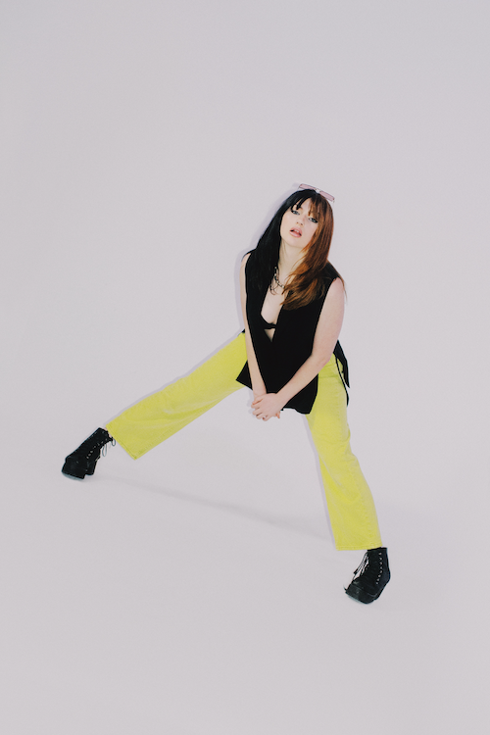

**CONNECT WITH GAYLE**

[GAYLEOFFICIAL.COM](https://nam04.safelinks.protection.outlook.com/?url=https%3A%2F%2Fwww.gayleofficial.com%2F&data=04%7C01%7CTiana.Timmerberg%40atlanticrecords.com%7Cacb8d16bc82340efc27308d951160365%7C8367939002ec4ba1ad3d69da3fdd637e%7C0%7C0%7C637629977289147930%7CUnknown%7CTWFpbGZsb3d8eyJWIjoiMC4wLjAwMDAiLCJQIjoiV2luMzIiLCJBTiI6Ik1haWwiLCJXVCI6Mn0%3D%7C1000&sdata=KAGVqBL5iFdja0tKwFPZjH1McVS39zCy%2B4sX%2Fb%2BhluE%3D&reserved=0) | [FACEBOOK](https://GAYLE.lnk.to/FacebookPR) | [INSTAGRAM](https://GAYLE.lnk.to/InstagramPR) | [YOUTUBE](https://GAYLE.lnk.to/SubscribePR) |  [TIKTOK](https://GAYLE.lnk.to/TikTokPR) | [TWITTER](https://GAYLE.lnk.to/TwitterPR)