FOR IMMEDIATE RELEASE

FEBRUARY 18, 2021

**OHGEESY DROPS “GEEZYWORLD” DELUXE EDITION**

[**STREAM HERE**](https://OhGeesy.lnk.to/GEEZYWORLDDeluxe)

**INCLUDING FEATURES FROM ELADIO CARRION, 1017’S BIG SCARR,**

**PRESSA & BUN DOG, KALAN.FRFR**

**“**[**GO FAST FT. ELADIO CARRION**](https://OhGeesy.lnk.to/GoFastVideo)**” OFFICIAL VIDEO STREAMING NOW**

**SECOND LEG OF GEEZYWORLD TOUR TICKETS, ON SALE NOW**

**OHGEESY OPENS FIRST RESTAURANT “SUNSET MARISCOS”**

**INSIDE WEST HOLLYWOOD’S FRED SEGAL**

[*DOWNLOAD HI-RES ASSETS HERE*](https://warnermusicgroup.box.com/s/9bdkx52c54spfed739eub2swkit8lr62)

*“Geesy’s raspy flow, master-crafted hooks, and ability to inject melody into every corner of the music was vital in bringing bounce to the collective’s infectious sound.”*

**PITCHFORK**

*“Shoreline Mafia member OhGeesy is rising up as a solo artist, making his mark on the rap game. The Los Angeles native is leveling up in a major way, prepping his fans for an onslaught*

*of new music in the coming months.”*

**HOT NEW HIP-HOP**

Following the success of his critically acclaimed solo debut, Platinum-selling artist OHGEESY is back with [GEEZYWORLD Deluxe](https://OhGeesy.lnk.to/GEEZYWORLDDeluxe). Features include Grammy-nominated and Latin trap star Eladio Carrion, 1017’s Big Scarr, Pressa, Bun Dog, and LA’s rising talent Kalan.FrFr. Alongside the release, OHGEESY released official visual for DVLP (Lil Wayne, Eminem) produced track, “[Go Fast ft Eladio Carrion](https://OhGeesy.lnk.to/GoFastVideo),” directed by Austin Simkins (YG).

Eladio Carrion says, “Hyped to link up with OHGEESY on this record. It was produced by our mutual friend DVLP out of Miami. It was fun to work with OHGEESY and his team on the set of the video shoot."

Standing alone, the 104K ticket-selling rapper sold out the first leg of his GEEZYWORLD tour with the second half set to kick off March 25th in Missoula, MT. [Tickets](https://event.etix.com/ticket/online/performanceSale.do?performance_id=5938876&method=restoreToken) on sale now.

Peaking #6 on Apple Music’s US Top Albums (Hip-Hop/Rap) and accumulating over 100M streams, OHGEESY has solidified his place as a solo artist. Produced by D.A Got That Dope, (Travis Scott, Eminem, Kodak Black) the debut single “Get Fly (feat. DaBaby)” landed #7 on Spotify’s Top 100 US Chart and #81 on Apple Music’s Rap Top 1500. His Latin-inspired record comprised a lavish Mexican-style visual that peaked #2 on YouTube with 16M views.

Continuing his journey of being an entrepreneur, OHGEESY has stepped into the culinary world by opening his first restaurant, Sunset Mariscos, in West Hollywood’s retail giant Fred Segal located at 8500 Sunset Blvd, open 12pm to 7pm Tuesday through Friday and weekends 12pm to 9pm. The raw seafood bar serves everything from fresh salsa and ceviche to wild shrimp, striped bass, Spanish octopus and more.

OHGEESY says, “I'm really excited to have opened Sunset Mariscos in my hometown of Los Angeles. I have great partners that have many years of experience in the industry which is invaluable. We serve the freshest seafood delivered three times a week from the Santa Barbara coast. Come check us out!”

*GEEZYWORLD* arrived after OHGEESY's work as the de facto leader of the hip-hop collective Shoreline Mafia. The group already have three RIAA Platinum Certified singles ("Nun Major, "Bands," "Musty"), two RIAA Gold Certified singles ("Whuss The Deal" and "Bottle Service"), headlined their own festival in Vancouver, sold over 108K tickets in 18 months, and their debut 2020 album*MAFIA BIDNESS* has over 592M streams and counting. Listen to *GEEZYWORLD*﻿above, see album details and read more about OHGEESY below, and stay tuned for more coming soon.

***GEEZYWORLD* DELUXE ALBUM TRACKLISTING:**

[*DOWNLOAD TRACKLIST ARTWORK HERE*](https://warnermusicgroup.box.com/s/jvxajxhau498sgeg3pxks0wqpcqz6vs5)

**GEEZYWORLD TOUR DATES**

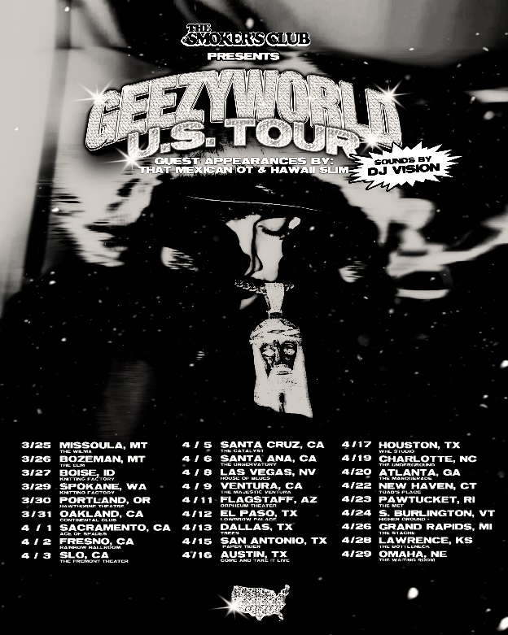

|  |  |  |  |
| --- | --- | --- | --- |
|  |  |  |  |

**ABOUT OHGEESY:**

Life works a lot like a game of chess. One move anticipates the next. OHGEESY maneuvers through hip-hop with a similar level of intention, knowing exactly where he wants to go and how he’ll get there. After bringing Shoreline Mafia from an internet phenomenon to a critically exalted multiplatinum-selling arena headliner, the Los Angeles-born Mexican American rapper asserts himself as an impactful and inimitable solo presence on the mic. His deft wordplay, head-nodding hooks, and undeniable swagger fuel his 2021 full-length debut, GEEZYWORLD [Atlantic Records], and much more to come.

“I definitely look at this like a new beginning,” he exclaims. “Everything was meant to unfold and play out like this, so I could take my career to the next level and really go all the way with it. That’s what I’m going to do now.”

During his childhood, he immediately gravitated to hip-hop. His uncle possessed an impressive CD collection, boasting classics by everyone from UGK and Juicy J to L.A. legends like Dr. Dre and Snoop Dogg. OHGEESY often pulled out random titles and listened to them. “Ever since I was a baby, I always had hip-hop around me,” he explains. “My whole household was playing rap. When I was in third grade, I used to copy lyrics from Three 6 Mafia songs in little notebooks. I finally rapped when I was 18.”

In 2017, he co-founded Shoreline Mafia. Within three years, the group picked up three platinum singles (“Bands,” “Nun Major,” and “Musty”) and two gold singles (“Whuss The Deal” and “Bottle Service”), gathered billions of streams, sold out one show after another, and earned acclaim from Pitchfork, The FADER, Forbes, The Washington Post, and Noisey, to name a few.

By the dawn of the Global Pandemic, OHGEESY’s life had changed forever. He became a father. He focused on “getting healthy,” and he recorded more than ever before. Linking up with trusted engineer Tez, he logged countless hours in the studio to bring GEEZYWORLD to life. “I got in tune with my voice and myself,” he admits. “I was more comfortable. I really want everyone to know where my head is at. It’s in the healthiest space that it’s ever been—both mentally and physically. I’ve been with my son for two years, and that turned me into a better man too. It made me grow up and more mature. I still want to go harder, because I know I’ve got to provide for him. All around, I’m trying to live better than I used to, and that’s made me a better artist too.”

That comes through loud and clear on the first single “Get Fly” [feat. DaBaby]. Latin-style guitar cuts through a thick fingersnap-laden beat as OHGEESY and DaBaby flex with each bar before the hypnotic hook. “That was the first time I had gotten into a bigger studio since the beginning of the Pandemic,” he says. “I walked in, played the beat, and finished it in 15 minutes. It’s my life. You wake up, start the day, and get fly to do anything. You even need to get fly just to listen to my music,” he grins.

“I don’t ever remember Hispanic rappers coming out with this style when I was a kid,” he states. “It makes me stand out. Everyone in L.A. fucks with me, and they’re proud of me. I think it shows kids this is possible. As my music grows, I want audiences to grow with me. I feel like this shit sounds way better and more elevated than anything I’ve done. It’s really me.”

**CONNECT WITH OHGEESY:**

[INSTAGRAM](https://www.instagram.com/ohgeesy/) | [TWITTER](https://twitter.com/OHGEESY)  | [TIKTOK](https://www.tiktok.com/@ohgeesy)

**PRESS CONTACT:**

Brittany Bell | [Brittany.Bell@atlanticrecords.com](mailto:Brittany.Bell@atlanticrecords.com)