**ATLANTIC RECORDS & WARNER BROS. PICTURES PRESENT:**

***IN THE HEIGHTS (ORIGINAL MOTION PICTURE SOUNDTRACK)***

**MUSICAL COMPANION TO THIS SUMMER’S EVENT FILM ARRIVES EVERYWHERE JUNE 11TH**

**ALBUM PRE-ORDER LAUNCHES THIS FRIDAY ACCOMPANIED BY FILM’S TITLE TRACK “IN THE HEIGHTS”**

**SOUNDTRACK TO FEATURE NEW ORIGINAL SONG, “HOME ALL SUMMER”**

**PERFORMED BY** **ANTHONY RAMOS, LESLIE GRACE & MARC ANTHONY**

**“IN THE HEIGHTS,” DIRECTED BY JON M. CHU AND BASED ON LIN-MANUEL MIRANDA’S HUGELY SUCCESSFUL STAGE MUSICAL,**

**ARRIVES IN U.S. THEATERS & STREAMING ON HBO MAX JUNE 11TH**

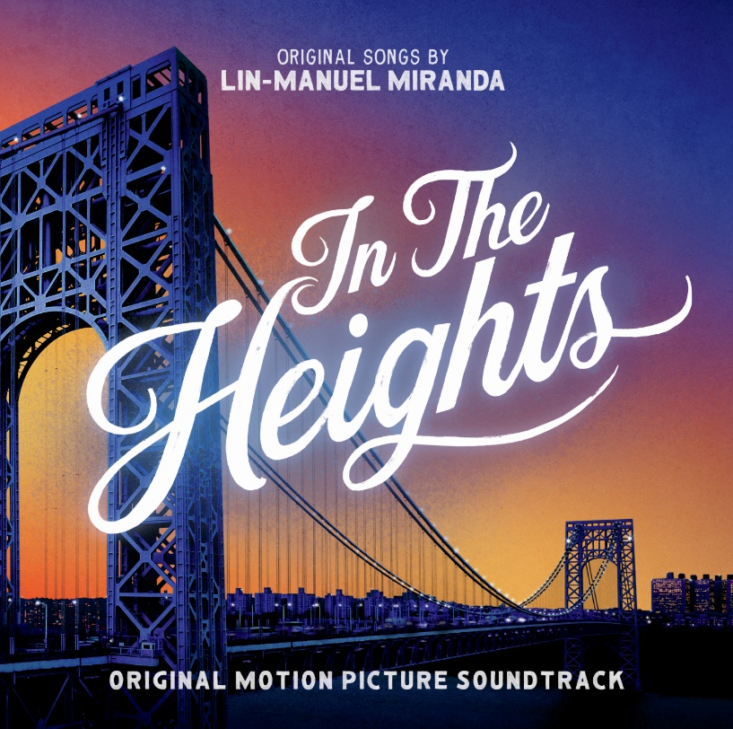

[DOWNLOAD ARTWORK HERE](https://press.atlanticrecords.com/in-the-heights-original-motion-picture-soundtrack/)

**(NEW YORK, NY – April 21, 2021) Atlantic Records** & **Warner Bros. Pictures** have announced ***IN THE HEIGHTS (ORIGINAL MOTION PICTURE SOUNDTRACK)****,* the musical companion to this summer’s highly anticipated event film “**IN THE HEIGHTS**,” written by Lin-Manuel Miranda and Quiara Alegría Hudes and directed by acclaimed filmmaker Jon M. Chu. The soundtrack’s pre-order will begin this **Friday, April 23rd**, accompanied by the film’s title track, **“In The Heights.”** The soundtrack will also feature a brand new, original song titled **“Home All Summer,”** written by Lin-Manuel Miranda and performed by the film’s stars, Anthony Ramos, Leslie Grace and Marc Anthony.

The latest in a massively successful partnership between Atlantic Records and Warner Bros. Pictures, ***IN THE HEIGHTS (ORIGINAL MOTION PICTURE SOUNDTRACK)*** will arrive everywhere on **June 11th**, the same day as the long-awaited film arrives in U.S. theatres and streaming on HBO Max; it will be available on HBO Max for 31 days from theatrical release. Based on the TONY Award-winning stage musical by **Lin-Manuel Miranda** & [**Quiara Alegría Hudes**](https://nam04.safelinks.protection.outlook.com/?url=https%3A%2F%2Furldefense.com%2Fv3%2F__https%3A%2Fnam04.safelinks.protection.outlook.com%2F%3Furl%3Dhttps*3A*2F*2Fen.wikipedia.org*2Fwiki*2FQuiara_Alegr*25C3*25ADa_Hudes%26data%3D04*7C01*7CJason.Davis*40atlanticrecords.com*7Ce49caefb3ed3448d0e4c08d9043212fa*7C8367939002ec4ba1ad3d69da3fdd637e*7C0*7C0*7C637545435393654410*7CUnknown*7CTWFpbGZsb3d8eyJWIjoiMC4wLjAwMDAiLCJQIjoiV2luMzIiLCJBTiI6Ik1haWwiLCJXVCI6Mn0*3D*7C1000%26sdata%3DMZL1iE7Z7e56epCr8GVbAlY32Cmxj*2FdBvAA9xhCbEhI*3D%26reserved%3D0__%3BJSUlJSUlJSUlJSUlJSUlJSUlJSUl!!AQdq3sQhfUj4q8uUguY!xVIpQKmaKHz7yELGNgXc2kwJFjt03ZzYZZOuHbX086nohk41BOIeosMXiL1DBvzRVnJxRxyZ%24&data=04%7C01%7CBrian.Sommer%40atlanticrecords.com%7C6905636b19774d80d50508d9043cb3c4%7C8367939002ec4ba1ad3d69da3fdd637e%7C0%7C0%7C637545481050047468%7CUnknown%7CTWFpbGZsb3d8eyJWIjoiMC4wLjAwMDAiLCJQIjoiV2luMzIiLCJBTiI6Ik1haWwiLCJXVCI6Mn0%3D%7C1000&sdata=3EiWhCyMoU7ywhRdrIwoix0URDVEC8j1RCWQXPbkVb0%3D&reserved=0)with arrangements and score by **Alex Lacamoire** & **Bill Sherman**, the film is scheduled to world premiere at the **Tribeca Festival** on June 9th.

***IN THE HEIGHTS (ORIGINAL MOTION PICTURE SOUNDTRACK)*** was produced by Alex Lacamoire, Bill Sherman, Lin-Manuel Miranda and Greg Wells, with soundtrack production for Atlantic Records by GRAMMY Award winners Kevin Weaver (President, Atlantic Records West Coast), Pete Ganbarg (President A&R, Atlantic Records) and Craig Rosen (EVP A&R and Label Operations, Atlantic Records), along with Riggs Morales (SVP Urban A&R, Atlantic Records). For Warner Bros Pictures, soundtrack produced by Darren Higman and Steven Gizicki.

***IN THE HEIGHTS (ORIGINAL MOTION PICTURE SOUNDTRACK)*** continues Lin-Manuel Miranda’s dominance as a Broadway phenomenon-turned-pop culture giant after the groundbreaking success of the 7X-Platinum, GRAMMY Award-winning ***HAMILTON (ORIGINAL BROADWAY CAST RECORDING)*** and the RIAA certified-gold ***HAMILTON MIXTAPE***, both released via Atlantic Records. ***HAMILTON (ORIGINAL BROADWAY CAST RECORDING)*** peaked at #2 on the Billboard “200 Albums” Chart and has since spawned 7 certified-platinum & 15 certified-gold tracks, with over 6 billion streams worldwide, to date.

**IN THE HEIGHTS (ORIGINAL MOTION PICTURE SOUNDTRACK) TRACK LIST:**

1. In The Heights
2. Benny’s Dispatch
3. Breathe
4. No Me Diga
5. It Won’t Be Long Now
6. 96,000
7. Piragua
8. When You’re Home
9. The Club
10. Blackout
11. Paciencia Y Fe
12. Alabanza
13. Carnaval del Barrio
14. When The Sun Goes Down
15. Champagne
16. Finale
17. Home All Summer

* * *

**ABOUT *IN THE HEIGHTS*:**

The creator of “Hamilton” and the director of “Crazy Rich Asians” invite you to a cinematic event, where the streets are made of music and little dreams become big... “In the Heights.” *Lights up on Washington Heights*...The scent of a cafecito caliente hangs in the air just outside of the 181st Street subway stop, where a kaleidoscope of dreams rallies this vibrant and tight-knit community.  At the intersection of it all is the likeable, magnetic bodega owner Usnavi (Anthony Ramos), who saves every penny from his daily grind as he hopes, imagines and sings about a better life. “In the Heights” fuses Lin-Manuel Miranda’s kinetic music and lyrics with director Jon M. Chu’s lively and authentic eye for storytelling to capture a world very much of its place, but universal in its experience.

“In the Heights” stars Anthony Ramos (“A Star is Born,” Broadway’s “Hamilton”), Corey Hawkins (“Straight Outta Compton,” “BlacKkKlansman”), singer/songwriter Leslie Grace, Melissa Barrera (TV’s “Vida”), Olga Merediz (Broadway’s “In the Heights”), Daphne Rubin-Vega (Broadway’s “Rent”), Gregory Diaz IV (Broadway’s “Matilda the Musical”), Stephanie Beatriz (TV’s “Brooklyn Nine-Nine”), Dascha Polanco (TV’s “Orange is the New Black”) and Jimmy Smits (the “Star Wars” films). Chu directed the film from a screenplay by Quiara Alegría Hudes, based on the musical stage play, music and lyrics by Lin-Manuel Miranda, book by Quiara Alegría Hudes and concept by Miranda.  Miranda, Hudes, Scott Sanders, Anthony Bregman and Mara Jacobs produced the film, with David Nicksay and Kevin McCormick serving as executive producers.

Behind the camera, Chu reunited with his “Crazy Rich Asians” production designer, Nelson Coates, and editor, Myron Kerstein.  He also collaborated with director of photography Alice Brooks (TV’s “The Walking Dead”) and costume designer Mitchell Travers ("Hustlers,” “Eighth Grade”).  Original songs by Miranda.  Alex Lacamoire (“Fosse/Verdon,” Broadway's "Hamilton") and Bill Sherman (“Sesame Street,” Broadway's "Hamilton") served as executive music producers.  The choreography is by Christopher Scott, who previously teamed with Chu on the award-winning “The Legion of Extraordinary Dancers.” “In the Heights” was filmed in New York, primarily on location in the dynamic community of Washington Heights.  Warner Bros. Pictures presents a 5000 Broadway / Barrio Grrrl! / Likely Story / SGS Pictures Production, A Jon M. Chu Film, “In the Heights.”

Slated to open on June 11, 2021 in U.S. theaters and on HBO Max, the film will be distributed worldwide by Warner Bros. Pictures.  It will be available on HBO Max for 31 days from theatrical release. “In the Heights” is rated PG-13 for some language and suggestive references.

For more information, please visit [www.intheheights-movie.com](https://nam04.safelinks.protection.outlook.com/?url=https%3A%2F%2Furldefense.com%2Fv3%2F__https%3A%2Fnam04.safelinks.protection.outlook.com%2F%3Furl%3Dhttps*3A*2F*2Fwww.intheheights-movie.com*2F%26data%3D04*7C01*7CJason.Davis*40atlanticrecords.com*7Ce49caefb3ed3448d0e4c08d9043212fa*7C8367939002ec4ba1ad3d69da3fdd637e*7C0*7C0*7C637545435393654410*7CUnknown*7CTWFpbGZsb3d8eyJWIjoiMC4wLjAwMDAiLCJQIjoiV2luMzIiLCJBTiI6Ik1haWwiLCJXVCI6Mn0*3D*7C1000%26sdata%3DUkCMzO60oXh9v7p6IiC0QzTmcfIuzL4QZLquBxAxIp4*3D%26reserved%3D0__%3BJSUlJSUlJSUlJSUlJSUlJSU!!AQdq3sQhfUj4q8uUguY!xVIpQKmaKHz7yELGNgXc2kwJFjt03ZzYZZOuHbX086nohk41BOIeosMXiL1DBvzRVrkLAKml%24&data=04%7C01%7CBrian.Sommer%40atlanticrecords.com%7C6905636b19774d80d50508d9043cb3c4%7C8367939002ec4ba1ad3d69da3fdd637e%7C0%7C0%7C637545481050057469%7CUnknown%7CTWFpbGZsb3d8eyJWIjoiMC4wLjAwMDAiLCJQIjoiV2luMzIiLCJBTiI6Ik1haWwiLCJXVCI6Mn0%3D%7C1000&sdata=qvWq0OymNZ4MRh3nxQdwO10tivP8ZHy8LhIcJoK%2F0OA%3D&reserved=0) , [Facebook](https://nam04.safelinks.protection.outlook.com/?url=https%3A%2F%2Furldefense.com%2Fv3%2F__https%3A%2Fnam04.safelinks.protection.outlook.com%2F%3Furl%3Dhttps*3A*2F*2Fwww.facebook.com*2FInTheHeightsMovie*2F%26data%3D04*7C01*7CJason.Davis*40atlanticrecords.com*7Ce49caefb3ed3448d0e4c08d9043212fa*7C8367939002ec4ba1ad3d69da3fdd637e*7C0*7C0*7C637545435393773887*7CUnknown*7CTWFpbGZsb3d8eyJWIjoiMC4wLjAwMDAiLCJQIjoiV2luMzIiLCJBTiI6Ik1haWwiLCJXVCI6Mn0*3D*7C1000%26sdata%3D3JWT1dycuftEDfQvJI*2B6tNfD5zCC6cdc5KQoKt0McGE*3D%26reserved%3D0__%3BJSUlJSUlJSUlJSUlJSUlJSUlJQ!!AQdq3sQhfUj4q8uUguY!xVIpQKmaKHz7yELGNgXc2kwJFjt03ZzYZZOuHbX086nohk41BOIeosMXiL1DBvzRVhnKX3D8%24&data=04%7C01%7CBrian.Sommer%40atlanticrecords.com%7C6905636b19774d80d50508d9043cb3c4%7C8367939002ec4ba1ad3d69da3fdd637e%7C0%7C0%7C637545481050057469%7CUnknown%7CTWFpbGZsb3d8eyJWIjoiMC4wLjAwMDAiLCJQIjoiV2luMzIiLCJBTiI6Ik1haWwiLCJXVCI6Mn0%3D%7C1000&sdata=Rch6Dw0nFAayrGeY0HWnmA5p7JCxy%2Bfs5QfwgyGdkT8%3D&reserved=0), [Twitter](https://nam04.safelinks.protection.outlook.com/?url=https%3A%2F%2Furldefense.com%2Fv3%2F__https%3A%2Fnam04.safelinks.protection.outlook.com%2F%3Furl%3Dhttps*3A*2F*2Ftwitter.com*2Fintheheights*3Fref_src*3Dtwsrc*255Egoogle*257Ctwcamp*255Eserp*257Ctwgr*255Eauthor%26data%3D04*7C01*7CJason.Davis*40atlanticrecords.com*7Ce49caefb3ed3448d0e4c08d9043212fa*7C8367939002ec4ba1ad3d69da3fdd637e*7C0*7C0*7C637545435393783844*7CUnknown*7CTWFpbGZsb3d8eyJWIjoiMC4wLjAwMDAiLCJQIjoiV2luMzIiLCJBTiI6Ik1haWwiLCJXVCI6Mn0*3D*7C1000%26sdata%3DpbLylxQczZU9hmVT1EoTM*2FmMB02eLjrghrygOQwMXR0*3D%26reserved%3D0__%3BJSUlJSUlJSUlJSUlJSUlJSUlJSUlJSUlJQ!!AQdq3sQhfUj4q8uUguY!xVIpQKmaKHz7yELGNgXc2kwJFjt03ZzYZZOuHbX086nohk41BOIeosMXiL1DBvzRVq6dnRVZ%24&data=04%7C01%7CBrian.Sommer%40atlanticrecords.com%7C6905636b19774d80d50508d9043cb3c4%7C8367939002ec4ba1ad3d69da3fdd637e%7C0%7C0%7C637545481050067458%7CUnknown%7CTWFpbGZsb3d8eyJWIjoiMC4wLjAwMDAiLCJQIjoiV2luMzIiLCJBTiI6Ik1haWwiLCJXVCI6Mn0%3D%7C1000&sdata=LOjmb9RVzeiPsFtf6NmbDA5xugzYkiGniHQfHwiLkGw%3D&reserved=0), and [Instagram](https://nam04.safelinks.protection.outlook.com/?url=https%3A%2F%2Furldefense.com%2Fv3%2F__https%3A%2Fnam04.safelinks.protection.outlook.com%2F%3Furl%3Dhttps*3A*2F*2Fwww.instagram.com*2Fintheheightsmovie*2F*3Fhl*3Den%26data%3D04*7C01*7CJason.Davis*40atlanticrecords.com*7Ce49caefb3ed3448d0e4c08d9043212fa*7C8367939002ec4ba1ad3d69da3fdd637e*7C0*7C0*7C637545435393783844*7CUnknown*7CTWFpbGZsb3d8eyJWIjoiMC4wLjAwMDAiLCJQIjoiV2luMzIiLCJBTiI6Ik1haWwiLCJXVCI6Mn0*3D*7C1000%26sdata%3DWS2izuSd6pF6roaBhLfFXUrxvTIwqlsp6dWGEfKe8YM*3D%26reserved%3D0__%3BJSUlJSUlJSUlJSUlJSUlJSUlJSU!!AQdq3sQhfUj4q8uUguY!xVIpQKmaKHz7yELGNgXc2kwJFjt03ZzYZZOuHbX086nohk41BOIeosMXiL1DBvzRVuP6F4HP%24&data=04%7C01%7CBrian.Sommer%40atlanticrecords.com%7C6905636b19774d80d50508d9043cb3c4%7C8367939002ec4ba1ad3d69da3fdd637e%7C0%7C0%7C637545481050077452%7CUnknown%7CTWFpbGZsb3d8eyJWIjoiMC4wLjAwMDAiLCJQIjoiV2luMzIiLCJBTiI6Ik1haWwiLCJXVCI6Mn0%3D%7C1000&sdata=4T6%2FO0svbf55wJ2fXb1GaQS8LSY4AmycGOblmVdRTP4%3D&reserved=0).

# # #

**PRESS CONTACTS:**

**ATLANTIC RECORDS:**

Jason Davis – [Jason.Davis@atlanticrecords.com](mailto:Jason.Davis@atlanticrecords.com)

**WARNER BROS. PICTURES:**

Stephanie Phillips – [Stephanie.Phillips@WarnerBros.com](mailto:Stephanie.Phillips@WarnerBros.com)

**LIN-MANUEL MIRANDA:**

Charlie Guadano – [cguadano@sunshinesachs.com](mailto:cguadano@sunshinesachs.com)

Jason Lee – [lee@sunshinesachs.com](mailto:lee@sunshinesachs.com)

**ALEX LACAMOIRE & BILL SHERMAN:**

Britney Thai – [britney@impact24pr.com](mailto:britney@impact24pr.com)

Lauren Mennuti – [lauren@impact24pr.com](mailto:lauren@impact24pr.com)