3x PLATINUM RAPPER JAYDAYOUNGAN DROPS “23 IS BACK” MIXTAPE

FOLLOWING SINGLE “ZAZA” & 2020 DEBUT ALBUM BABY23

LISTEN HERE: https://JayDaYoungan.lnk.to/23isBack
WATCH THE OFFICIAL MUSIC VIDEO FOR MIXTAPE TRACK “MURDER” HERE

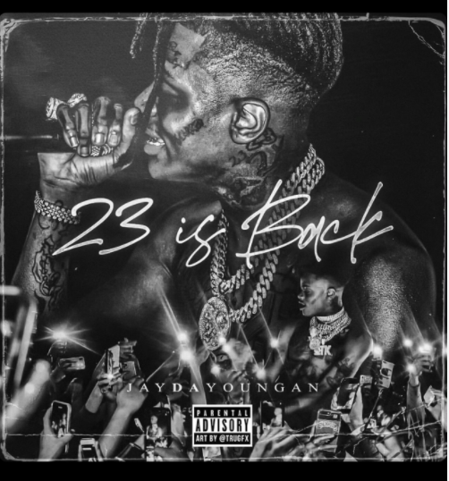
DL art

Louisiana-born rapper JayDaYoungan releases the ’23 Is Back’ mixtape today, following mixtape single “ZaZa” which was released earlier this year. Mixtape track “Murder” (produced by JahDaGod & Jahmoni) receives an official music video out today, featuring JayDaYoungan. Watch HERE.

“23 Is Back” track list
- Lego
- Spot Em
- ZaZa
- What’s Wrong With You
- Hellcat
- Bankroll
- Looking For You
- Murder
- Tear Drops
- Young Niggas
- Shit Bag
- Tell Me The Truth
- Confidential Decisions

JayDaYoungan’s debut album Baby23 was released in June 2020 and boasts 23 tracks, including 2x Platinum single “23 Island”, “Perky Activated”, “38K” and “Touch Your Toes” (ft. Mulatto), with Kevin Gates, Moneybagg Yo, Dej Loaf, and Mulatto featured. Listen HERE

Bogalusa, Louisiana gave rise to JayDaYoungan. In just four years, the rapper and singer has gone from anonymity in his hometown to Double Platinum success, 2.8 billion-plus global streams, acclaim by The FADER and more.

After casually writing rhymes in class, he started to take hip-hop seriously in 2016. He first joined forces with FG Famous for “Stick Up,” generating 1.2 million YouTube views. Turning heads locally, he ignited a prolific string of projects, including his breakout mixtape Ruffwayy [2017], The Real Jumpman 23 [2017], Wake Up [2018], 23 [2018], Forever 23 [2018], Endless Pain [2019], Can’t Speak On It [2019], and Misunderstood [2019]. Along the way, he inked a deal with Atlantic Records, as single “23 Island” achieved a Platinum plaque with over 300 million streams. Singles “Thot Thot,” “Elimination” & “Opps” have also received RIAA Gold certifications.

In 2020, he released his debut album Baby23, which serves as an authentic glimpse into who JayDaYoungan is and how he got here. “I stand on 23 as a brand. Michael Jordan is my favorite basketball player. It’s my auntie’s number (who passed away in a tragic car accident Jan 23, 2011.) I’ve got a son now, so he’s 23 Baby. Everything is dedicated to him. This is my first child, my first album, and my story,” Jay says. “Lyrically, some of the songs are about pain. Some of them are good things. Some of them are about my wife and what we’re going through. It’s all of the smiles and all of the frowns. You’re hearing the good times and the bad times from me. It’s versatile.”

CONNECT WITH JAYDAYOUNGAN
Facebook | Twitter | Instagram | Website

Press contact: corey.brewer@atlanticrecords.com

