2x PLATINUM RAPPER JAYDAYOUNGAN RETURNS WITH “ZAZA”

TAKEN FROM HIS FORTHCOMING MIXTAPE '23 IS BACK'

& FOLLOWING HIS 2020 DEBUT ALBUM BABY23

LISTEN HERE: https://jaydayoungan.lnk.to/ZaZa
WATCH THE OFFICIAL MUSIC VIDEO HERE

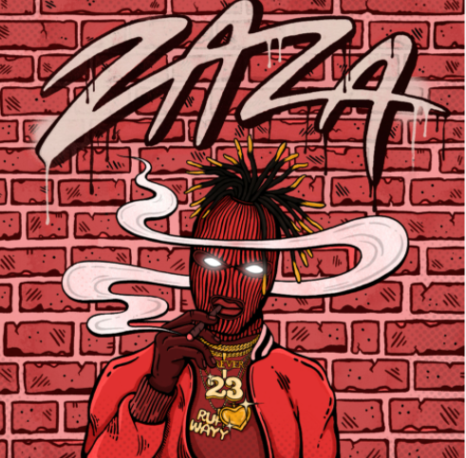
DL art

Louisiana-born rapper JayDaYoungan releases single “ZaZa” with the official video today, and announces his forthcoming project, the ’23 Is Back’ mixtape. Listen to “ZaZa” HERE. The track follows his debut album, Baby23, which was released in June 2020 and boasts 23 tracks, including 2x Platinum single “23 Island”, “Perky Activated”, “38K” and “Touch Your Toes” (ft. Mulatto), with Kevin Gates, Moneybagg Yo, Dej Loaf, and Mulatto featured. Listen HERE

Bogalusa, Louisiana gave rise to JayDaYoungan. In just four years, the rapper and singer has gone from anonymity in his hometown to Double Platinum success, 2.5 billion-plus global streams, acclaim by The FADER and more.

After casually writing rhymes in class, he started to take hip-hop seriously in 2016. He first joined forces with FG Famous for “Stick Up,” generating 1.2 million YouTube views. Turning heads locally, he ignited a prolific string of projects, including his breakout mixtape Ruffwayy [2017], The Real Jumpman 23 [2017], Wake Up [2018], 23 [2018], Forever 23 [2018], Endless Pain [2019], Can’t Speak On It [2019], and Misunderstood [2019]. Along the way, he inked a deal with Atlantic Records, as single “23 Island” achieved a Platinum plaque with over 300 million streams.

In 2020, he released his debut album Baby23, which serves as an authentic glimpse into who JayDaYoungan is and how he got here. “I stand on 23 as a brand. Michael Jordan is my favorite basketball player. It’s my auntie’s number (who passed away in a tragic car accident Jan 23, 2011.) I’ve got a son now, so he’s 23 Baby. Everything is dedicated to him. This is my first child, my first album, and my story,” Jay says. “Lyrically, some of the songs are about pain. Some of them are good things. Some of them are about my wife and what we’re going through. It’s all of the smiles and all of the frowns. You’re hearing the good times and the bad times from me. It’s versatile.”

CONNECT WITH JAYDAYOUNGAN
Facebook | Twitter | Instagram | Website

Press contact: corey.brewer@atlanticrecords.com

