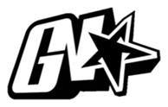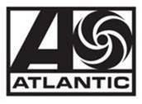

JACK HARLOW’S “FIRST CLASS” DEBUTS AT #1 ON
BILLBOARD HOT 100

RAP SUPERSTAR CELEBRATES FIRST SOLO #1 SINGLE WITH THE BIGGEST FIRST WEEK DEBUT FOR 2022

ADDITIONAL HIGHLIGHTS:
- OVER 54.5 MILLION STREAMS SO FAR
- HIGHEST FIRST DAY STREAMS ON APPLE MUSIC IN 2022

HIGHLY ANTICIPATED SOPHOMORE ALBUM
‘COME HOME THE KIDS MISS YOU’ ARRIVES EVERYWHERE MAY 6

DOWNLOAD/STREAM

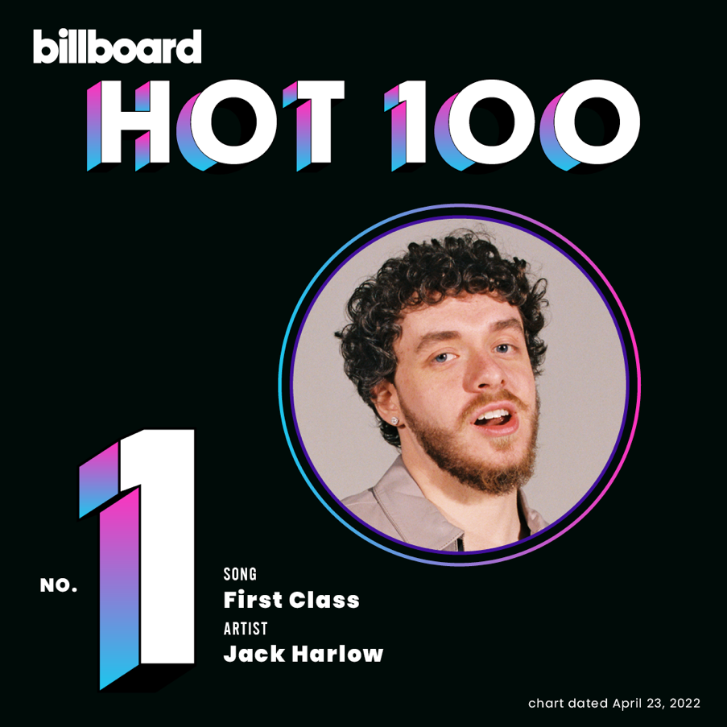
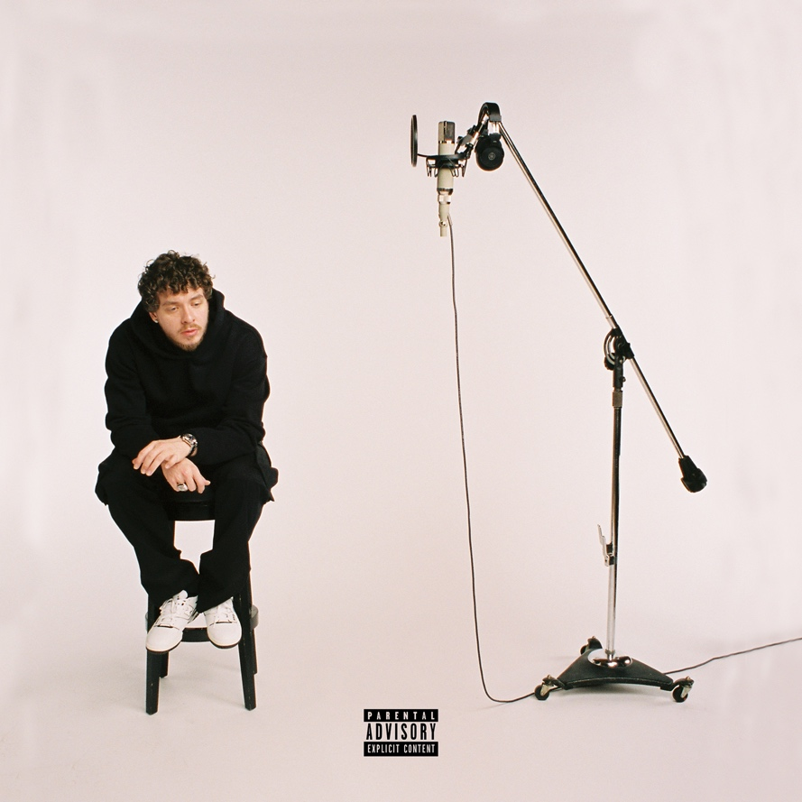
‘Come Home The Kids Miss You’ Album Art
Photo Credit: Urban Wyatt - download assets

Produced by Jack Harlow, Charlie Handsome, Jasper Harris, Angel “BabeTruth” Lopez & Rogét Chahayed

(New York, NY – April 18, 2022) Multiple GRAMMY-nominated, chart-topping rap superstar Jack Harlow is celebrating his new single, “First Class,” debuting at #1 on the Billboard Hot 100 chart. This marks Harlow’s first solo #1 single and second career #1, which was “Industry Baby,” his multi-platinum smash collaboration with Lil Nas X.

The song was released last week via Generation Now/Atlantic Records and brilliantly samples Fergie’s classic 2006 hit, “Glamorous.” The song had already become a viral trend on Tik Tok prior to its release, after Jack teased a snippet of the song from the studio. The single received a wide array of press coverage ranging from Rolling Stone, Billboard and XXL to New York Magazine, People, NPR and many more.

Download/Stream “First Class” here

“First Class” followed Harlow’s previously released, bombastic single, “Nail Tech,” and is the second offering from the hitmaker’s highly anticipated sophomore album, COME HOME THE KIDS MISS YOU, which arrives everywhere May 6.

Pre-order COME HOME THE KIDS MISS YOU here

Following the release of “First Class,” the Louisville-bred hitmaker took the stage to perform a crowd-favorite medley of “Nail Tech,” “Industry Baby” and “First Class” at the 2022 Kids’ Choice Awards, where he was also nominated for Favorite Breakout Artist.

Earlier this month, Harlow took the 64th Annual GRAMMY Awards by storm as one of the most talked about artists of the night thanks to his “best-dressed” red carpet look and showstopping performance with Lil Nas X. He is also on the cover of the current issue of Rolling Stone. Read the full cover story here.
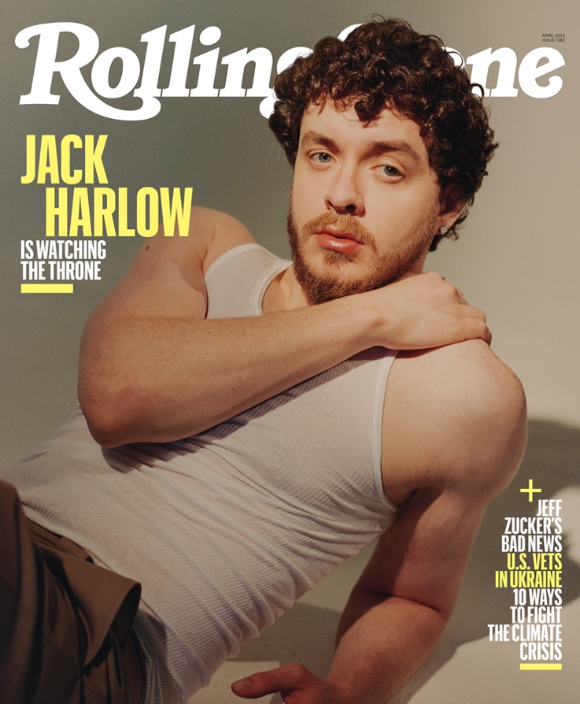

For all Jack Harlow press inquiries, please contact:
Jason Davis jason.davis@atlanticrecords.com

Harlow’s new album comes after a blockbuster 2021, which saw the acclaimed rapper ascend to become a household name. In addition to gracing the cover of Variety, Forbes, Complex, SPIN and Footwear News, he made his Saturday Night Live debut, performed with Lil Nas X at the 2021 MTV Video Music Awards, attended the MET Gala, and celebrated his first ever #1 on the Billboard Hot 100 with his GRAMMY-nominated Lil Nas X collaboration, “Industry Baby.”

Harlow also cemented himself as one of music’s most dynamic live performers with standout performances at major festivals including Lollapalooza, Austin City Limits, Rolling Loud and more, all before embarking on his sold-out, North American “Crème de la Crème Tour.” He wrapped up the year by returning to Louisville for his “No Place Like Home” shows, which saw Harlow performing 5 unforgettable shows at 5 iconic venues in his hometown.

The 24-year-old gave back to his hometown with donations to five different organizations that benefit causes close to his heart: AMPED, The Center for Women and Families, Grace James Academy, Louisville Urban League & Metro United Way. Inspired by his initial individual efforts, Instagram and KFC joined Harlow in making additional donations to these organizations.

(Photo Credit: Urban Wyatt – download assets)

# # #

