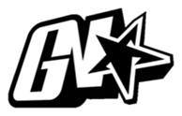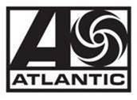

JACK HARLOW COVERS ROLLING STONE

ANNOUNCES NEW ALBUM ‘COME HOME THE KIDS MISS YOU’ OUT EVERYWHERE MAY 6

3X-GRAMMY NOMINEE SET TO PERFORM AT THE
64TH ANNUAL GRAMMY AWARDS ON APRIL 3

READ FULL COVER STORY HERE

Harlow discusses the creative process of making COME HOME THE KIDS MISS YOU, being in his “well-oiled machine” era, giving back to his hometown of Louisville, KY, life as a Gen-Z sex symbol and goals of becoming the greatest rapper of his generation.

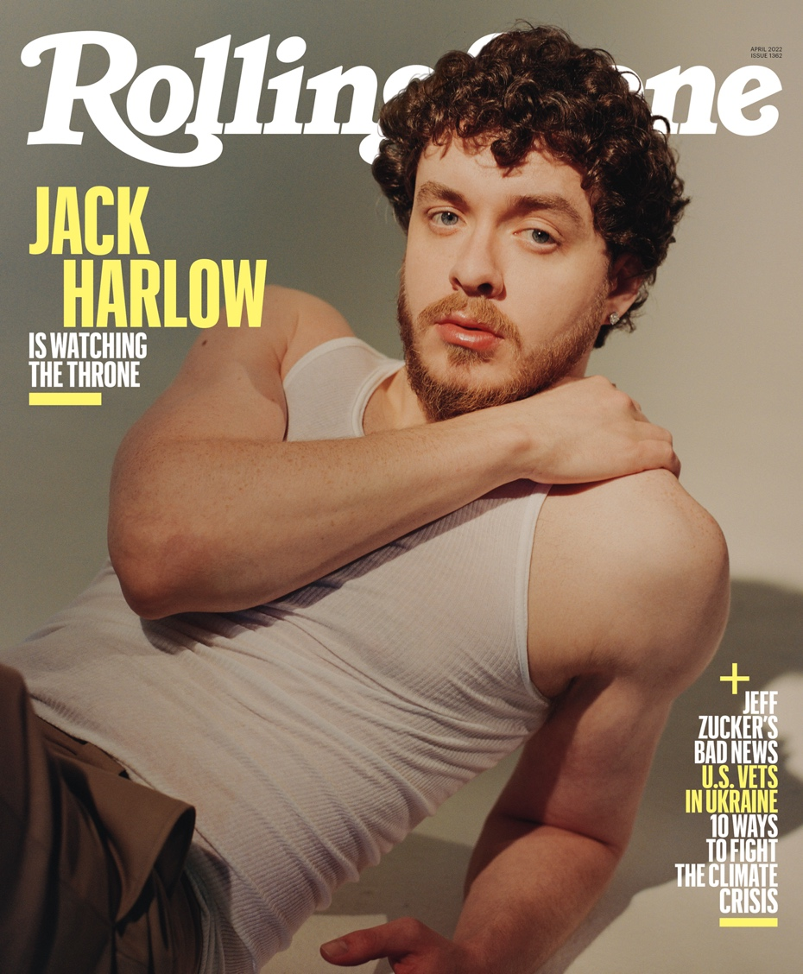
Download all hi-res photos

(New York, NY – March 16, 2022) While gracing the cover of the April issue of Rolling Stone, rap superstar Jack Harlow has announced that his highly-anticipated sophomore album, COME HOME THE KIDS MISS YOU, will be released everywhere May 6 via Generation Now/Atlantic Records. The album will feature the triumphant new hit single “Nail Tech,” which was released last month.

In the cover story, Harlow discusses the creative process of making COME HOME THE KIDS MISS YOU, being in his “well-oiled machine” era, giving back to his hometown of Louisville, KY, life as a Gen-Z sex symbol and goals of becoming the greatest rapper of his generation.

Read the full Rolling Stone cover story here & download all hi-res photos here.

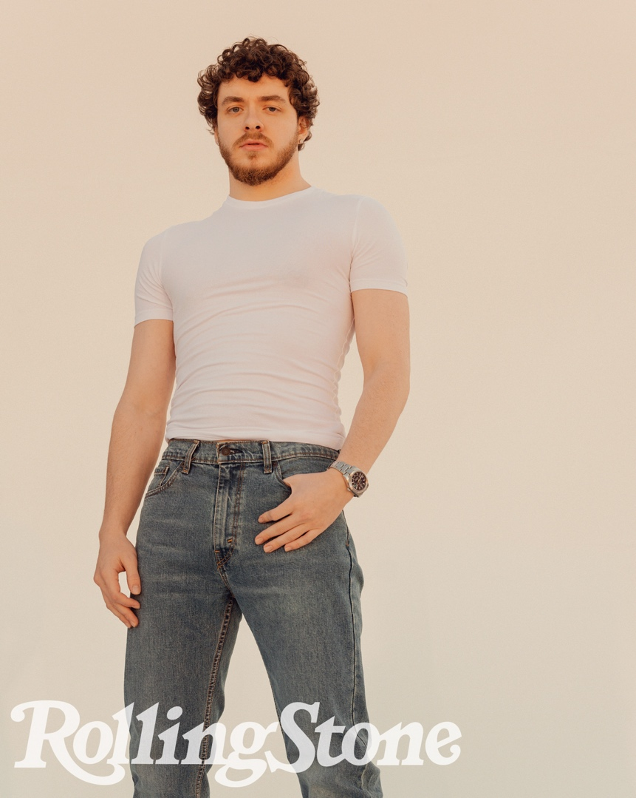
Photo Credit: Ryan Pfluger

Looking ahead, the 3x-GRAMMY nominee is set to take the stage, alongside Lil Nas X, at the 64th annual GRAMMY Awards, where the Louisville-bred rapper is also nominated for two awards for his work on Lil Nas X’s MONTERO (“Best Melodic Rap Performance” and “Album of the Year”). The 64th Annual GRAMMY Awards airs on April 3 on CBS (check local listings).

Adding to all of this, it was recently announced that Harlow is set to make his acting debut in the lead role in 20th Century’s upcoming reboot of the classic film, White Men Can’t Jump. Calmatic is directing a script by Kenya Barris and Doug Hall. Barris and his Khalabo Ink Society banner are producing. Blake Griffin, Ryan Kalil and Noah Weinstein are executive producing through their Mortal Media banner. Hall and E. Brian Dobbins will also exec produce.

* * *

“Nail Tech” marked Harlow’s first solo song since the release of his critically acclaimed, Platinum-certified debut album, THATS WHAT THEY ALL SAY, in December 2020. The song’s companion visual – co-directed by Frank Borin, Ace Pro and Harlow himself – has nearly 18M views since debuting last month.

Harlow was also recently announced as the latest brand ambassador for New Balance. “I have been rocking New Balance since I was a kid, so to officially join the brand in this way is really exciting,” says Jack. “I’ve always loved the 990 and recently the Joe Fresh Goods 993 and collabs with the 550’s have been fire. I’m excited to peek behind the curtain and work with the brand more.”

In addition to New Balance, Jack joined forces with fellow Kentucky brand KFC for a one-of-a-kind yearlong partnership. He also starred in Tommy Hilfiger’s “Pass The Mic” Fall 2021 campaign.

Harlow’s return comes after a blockbuster 2021, which saw the acclaimed rapper become a household name. In addition to gracing the covers of Variety, Forbes, Complex, SPIN and Footwear News, he made his Saturday Night Live debut, performed with Lil Nas X at the 2021 MTV Video Music Awards, attended the MET Gala, and celebrated his first ever #1 on the Billboard Hot 100 with his GRAMMY-nominated Lil Nas X collaboration, “Industry Baby.”

Harlow also cemented himself as one of music’s most dynamic live performers with standout performances at major festivals including Lollapalooza, Austin City Limits, Rolling Loud and more, all before embarking on his sold-out, North American “Crème de la Crème Tour.” He wrapped up the year by returning to Louisville for his “No Place Like Home” shows, which saw Harlow performing 5 unforgettable shows at 5 iconic venues in his hometown.

The 24-year-old gave back to his hometown with donations to five different organizations that benefit causes close to his heart: AMPED, The Center for Women and Families, Grace James Academy, Louisville Urban League & Metro United Way. Inspired by his initial individual efforts, Instagram and KFC joined Harlow in making additional donations to these organizations.

For all Jack Harlow press inquiries, please contact:
Jason Davis jason.davis@atlanticrecords.com

