JASIAH BREAKS OUT OF “LOCKDOWN”

GENRE-DEFYING RECORDING ARTIST WRAPS UP THE YEAR WITH ADRENALINE-INFUSED SINGLE, ROLLING LOUD CALIFORNIA SET & NATIONWIDE TOUR

STREAM/DOWNLOAD: “Lockdown”

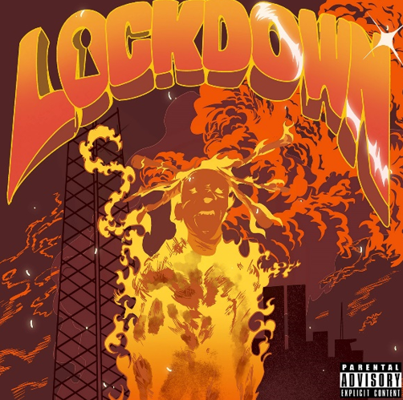
DOWNLOAD ARTWORK HERE

New York, NY – December 3, 2021 – Genre-defying recording artist Jasiah has released his latest adrenaline-infused single, “Lockdown,” available now via Atlantic Records – LISTEN HERE. Driven by guitar and horn samples that pair perfectly with the song’s trap beat and Jasiah’s aggro-rap delivery, “Lockdown” will appear on his forthcoming mixtape out next year.

Recent releases from Jasiah include “Right Now (Feat. Travis Barker),” “WORLD $TAR” and “Art of War (Feat. Denzel Curry & Rico Nasty),” the latter of which was hailed by PAPER as an, “exhilarating, blown-out rager.” UPROXX also praised the collaboration as, “an absolute head-banging track, one that should be perfect for the mosh pits that are set to return at festivals later this year.”

Additionally, Jasiah released his acclaimed War EP in April 2021 featuring the songs “Unintelligible (Feat. nascar aloe),” “Surfs Up,” “Break Shit” and the viral single “Crisis,” which has accrued over 50M+ streams, 25M+ video views and 1.3M+ video creations on TikTok to date. Pitchfork praised the EP and Jasiah’s impact, emphasizing that, “the rap industry has always moved fast, but the tempo at which new hip-hop trends spread and proliferate means that many artists can become deeply influential while still being relatively young. Dayton, Ohio’s Jasiah is an obvious byproduct of the speed of digital music, steeped in a world of online micro-genres…”

Jasiah also hit the road in November as support on Pouya’s nationwide tour which concludes on December 18th at Revolution Live in Ft. Lauderdale, FL and will also perform at Rolling Loud California in San Bernardino on December 10th.

FALL 2021 TOUR DATES (SUPPORTING POUYA):
12/3 – House of Blues – Anaheim, CA*
12/6 – Echoplex – Los Angeles, CA*
12/7 – Echoplex – Los Angeles, CA*
12/8 – The Pressroom – Phoenix, AZ*
12/10 – Rolling Loud – San Bernardino, CA
12/11 – Trees – Dallas, TX*
12/12 – Warehouse Live – Houston, TX*
12/14 – The Basement East – Nashville, TN*
12/16 – Center Stage Theater – Atlanta, GA*
12/17 – The Plaza Live – Orlando, FL*
12/18 – Revolution Live – Ft. Lauderdale, FL*
*Supporting Pouya

ABOUT JASIAH
Known for his groundbreaking fusion of sonic styles, from melodic R&B and emo rap to aggro-rock and even opera, Jasiah made his name with self-produced tracks on SoundCloud before truly exploding into the national consciousness with “Case 19 (Feat. 6ix9ine),” which was joined by a companion video that proved an equivalent smash with total video views over 12 million HERE. “Shenanigans (Feat. Yung Bans)” followed, quickly rising to #1 on both SoundCloud’s “New & Hot” chart as well as the official TikTok chart, where it has become an undeniable viral favorite. As if all that weren’t enough, after the release of his single “Heartbreak (Feat. Travis Barker,)” Complex praised the song, highlighting, “Jasiah and Barker’s high-performance energy, which oscillates between hushed and aggressive.” In 2019, Jasiah released his debut project, Jasiah I Am, which accrued over 175M+ streams. Jasiah followed the project with his acclaimed War EP, which boasted collaborations with Rico Nasty, The Hxliday, Pouya and more. With an astounding 300M+ career streams under his belt, Jasiah is ready to take the world by storm one mosh pit anthem at a time.

Jasiah Press Contacts:
Jason Davis – Jason.Davis@AtlanticRecords.com
Brian Sommer – Brian.Sommer@AtlanticRecords.com

DOWNLOAD HIGH-RES PHOTO
Credit: Nathan James
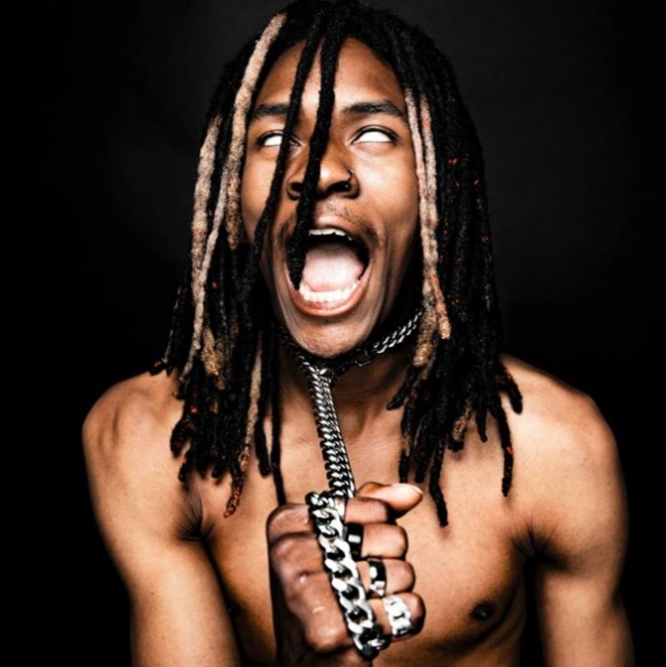

CONNECT WITH JASIAH:
WEBSITE | FACEBOOK | TWITTER | INSTAGRAM | YOUTUBE

# # #

