**GENRE-BENDING RECORDING ARTIST JASIAH PREMIERES**

**NEW VISUAL FOR “WHEN I’M GONE”**

**CO-HEADLINING “NORTH AMERICAN TOUR” WITH $NOT**

**TO COMMENCE FEBRUARY 6TH IN DALLAS, TX**

**DEBUT PROJECT** [***JASIAH I AM***](https://jasiah.lnk.to/JasiahIAm) **EXCEEDS 36M STREAMS**

[**WATCH “WHEN I’M GONE” HERE**](https://Jasiah.lnk.to/WhenImGoneVideo)

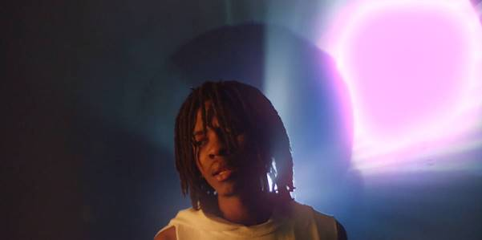

**New York, NY – January 22, 2020 –** Rising recording artist **Jasiah** has unveiled a stunning new visual for **“When I’m Gone,”** handpicked from his [***Jasiah I Am***](https://jasiah.lnk.to/JasiahIAm)project released in 2019 – [**WATCH HERE**](https://Jasiah.lnk.to/WhenImGoneVideo).

The new visual arrives as Jasiah prepares to embark on his co-headlining, 17-city **“North American Tour”** alongside **$NOT**, kicking off on February 6th in Dallas, TX and ending in West Hollywood, CA on March 3rd – [**TICKETS ON SALE NOW**](https://www.phreejasiah.com/jasiahxsnot/?ref=Typed/Bookmarked). Fans received a preview of Jasiah’s high-energy performances when he made his **Rolling Loud** debut in Los Angeles on December 16th.

Noted for his genre-fluid style, Jasiah released his debut project in ***Jasiah I Am***in July 2019 to critical-acclaim, having garnered **over 36M collective streams** to date – [LISTEN HERE](https://jasiah.lnk.to/JasiahIAm).

“…*an exciting new artist with a penchant for blending genres.”*

**- HYPEBEAST**

*“[‘Jasiah I Am’] is a comprehensive blend of all the elements that makes the Ohio native one to watch…”*

**- HOT NEW HIP HOP**

***ABOUT JASIAH:***

Known for his groundbreaking fusion of sonic styles, from melodic R&B and emo rap to aggro rock and even opera, Jasiah made his name with self-produced tracks on SoundCloud before truly exploding onto the national consciousness with [**“Case 19 (Feat. 6Ix9ine),”**](https://jasiah.lnk.to/Case19) which was joined by a companion video that proved an equivalent smash with total video views now approaching **10 million** [**HERE**](https://www.youtube.com/watch?v=gr0EgCcD-v0). [**“Shenanigans (Feat. Yung Bans)“**](https://www.youtube.com/watch?v=ToL-Mn2ZISM) followed, quickly rising to **#1 on both SoundCloud’s “New & Hot” chart as well as the official TikTok chart**, where it has become an undeniable viral favorite. As if all that weren’t enough, after the release of his latest single, [**“Heartbreak (Feat. Travis Barker),”**](https://www.youtube.com/watch?v=trg5z-4bg0U)[***Complex***](https://www.complex.com/music/2019/09/jasiah-travis-barker-heartbreak-video) praised the song, highlighting “Jasiah and Barker’s high-performance energy, which oscillates between hushed and aggressive.”

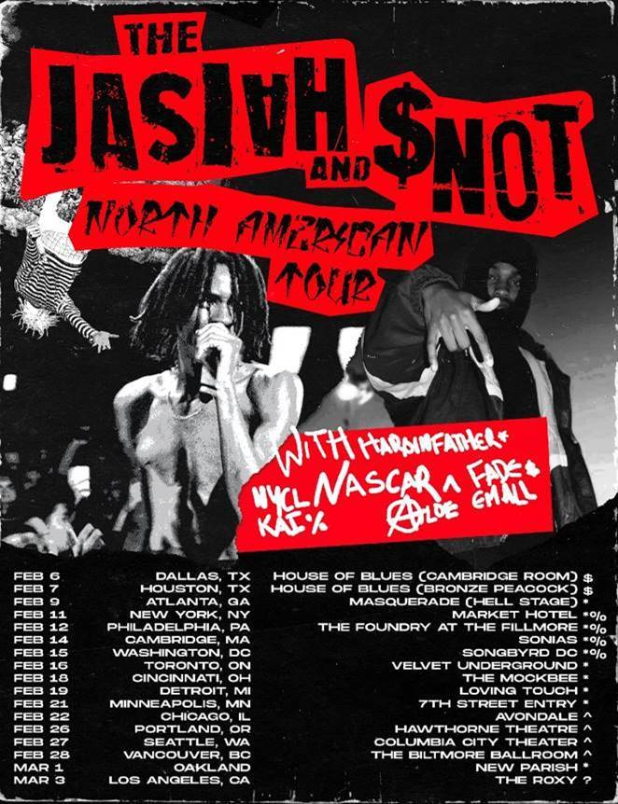

[**DOWNLOAD ADMAT HERE**](https://warnermusicgroup.box.com/s/f6xdavrra6oc3bdfhyprofmqrv0e5msl)

**“NORTH AMERICAN TOUR”:**

2/6 – Dallas, TX – House of Blues - Cambridge Room $

2/7 – Houston, TX – House of Blues - Bronze Peacock $

2/9 – Atlanta, GA – Masquerade - Hell Stage *\**

2/11 – Brooklyn, NY – Market Hotel *\*%*

2/12 – Philadelphia, PA – The Foundry at The Fillmore *\*%*

2/14 – Cambridge, MA – Sonia’s *\*%*

2/15 – Washington, DC – Songbyrd DC *\*%*

2/16 – Toronto, ON - Velvet Underground *\**

2/18 – Cincinnati, OH – The Mockbee *\**

2/19 – Ferndale, MI – The Loving Touch *\**

2/21 – Minneapolis, MN - 7th Street Entry *\**

2/22 – Chicago, IL – Avondale Music Hall *^*

2/26 – Portland, OR – Hawthorne Theatre *^*

2/27 – Seattle, WA – Columbia City Theater *^*

2/28 – Vancouver, BC – The Biltmore Ballroom *^*

3/1 – Oakland, CA – The New Parish *\**

3/3 – West Hollywood, CA – The Roxy Theatre ?

*$ Dates with Fade Em All*

*\* Dates with Haroinfather*

*% Dates with NYCL KAI*

*^ Dates with Nascar Aloe*

**\*\*\***

**PRESS PHOTO:**

*[Photo Credit: Travis Shinn]*

[DOWNLOAD HIGH-RES PHOTO](https://warnermusicgroup.box.com/s/mj3z6qv6dpwimevjcgdl07y82grte9jy)



**CONNECT WITH JASIAH:**

[WEBSITE](https://nam04.safelinks.protection.outlook.com/?url=https%3A%2F%2Fwww.phreejasiah.com%2F&data=02%7C01%7CBrian.Sommer%40atlanticrecords.com%7C3ccdef3d1d6741d9e62a08d771c0056c%7C8367939002ec4ba1ad3d69da3fdd637e%7C0%7C0%7C637102941848199233&sdata=pDkAgiVlYJLj%2B88jmOZIwESFrrLH5DqqmED5K0pIVG8%3D&reserved=0) | [FACEBOOK](https://nam04.safelinks.protection.outlook.com/?url=https%3A%2F%2Fwww.facebook.com%2Fjasiah999%2F&data=02%7C01%7CBrian.Sommer%40atlanticrecords.com%7C3ccdef3d1d6741d9e62a08d771c0056c%7C8367939002ec4ba1ad3d69da3fdd637e%7C0%7C0%7C637102941848209224&sdata=YV4FAHkmTQgD04G5XJofF3k0VU%2ByHnNVAZwXMlIGqTE%3D&reserved=0) | [TWITTER](https://nam04.safelinks.protection.outlook.com/?url=https%3A%2F%2Ftwitter.com%2Fphreejasiah&data=02%7C01%7CBrian.Sommer%40atlanticrecords.com%7C3ccdef3d1d6741d9e62a08d771c0056c%7C8367939002ec4ba1ad3d69da3fdd637e%7C0%7C0%7C637102941848219225&sdata=KVT02lRkEQyvRBGKAox6Biv4jERgsMMWFV%2BDsAx32ig%3D&reserved=0) |[INSTAGRAM](https://nam04.safelinks.protection.outlook.com/?url=https%3A%2F%2Fwww.instagram.com%2Fjasiah%2F&data=02%7C01%7CBrian.Sommer%40atlanticrecords.com%7C3ccdef3d1d6741d9e62a08d771c0056c%7C8367939002ec4ba1ad3d69da3fdd637e%7C0%7C0%7C637102941848229216&sdata=jG7c023oR7bA45bva%2B7Du8jt%2FKNI43Z3kkcUIimwlp4%3D&reserved=0) |[YOUTUBE](https://nam04.safelinks.protection.outlook.com/?url=https%3A%2F%2Fwww.youtube.com%2Fchannel%2FUCMLLndGScE19J-WgBOMDOaw&data=02%7C01%7CBrian.Sommer%40atlanticrecords.com%7C3ccdef3d1d6741d9e62a08d771c0056c%7C8367939002ec4ba1ad3d69da3fdd637e%7C0%7C0%7C637102941848239218&sdata=TcYCeR4gJcBIULkaSHaR%2FPHlZGWSD%2BEffKJzplCyZzc%3D&reserved=0)

**CONTACT:**

JASON DAVIS | [JASON.DAVIS@ATLANTICRECORDS.COM](mailto:JASON.DAVIS@ATLANTICRECORDS.COM)

# # #