For Immediate Release
MAY 7, 2021

JAX Shares “90s Kids” (Unplugged)

Multi-talented singer-songwriter strips back
nostalgia anthem, available now via Atlantic Records

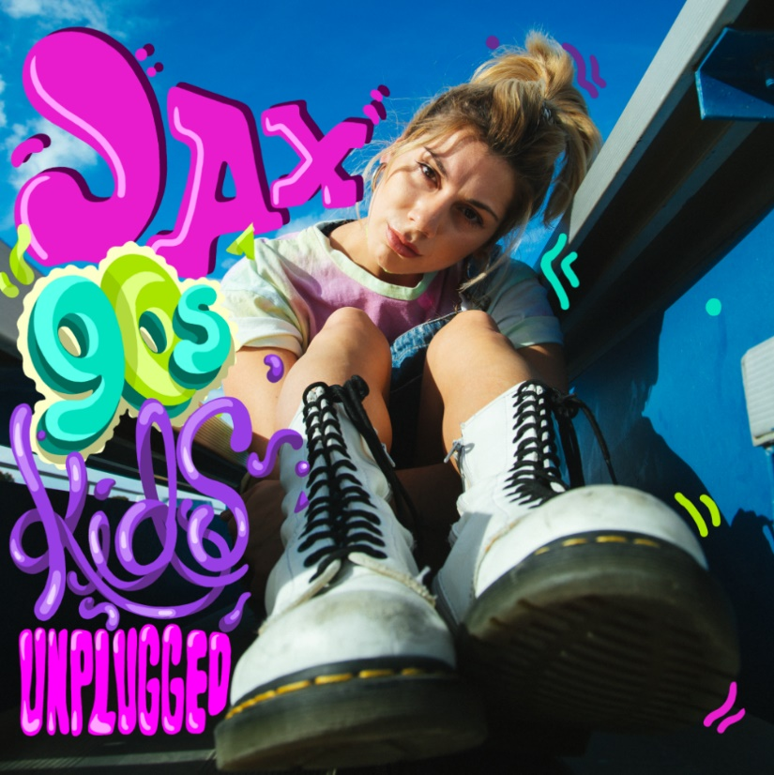
DOWNLOAD HIGH-RES IMAGES

STREAM “90S KIDS (UNPLUGGED)”: https://JAX.lnk.to/90sKidsUnpluggedPR
STREAM “90S KIDS”: JAX.lnk.to/90sKidsPR

Singer-songwriter Jax has shared an unplugged rendition of her new single “90s Kids” – available now via Atlantic Records. The nostalgia-fueled anthem became an instant fan-favorite after being previewed on TikTok late last year, packed with quintessential decade references from Tamagotchi to Britney Spears.

“I’m obviously a 90s kid, and grew up with all these amazing trends that I’m still obsessed with today” said Jax. “One night at 3am I was just thinking of all the times I’d watched ‘Saved By The Bell,’ played Super Smash Bros, danced to Britney Spears and I just put it all in a voice memo. Next thing I knew by sunrise I had this anthem to rep all my fellow 90s babies.”

“90s Kids” follows the release of “Ring Pop,” Jax’s major label-debut which yielded a massive viral response and high-profile appearances on The Ellen DeGeneres Show, Access Hollywood & more. Initially teased on TikTok, “Ring Pop” instantly captivated fans with it’s honest lyrics that perfectly encapsulate the emotions being felt by so many in today’s predicament. Her warm delivery coasting over dreamy guitar and snappy percussion as she croons to her boyfriend, “Don’t need no diamonds, you’re my rock, and I’m okay with a ring pop.”

Raised in New Jersey by way of New York, Jax got her start by performing a wide variety of genres and in bands growing up. At the age of 18, she developed cancer above her vocal cords, which returned following a couple months of remission right as she relocated to Los Angeles in pursuit of her music. Left unable to sing herself, Jax turned to songwriting for others and found industry success behind-the-scenes.

As her ability to perform returned, Jax needed to pivot yet again when the COVID-19 pandemic struck. This time she turned to TikTok, posting a hilarious response to the pop gem “Stacy’s Mom” from “Stacy’s Mom’s Perspective” which exploded with nearly 9 million views in just a few months and “Update from Avril Lavigne & Sk8er Boi 18 years later” which became her most successful parody to date with over 14.5 million views. She continued to go viral a dozen or more times over, now having amassed over 2.4 million followers on the platform and 39 million “likes.” With a massive online audience under her belt, Jax began sharing her own original music in late 2020 to an overwhelmingly positive response – ultimately leading to her singing with Atlantic Records for her forthcoming debut full-length.

DOWNLOAD HIGH-RES IMAGES

CONNECT WITH JAX:
TikTok | YouTube | Instagram | Twitter | Facebook | Press Assets

CONTACT:
Ted Sullivan | ted.sullivan@atlanticrecords.com

