For Immediate Release
June 3, 2021 (11a EST)

JAX gets sentimental with “Like My Father”

Multi-talented singer-songwriter’s new single
arrives today with heartwarming video

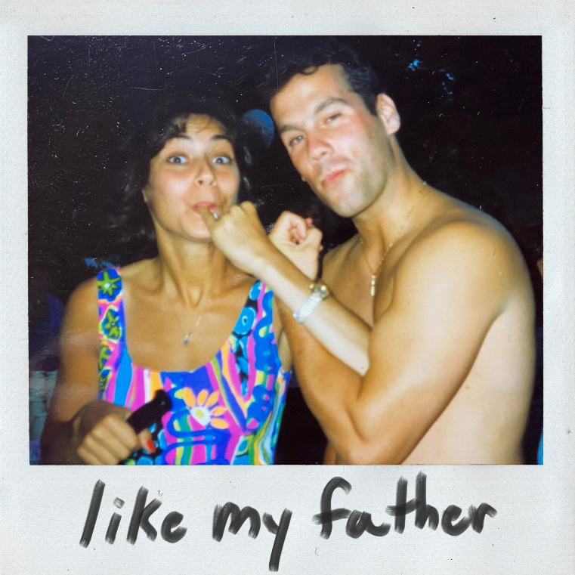
DOWNLOAD HIGH-RES IMAGES

WATCH/STREAM “LIKE MY FATHER”: https://JAX.lnk.to/LikeMyFatherPR

Jax gets sentimental with new single “Like My Father” (available now via Atlantic Records), a heartwarming tribute to her parents arriving today alongside an equally touching video companion. The track initially premiered on the singer-songwriter’s buzzworthy TikTok, as she sang the track to her parents for the very first time.

"I wrote a song about the best relationship I’ve ever known....my mom and dad set the bar pretty high and gave me the perfect example of what love is. So, this Father’s Day I wanted to give them this song in return.” – JAX

“Like My Father” follows the release of “90s Kids,” Jax’s addictively nostalgic single that proved a fast fan-favorite – having just received a sixth consecutive round of over 1 million weekly streams in the US alone and complimented by a music video starring The Sandlot’s Patrick Renna. Meanwhile, her label-debut single “Ring Pop” arrived earlier this year to massive viral response and high-profile appearances on The Ellen DeGeneres Show, Access Hollywood & more.

Raised in New Jersey by way of New York, Jax got her start by performing a wide variety of genres and in bands growing up. At the age of 18, she developed cancer above her vocal cords, which returned following a couple months of remission right as she relocated to Los Angeles in pursuit of her music. Left unable to sing herself, Jax turned to songwriting for others and found industry success behind-the-scenes.

As her ability to perform returned, Jax needed to pivot yet again when the COVID-19 pandemic struck. This time she turned to TikTok, posting a hilarious response to the pop gem “Stacy’s Mom” from “Stacy’s Mom’s Perspective” which exploded with nearly 9 million views in just a few months and “Update from Avril Lavigne & Sk8er Boi 18 years later” which became her most successful parody to date with over 14.5 million views. She continued to go viral a dozen or more times over, now having amassed over 4 million followers on the platform and 60 million “likes.” With a massive online audience under her belt, Jax began sharing her own original music in late 2020 to an overwhelmingly positive response – ultimately leading to her singing with Atlantic Records for her forthcoming debut full-length.

DOWNLOAD HIGH-RES IMAGES

CONNECT WITH JAX:
TikTok | YouTube | Instagram | Twitter | Facebook | Press Assets

CONTACT:
Ted Sullivan | ted.sullivan@atlanticrecords.com

