For Immediate Release
FEBRUARY 12, 2021

JAX captivates WITH “RING POP”

Multi-talented singer-songwriter unveils music video for viral new single
following debut appearance on The Ellen DeGeneres Show

“Ring Pop” available now via Atlantic Records

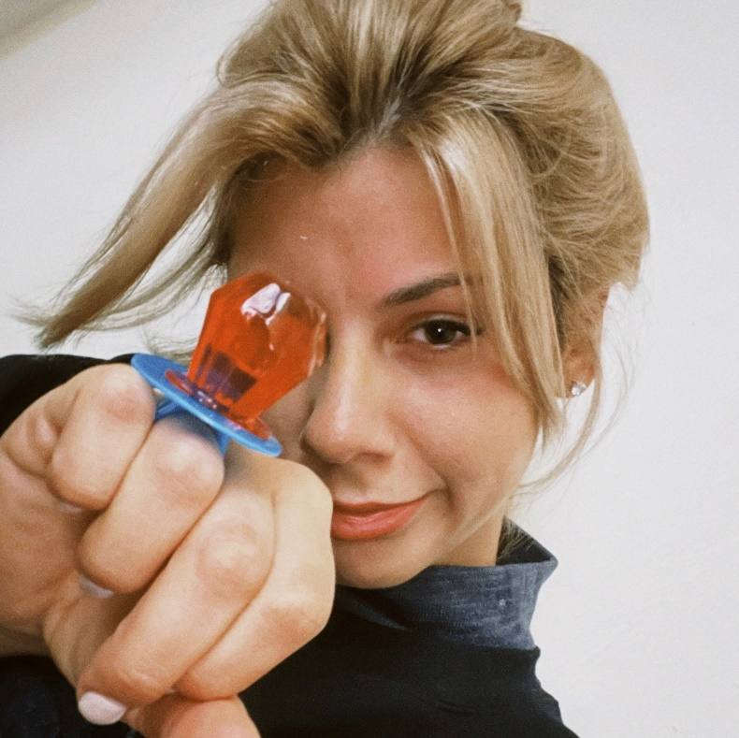

WATCH “RING POP” VIDEO: https://JAX.lnk.to/RingPopVideoPR
STREAM “RING POP”: https://JAX.lnk.to/RingPopPR

Atlantic Records has proudly announced the signing of singer-songwriter Jax, along with unveiling the music video for her sensational viral single “Ring Pop” (watch here). The Connor Ellmann-directed visual (also starring Devon Werkheiser of Nickelodeon’s classic sitcom Ned’s Declassified School Survival Guide) arrives on the heels of Jax’s debut post-signing interview yesterday on The Ellen DeGeneres Show (watch here).

After attracting a massive online following this past year with her viral parodies of hit songs, Jax began sharing her own original music in late 2020 to an overwhelmingly positive response. Initially teased on TikTok, “Ring Pop” instantly captivated fans with it’s honest lyrics that perfectly encapsulate the emotions being felt by so many in today’s predicament. Her warm delivery coasts over dreamy guitar and snappy percussion as she croons to her boyfriend, “Don’t need no diamonds, you’re my rock, and I’m okay with a ring pop.”

“I was, and currently am, broke in L.A. living in a one-bedroom apartment, but very much in love,” Jax explains. “My boyfriend and I weren’t having a great week, so I wrote the song for him to feel better about not being able to just buy a diamond engagement ring and get married. Who cares? We’re living our best times now.”

Raised in New Jersey by way of New York, Jax got her start by performing a wide variety of genres and in bands growing up. At the age of 18, she developed cancer above her vocal cords, which returned following a couple months of remission right as she relocated to Los Angeles in pursuit of her music. Left unable to sing herself, Jax turned to songwriting for others and found industry success behind-the-scenes.

As her ability to perform returned, Jax needed to pivot yet again when the COVID-19 pandemic struck. This time she turned to TikTok, posting a hilarious response to the pop gem “Stacy’s Mom” from “Stacy’s Mom’s Perspective” which exploded with nearly 9 million views in just a few months and “Update from Avril Lavigne & Sk8er Boi 18 years later” which became her most successful parody to date with over 14 million views. She continued to go viral a dozen or more times over, eventually amassing over 1.3 million followers on the platform, 125 million total views and 17 million “likes.”

“Ring Pop” marks only the beginning of Jax’s musical journey, fueled by her creative penchant and candid relatability that has fans around the world finding a friend through their screens.

“I’m a total dork in real life,” she affirms. “Sometimes I’m feeling myself and I’ll put out something sexy, but it’s not really who I am. I wanted that to shine through in the music. In my songs, I write things I’d actually say in conversation and see if anybody wants to be my friend.”


DOWNLOAD HIGH-RES IMAGES

CONNECT WITH JAX:
TikTok | YouTube | Instagram | Twitter | Facebook | Press Assets

CONTACT:
Ted Sullivan | ted.sullivan@atlanticrecords.com

