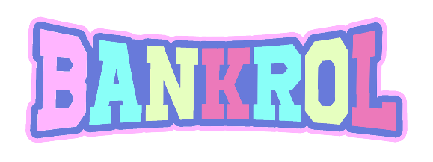
OFFICIAL BIO | UPDATED JULY 2021

Using his gift to inspire, uplift, and ignite change in his hometown of Modesto, California, Bankrol Hayden has always used music to invest in his roots. The young artist found his way into the music industry at only 15-years-old, dropping a single that amassed over 40k streams upon its arrival. At 16, he discovered the virtue of healing after a car accident taught him what it means to live. During those painful days of recovery, Bankrol Hayden realized that turning negativity into positivity would be the foundation of his mission. And just like that, at 18-years-old, the rapper signed to Atlantic Records and went Gold for his celebrated single “Costa Rica.”

In 2020, Bankrol Hayden toured as direct support for Lil Mosey on his Certified Hitmaker tour and released his debut album Pain Is Temporary which boasts features from artists by the likes of Lil Baby and The Kid LAROI. With 3M+ monthly listeners on Spotify alone, 100s of millions of streams across his entire discography, and support from tastemakers like Complex, XXL, Flaunt, and many more, the now 19-year-old musician is dedicated to redistributing this abundance of wealth throughout Modesto. With no finish line in sight, Bankrol Hayden is a humanitarian artist whose worldwide influence is only at its genesis.

