FOR IMMEDIATE RELEASE
AUGUST 6, 2021

MAY-A SHARES COMING-OF-AGE DEBUT EP
DON'T KISS UR FRIENDS
VIA ATLANTIC RECORDS

WATCH NEW VIDEO FOR "CENTRAL STATION"
DOWNLOAD PRESS PHOTOS HERE

PRAISE FOR MAY-A
"MAY-A is moving full force" - PAPER
"Aged just 19, she’s turned the heads of critics and tastemakers around the globe
with her effortless, and honest, observations of everyday life and love" - Billboard
“glorious” - Variety
"MAY-A’s 'Swing of Things' is a guitar-driven sad banger, made for late-night pining" - PopMatters
“a soon-to-be star” - Gay Times
“welcome to your new fave artist” - Dork
“dreamy, stacked vocals and fuzzy guitar...feels akin to
the writing of Lorde and King Princess” - Ones To Watch
"A proper pop whiz" - triple j

WATCH “CENTRAL STATION” HERE

Fresh off her signing to Atlantic Records, burgeoning pop star MAY-A today shares her eagerly anticipated debut EP via Atlantic Records, Don’t Kiss Ur Friends, featuring a new video for focus track, "Central Station".
Watch the video HERE and listen to Don't Kiss Ur Friends HERE
From the tentative first steps of opener 'Apricots' to the arena-sized catharsis of "Amiinmyhead?", the songs throughout Don’t Kiss Ur Friends bristle with a ripening sense of assurance in themselves. In crystalline pop vocals, whispered D&M-style relatability, and 90s pop-rock channeling instrumentation, MAY-A suffuses her debut outing with clear-eyed observational lyricism, poignant, elliptical storytelling and songwriting full of musical left-turns, traversing queer identity, first love, break-ups, and more. Don’t Kiss Ur Friends brims with the elated rush of these formative years, but is tinged with the hurt that so often accompanies them.
'Central Station' is the newest focus track lifted from MAY-A's debut EP, which threads together previous releases, "Swing Of Things", "Time I Love To Waste", "Apricots" and "Green", an opening statement, years in the making, from an artist who has been writing since the age of 12 but has only, over the past year, begun to share her once private creative trove with the wider world. Plaudits for MAY-A's generational songwriting have flowed from far and wide in due course, racking up tens of millions of streams, amassing over 250k YouTube subscribers and heralded as “glorious” by Variety, the mark of a “proper pop wiz” by triple j and “a soon-to-be-star” by GayTimes, “your favorite new artist” by Dork Magazine, amongst others.
Such a patient and astute approach has yielded a debut EP which is remarkably cohesive for such a young artist, indicative of not only the talent and wisdom that MAY-A possesses in spades/quantities beyond her years, but that she is also an artist who carries an essential and compelling story to share, with an acute, discerning vision for exactly how she wants to tell this story. From her vantage point of nineteen years, she is able to survey her adolescence, infusing the EP with a strong narrative drive that reflects both an authentic, in-the-moment maturation and a retrospective awareness of all the important moments, realizations, and experiences that led MAY-A to where she now finds herself.
In her words, Don’t Kiss Ur Friends "follows the course of a relationship, a journey of queer discovery, and the growth from an adolescent to a young adult. Each song is a piece of the last four or five years of my life, the most recent track having been written last year and the earliest at 16. As the music developed, so did I. You can listen to me grow up, gain confidence and understand myself through the way I approach my relationships." With her gift for writing about universally felt emotions coming to the fore throughout Don’t Kiss Ur Friends, MAY-A hones her ability to take these small moments in life and make them feel larger than they seem, injecting her vignettes of navigating relationships and everyday existence with an intoxicating vulnerability that invites you in and then hints at something more left unseen.

Don't Kiss Ur Friends by MAY-A is out now via Atlantic Records, buy/stream it here.
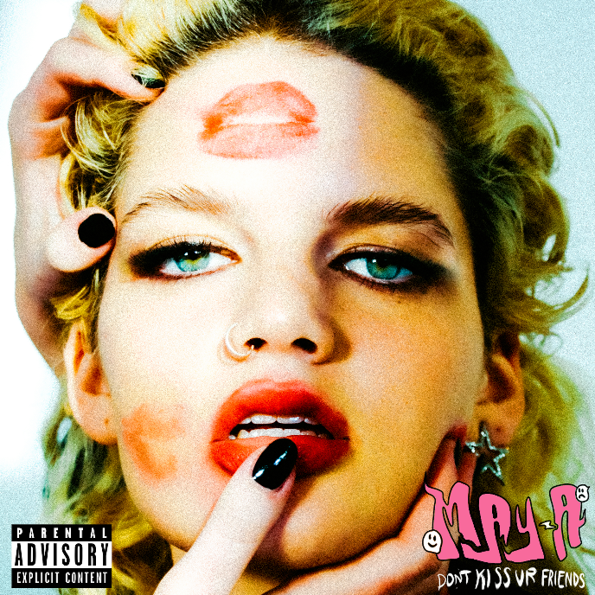
DOWNLOAD ARTWORK HERE
TRACKLIST
Amiinmyhead
Swing Of Things
Central Station
Daffodils
Time I Love To Waste
Apricots
Swing Of Things ft. Powfu
Stay connected with MAY-A:
Instagram | Facebook | Youtube | TikTok

For more information, please contact:
Kelly McWilliam // Kelly.McWilliam@atlanticrecords.com
WATCH NEW VIDEO FOR "CENTRAL STATION"

