NYC collective MICHELLE release “FYO”

PREMIERED GLOBALLY VIA THE MATT WILKINSON SHOW ON APPLE MUSIC 1

WATCH SELF-DIRECTED OFFICIAL MUSIC VIDEO HERE
BUY/STREAM "FYO"

“…crisp R&B with a bright indie flourish… musical serotonin you’ll want to bathe in for hours…”
– The NME 100 “Essential Emerging Artists for 2021”

“the collective’s contagious charm and versatile creative approach is worth our attention”
– Pigeons & Planes “Best New Artists”

“…plush R&B pop that feels wholly indebted to the flexuous city that surrounds them…”
– The FADER

download hi-res press image

NYC collective MICHELLE has today unveiled their first new single of 2021. Titled “FYO,” the track powerfully recounts the four lead singers’ experiences growing up with mixed race identities. Globally premiered today via The Matt Wilkinson Show on Apple Music 1, the track arrives alongside a music video directed by the band’s own Layla Ku and Emma Lee – watch HERE.

Speaking on the message behind the song, Jamee Lockard from the band shares:

“FYO” is about belonging to different worlds but feeling rejected by both. Growing up as a mixed-race minority in the US, my self concept was warped by other people telling me what I am and am not, pushing and pulling me between identities. Although my feelings of cultural dissonance still ebb and flow, now I have the vocabulary, support system, and perspective to unpack that inner conflict on my own terms.

We should never give others the authority to define who we are.

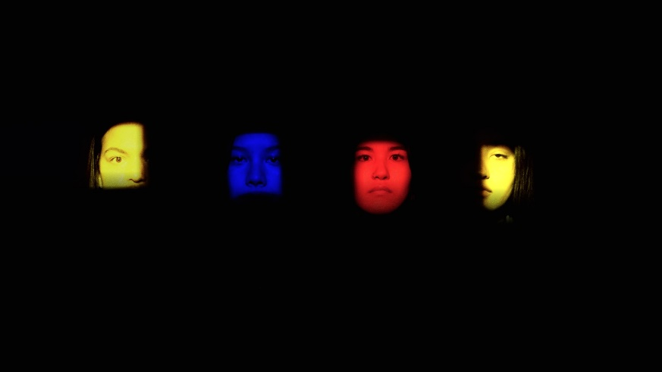
download still from “FYO” official video

Today’s release of “FYO” marks the first new single from the group since “UNBOUND,” released last October. That track debuted as Annie Mac’s Hottest Record in the World and was met with praise from editorial outlets including NYLON (“glittery, soulful track”) + Refinery29 (“‘UNBOUND’ wraps listeners in dreamy nostalgia”), among others.

The official video for “UNBOUND” was premiered via The FADER, who praised the band’s “plush R&B pop that feels wholly indebted to the flexuous city that surrounds them.” The official lyric video was created by UK-based animator Juliet Bryant – watch here – whose other recent credits include animating and directing the official video for The Japanese House x Justin Vernon collab “Dionne.”

MICHELLE was recently included in The NME 100 “ Essential emerging artists for 2021,” with the UK outlet praising the band’s “crisp R&B with a bright indie flourish… musical serotonin you’ll want to bathe in for hours.” The accolade comes on the heels of their single “SUNRISE” being named to Spotify’s Best Indie Songs of 2020.

Earlier this month, the band’s remix of Samia’s “Minnesota” was released via her The Baby Reimagined project. Featuring a new original verse and reworked production, the track sits alongside other covers and reworked tracks from Briston Maroney, Bartees Strange, Anjimile, and more.

In November 2020, MICHELLE performed live from New York mainstay LPR as part of the venue’s LPR.tv series, which also featured Overcoats, Samia, Oso Oso, and more. The group also recently performed for High Snobiety’s JazzTV, presented in partnership with the Newport Jazz Festival. Watch their performance of “KIP” here.

In August 2020, the band was named to Pigeons & Planes Best New Artists, with the outlet declaring: “With its forward-thinking production and alchemization of genres—from synth-pop melding to R&B—there’s an undeniable allure to the group… The collective’s contagious charm and versatile creative approach is worth our attention.”

MICHELLE’s debut single of 2020 – “SUNRISE” – was released in July to praise from V Magazine, NME, Dork, The Line of Best Fit and more. The track marked the first new single from the collective since their self-released 2018 debut album HEATWAVE.

A streets-and-skylines homage to their hometown, HEATWAVE was created in just 2 weeks - seamlessly weaving together R&B-inflected pop, sleek synths, plush harmonies, and buoyant groove. Heralded by stand-out track “THE BOTTOM,” the album amassed millions of streams, led to shows for sold-out NYC crowds, and earned critical acclaim from The Fader, NME and more.

Born-and-bred New Yorkers, MICHELLE is refreshingly comprised of predominately POC + queer members. The collective references equally diverse influences — Noname, Led Zeppelin, Sly and the Family Stone, Orion Sun, My Chemical Romance, SZA — all of which distill to create a cohesively diverse sound.

The group's unique stylings are the result of songwriting from Sofia D’Angelo, Julian Kaufman, Charlie Kilgore, Layla Ku, Emma Lee and Jamee Lockard with production from Kaufman and Kilgore.

Website | YouTube | Instagram | Twitter| Facebook

