NEW YORK-BASED COLLECTIVE MICHELLE RELEASE “SUNRISE”

TRACK MARKS FIRST NEW SINGLE SINCE SELF-RELEASED
2018 DEBUT LP HEATWAVE

“SUNRISE” ARRIVES ALONGSIDE OFFICIAL MUSIC VIDEO

WATCH: https://michelle.lnk.to/SUNRISEPR/youtube
BUY/STREAM “SUNRISE”: https://Michelle.lnk.to/SUNRISEPR

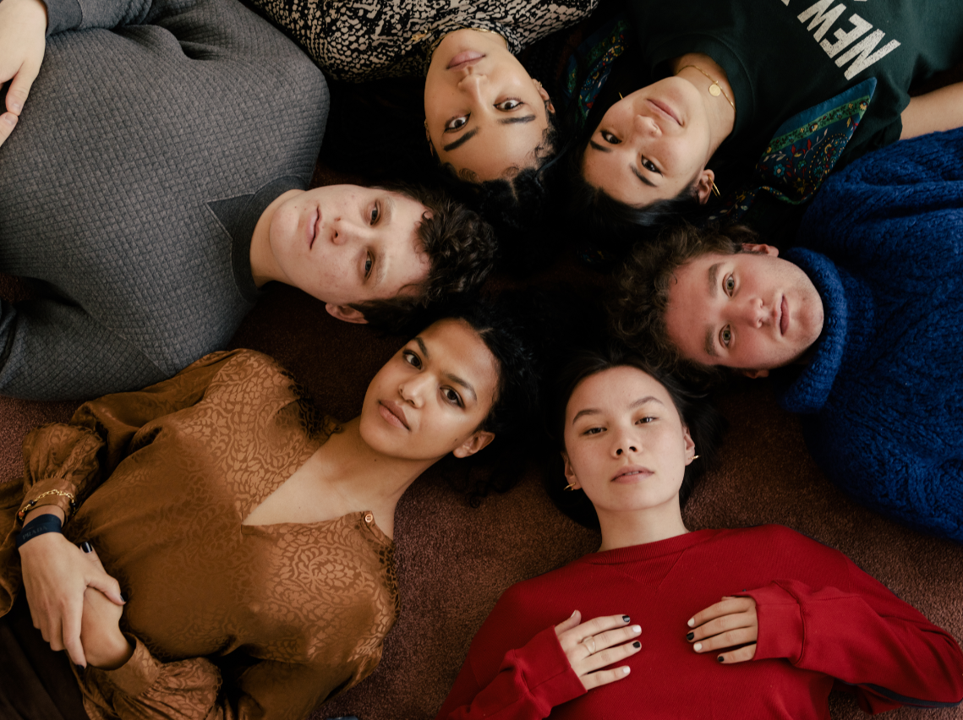
download hi-res press image; credit Daniel Dorsa

“A formidable new collective with a genre-bending approach to songwriting” – The Line of Best Fit

“A groovy pop smasher with that fearless NYC mentality. What a band.” – NME

“a new, NYC-based musical collective… who make pop music so catchy that they've been picked up by Canvasback Music with one breezy LP behind them.” – The FADER

Canvasback Music/Atlantic Records artists MICHELLE today announce the release of “SUNRISE,” a shimmering pop track with an indelible hook. The song marks the first new single from the NYC-based collective since their self-released 2018 debut album HEATWAVE, and their first original release with Canvasback (Transgressive Records in the UK).

“SUNRISE” arrives alongside an official music video, animated by New York artist Kohana Wilson – watch here – with the single’s artwork created by fellow NYC creative Niko Chang.

Of the track, the band shares: “SUNRISE holds some kind of a summer air, but more so a longing for someone who could never really show up. A sentiment as sticky, sweaty, and fleeting as summer. Sunrise is as bittersweet as it is groovy. We’re grateful that the first song we’re releasing since HEATWAVE gets to be on we've held on to, sang, rewritten, and lived with for so long.”

Today’s new music comes on the heels of recent video releases from the six-piece – including a pair of performance videos for HEATWAVE track “THE BOTTOM,” recorded during a show at The Dance + live from Atlantic Records Studio in New York.

In May, “THE BOTTOM” received the remix treatment from Rosa Walton of UK act Let’s Eat Grandma (listen), as well as a cover from Transgressive Records labelmate Arlo Parks (watch). Earlier this year, MICHELLE released a cover of their own, by way of a rendition of Roberta Flack’s “Killing Me Softly” (watch).

This spring, the group was featured in The FADER’s Digital SXSW Fort, creating a deconstructed version of “STUCK ON U,” also off their 2018 LP (watch here). In May, the band recorded a ‘quarantine version’ of their song “MANGO,” raising money for No Kid Hungry (watch here).

The group’s debut album HEATWAVE – a streets-and-skylines homage to their hometown – was created in just 2 weeks and self-released in 2018, seamlessly weaving together R&B-inflected pop, sleek synths, plush harmonies, and buoyant groove. Heralded by stand-out track “THE BOTTOM,” HEATWAVE amassed millions of streams, led to shows for sold-out NYC crowds at Baby’s All Right and Webster Hall, and has earned critical acclaim from The Fader, NME and more, as well as airplay from BBC Radio 1 and 6 Music.

Born-and-bred New Yorkers, MICHELLE is refreshingly comprised of predominately POC + queer members. The collective references equally diverse influences — Noname, Led Zeppelin, Sly and the Family Stone, Orion Sun, My Chemical Romance, SZA — all of which distill to create a cohesively diverse sound.

The group's unique stylings are the result of songwriting from Sofia D’Angelo, Julian Kaufman, Charlie Kilgore, Layla Ku, Emma Lee and Jamee Lockard with production from Kaufman and Kilgore.

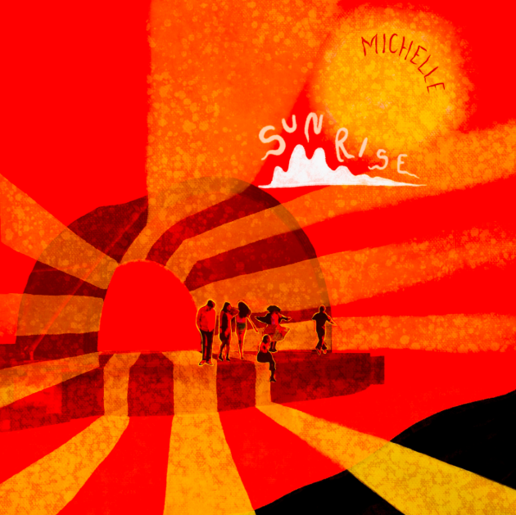
download hi-res single art here

###

Connect with MICHELLE:
Website | YouTube | Instagram | Twitter| Facebook

Press Assets:
https://press.atlanticrecords.com/MICHELLE

Press Contact:
Libby Kober | Atlantic Records
Libby.Kober@atlanticrecords.com

