NEW YORK-BASED COLLECTIVE MICHELLE RELEASE NEW MUSIC VIDEO FOR “SUNRISE”

NEW VISUAL FEATURES ALL SIX MEMBERS FILMED REMOTELY

WATCH: https://Michelle.lnk.to/SUNRISEQuarVidPR
BUY/STREAM “SUNRISE”: https://Michelle.lnk.to/SUNRISEPR

“The six-member collective is riding at the forefront of New York’s energetic music scene… multi-talented singers, songwriters and musicians blend a vast range of genres to deliver a fresh sound” – V Magazine

“A new, NYC-based musical collective… who make pop music so catchy that they've been picked up by Canvasback Music with one breezy LP behind them.” – The FADER

“They have something really special… their blend of R&B and retro synth-pop is warm, intimate and danceable all at once” – Dork

“Sent down from the heavens is MICHELLE’s latest summer track ‘SUNRISE’… wavy, smooth, vibrant, and the ultimate feel-good song.” – LADYGUNN

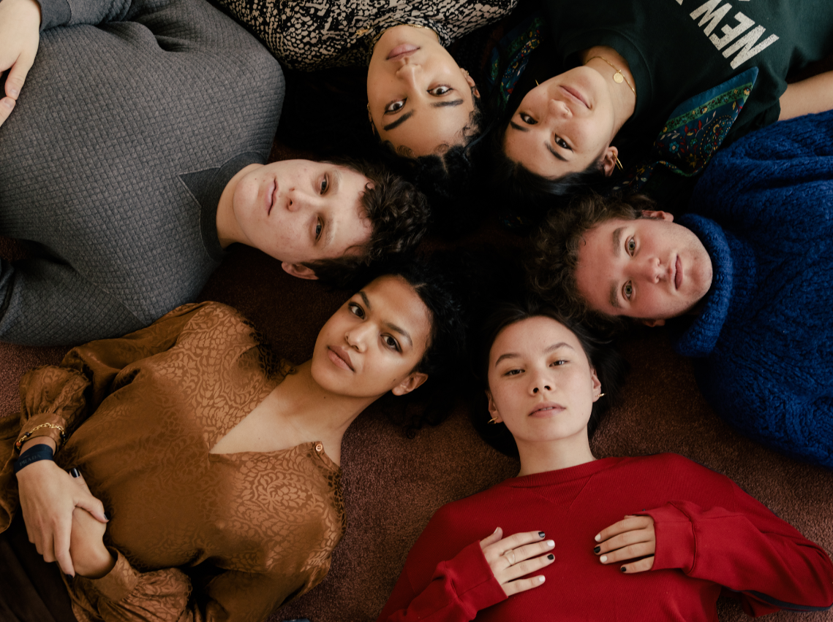
download hi-res press image; credit Daniel Dorsa

Canvasback Music/Atlantic Records artists MICHELLE have released a new video for “SUNRISE” – watch here – featuring all six members of the NYC-based collective. The video is highlighted alongside a LADYGUNN feature with the band out today, with the magazine noting: “Sent down from the heavens is MICHELLE’s latest summer track ‘SUNRISE’… wavy, smooth, vibrant, and the ultimate feel-good song.”

Originally released last month, “SUNRISE” was met with praise from V Magazine, NME, Dork, and more. Uproxx highlighted the track in their “Best New Indie Music of the Week,” declaring “One of the more exciting tracks I’ve heard in a long time, ‘Sunrise’ combines elements of indie pop, funk, and R&B to create something truly unique and modern.”

The song is currently featured on a number of tastemaker playlists across streaming platforms – including Spotify’s POLLEN and Lorem and Apple Music’s INDIY and ALT-R&B. “SUNRISE” has also received support from Sirius XM and BBC Radio 1, with Annie Mac exclaiming: “Everything they do is written so well. The songs are so hooky!”

“SUNRISE” marks the first new single from the NYC-based collective since their self-released 2018 debut album HEATWAVE, and their first original release with Canvasback (Transgressive Records in the UK).

HEATWAVE – a streets-and-skylines homage to their hometown – was created in just 2 weeks and self-released in 2018, seamlessly weaving together R&B-inflected pop, sleek synths, plush harmonies, and buoyant groove. Heralded by stand-out track “THE BOTTOM,” the album amassed millions of streams, led to shows for sold-out NYC crowds at Baby’s All Right and Webster Hall, and earned critical acclaim from The Fader, NME and more, as well as airplay from BBC Radio 1 and 6 Music.

Born-and-bred New Yorkers, MICHELLE is refreshingly comprised of predominately POC + queer members. The collective references equally diverse influences — Noname, Led Zeppelin, Sly and the Family Stone, Orion Sun, My Chemical Romance, SZA — all of which distill to create a cohesively diverse sound.

The group's unique stylings are the result of songwriting from Sofia D’Angelo, Julian Kaufman, Charlie Kilgore, Layla Ku, Emma Lee and Jamee Lockard with production from Kaufman and Kilgore.

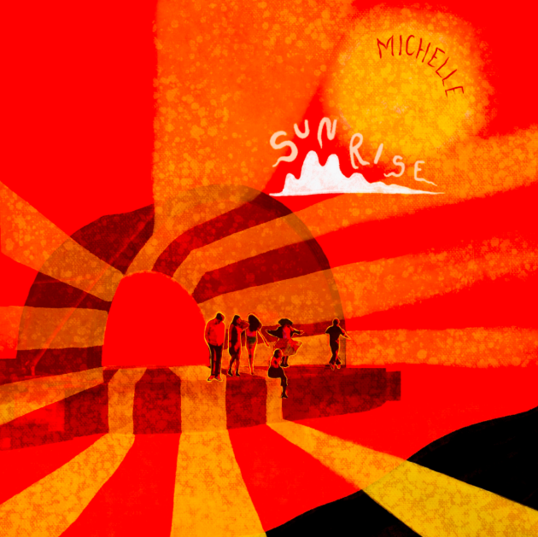
single art created by NYC artist Niko Chang | download hi-res here

###

Connect with MICHELLE:
Website | YouTube | Instagram | Twitter| Facebook

Press Assets:
https://press.atlanticrecords.com/MICHELLE

Press Contact:
Libby Kober | Atlantic Records
Libby.Kober@atlanticrecords.com

