NYC collective MICHELLE unveil 3 new original videos + announce LPR livestream show set for 11/29

**videos include Juliet Bryant-animated video for “UNBOUND,”
Bruno Mars cover + behind-the-scenes footage from recent video shoot**

WATCH “UNBOUND” LYRIC VIDEO: HERE
WATCH “TALKING TO THE MOON” (BRUNO MARS COVER): HERE
WATCH “UNBOUND” BTS VIDEO: HERE

“…plush R&B pop that feels wholly indebted to the flexuous city that surrounds them…”
– The FADER

“the collective’s contagious charm and versatile creative approach is worth our attention”
– Pigeons & Planes “Best New Artists”

“This glittery, soulful track courtesy of sextet MICHELLE gives major '00s vibes.”
– NYLON

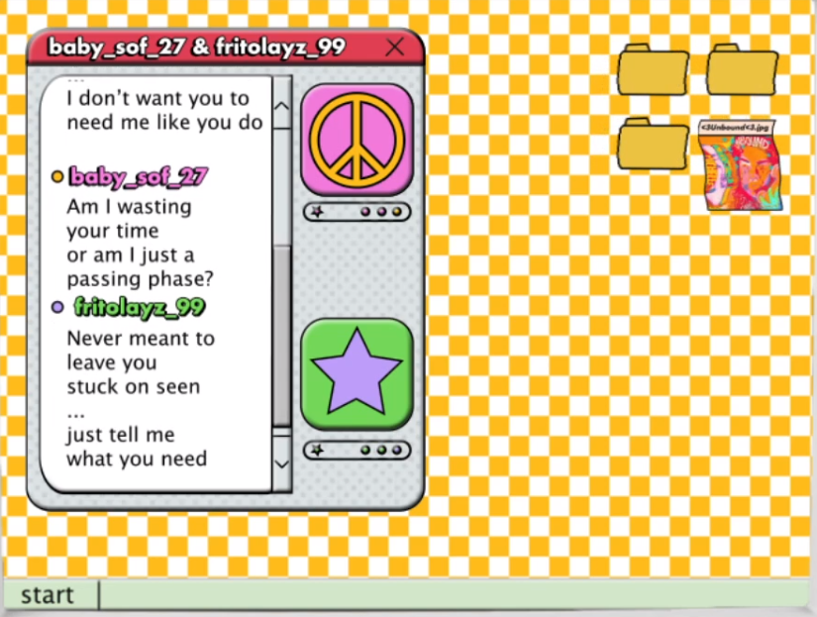

NYC collective MICHELLE has released a number of new videos over the last week, culminating with today’s release of the official lyric video for current single “UNBOUND,” created by UK-based animator Juliet Bryant – watch here. Featuring lyrics that scroll as AIM’s, the video is a welcome bit of nostalgia for any child of the 90’s or early ‘00s. Bryant’s recent credits include animating and directing the official video for The Japanese House x Justin Vernon collab “Dionne.”

Last week, the group released a cover of Bruno Mars’ “Talking To The Moon” – watch here. The performance video was released as part of an Atlantic Records initiative commemorating the 10th anniversary of Mars’ debut album ‘Doo-Wops & Hooligans.’

The group also recently released a behind-the-scenes look into the filming of the official music video for “UNBOUND” – watch here. Directed by Madeleine Leshner and shot across New York, the original visual premiered via The FADER, with the outlet praising the band’s “plush R&B pop that feels wholly indebted to the flexuous city that surrounds them.”

“UNBOUND” debuted last month as Annie Mac’s Hottest Record in the World on BBC Radio 1 and was met with praise from editorial outlets including NYLON (“glittery, soulful track”) and Refinery29 (“‘UNBOUND’ wraps listeners in dreamy nostalgia”), among others.

On November 29, MICHELLE will perform live from New York mainstay LPR as part of the venue’s LPR.tv series. Other artists participating in the series include Overcoats, Samia, and Oso Oso. Tickets + additional info are available here.

The band recently participated in High Snobiety’s JazzTV, an initiative presented in partnership with the Newport Jazz Festival. Watch their performance of “KIP” here.

In August, the band was named to Pigeons & Planes “Best New Artists,” with the outlet heralding: “With its forward-thinking production and alchemization of genres—from synth-pop melding to R&B—there’s an undeniable allure to the group. Encapsulating the diverse experience of a New York upbringing and its dynamic music scene, each member adds something distinctive to the project… the collective’s contagious charm and versatile creative approach is worth our attention.”

“UNBOUND” was the second single to be released by the band this year and follows “SUNRISE,” released in July to praise from V Magazine, NME, Dork, The Line of Best Fit and more.

SUNRISE marked the first new single from the NYC-based collective since their self-released 2018 debut album HEATWAVE. That album – a streets-and-skylines homage to their hometown – was created in just 2 weeks and self-released in 2018, seamlessly weaving together R&B-inflected pop, sleek synths, plush harmonies, and buoyant groove. Heralded by stand-out track “THE BOTTOM,” HEATWAVE amassed millions of streams, led to shows for sold-out NYC crowds at Baby’s All Right and Webster Hall, and earned critical acclaim from The Fader, NME and more, as well as airplay from BBC Radio 1 and 6 Music.

Born-and-bred New Yorkers, MICHELLE is refreshingly comprised of predominately POC + queer members. The collective references equally diverse influences — Noname, Led Zeppelin, Sly and the Family Stone, Orion Sun, My Chemical Romance, SZA — all of which distill to create a cohesively diverse sound.

The group's unique stylings are the result of songwriting from Sofia D’Angelo, Julian Kaufman, Charlie Kilgore, Layla Ku, Emma Lee and Jamee Lockard with production from Kaufman and Kilgore.

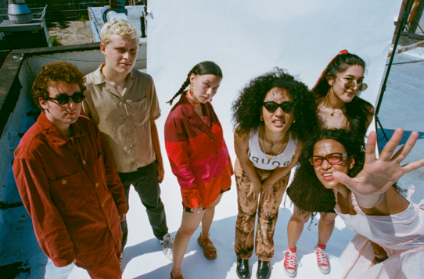
download hi-res press image
Website | YouTube | Instagram | Twitter| Facebook

