NEW YORK-BASED COLLECTIVE MICHELLE RELEASE ARLO PARKS’ REWORK OF ‘SUNRISE’

LISTEN TO “SUNRISE (FEAT. ARLO PARKS)”
HERE

BUY/STREAM “SUNRISE”

“A groovy pop smasher with that fearless NYC mentality. What a band.” – NME

“A new, NYC-based musical collective… who make pop music so catchy that they've been picked up by Canvasback Music with one breezy LP behind them.” – The FADER

“The six-member collective is riding at the forefront of New York’s energetic music scene… multi-talented singers, songwriters and musicians blend a vast range of genres to deliver a fresh sound” – V Magazine

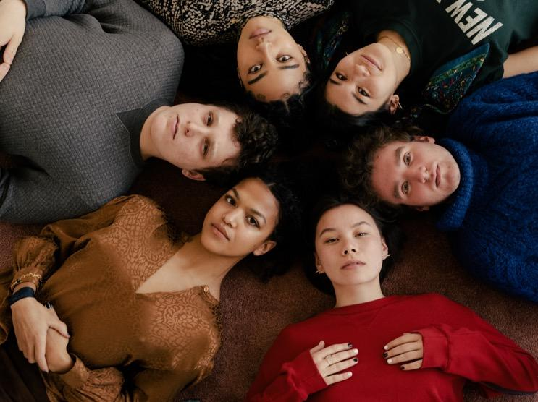
download hi-res press image; credit Daniel Dorsa

MICHELLE are excited to release a new version of their single “SUNRISE,” featuring the mesmerizing vocals of British poet and singer Arlo Parks. Listen here.

SUNRISE, released in July, marked the first new single from the NYC-based collective since their self-released 2018 debut album HEATWAVE, and their first original release with Canvasback/Transgressive. It was met with praise from V Magazine, NME, Dork, and more. Uproxx highlighted the track in their “Best New Indie Music of the Week,” declaring “One of the more exciting tracks I’ve heard in a long time, ‘SUNRISE’ combines elements of indie pop, funk, and R&B to create something truly unique and modern.”

The band had to say on today’s new track:

“Our good friend Arlo Parks hopped on our newest version of SUNRISE. What a pleasure it is to hear new voices reimagine a tune we’ve held so close. Her soothing voice and stunning lyricism is everything we could’ve asked for”

Arlo Parks says of SUNRISE:

“There‘s such a warmth and an energy to this track and MICHELLE are such a talented, genuine bunch - I feel so honoured to be a part of it”

SUNRISE followed on the heels of a pair of performance videos for HEATWAVE track “THE BOTTOM,” recorded during a show at The Dance + live from Atlantic Records Studio in New York and released in April this year.

This spring, the group was featured in The FADER’s Digital SXSW Fort, creating a deconstructed version of “STUCK ON U,” also off their 2018 LP (watch here). In May, the band recorded a ‘quarantine version’ of their song “MANGO,” raising money for No Kid Hungry (watch here).

MICHELLE’s debut album HEATWAVE – a streets-and-skylines homage to their hometown – was created in just 2 weeks and self-released in 2018, seamlessly weaving together R&B-inflected pop, sleek synths, plush harmonies, and buoyant groove. Heralded by stand-out track “THE BOTTOM,” HEATWAVE amassed millions of streams, led to shows for sold-out NYC crowds at Baby’s All Right and Webster Hall, and has earned critical acclaim from The Fader, NME and more, as well as airplay from BBC Radio 1 and 6 Music.

Born-and-bred New Yorkers, MICHELLE is refreshingly comprised of predominately POC + queer members. The collective references equally diverse influences — Noname, Led Zeppelin, Sly and the Family Stone, Orion Sun, My Chemical Romance, SZA — all of which distill to create a cohesively diverse sound.

The group's unique stylings are the result of songwriting from Sofia D’Angelo, Julian Kaufman, Charlie Kilgore, Layla Ku, Emma Lee and Jamee Lockard with production from Kaufman and Kilgore.

Website | YouTube | Instagram | Twitter| Facebook

