RISING NASHVILLE SONGWRITER MUNN RELEASES A REIMAGINED VERSION OF HIT SINGLE “I LOST MYSELF” AS A DUET WITH ANNA CLENDENING

LISTEN HERE: https://munn.lnk.to/ILostMyselfACPR

OUT TODAY VIA ATLANTIC RECORDS

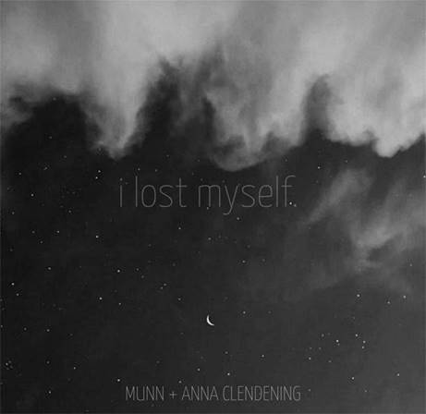

Nashville’s always been a town known for its rich history of songwriting and musicianship but it was blindsided by the recent arrival of MUNN, a native Midwest singer/songwriter with a heartbreakingly beautiful voice, and musicianship to match. After catching the attention of Atlantic Records thanks to the original self-release of his delicate 2019 single “I Lost Myself”, MUNN has teamed up on a reimagined duet of “I Lost Myself” with Anna Clendening, an acclaimed rising singer-songwriter and fellow Atlantic Records artist. It’s hard to imagine a more compelling version of “I Lost Myself” than MUNN’s original tearjerker, but the combined star power on this duet and its endearing lyric video is sure to pull at your heart strings - LISTEN HERE.

Born in rural Nebraska and raised in Indiana, MUNN first took a road trip to Nashville in 2019 to explore the area and wound up signing a lease on a house he couldn’t afford on the second day of the trip. After having his heart broken by his fiancé during his sophomore year of college, MUNN lost all interest in school, and struggled to figure out what was next. It was this emotional revelation that opened up his creative floodgates and led him to pen his debut single “I Tried.” He had finally found a way to heal, and, from then on, creating music was the only thing on his mind. After recognizing the potential of a song he’d had in the works, he diverted all of his attention to finishing it. That song became “I Lost Myself” and finally came out on September 6, 2019 -- over the course of the next seven months, MUNN kept releasing new songs every few weeks. During that time, “I Lost Myself” kept doubling in popularity month after month, at which point MUNN quickly realized that this was the direction his music needed to go.

Anna Clendening is a Chapel Hill-born, Los Angeles-based singer/songwriter on Atlantic Records who relates through unfiltered lyrics ripped right from her notebook, robust vocals quaking with emotion, and brutal honesty. These ingredients struck a chord with listeners everywhere when she released her RIAA-certified Gold single “Boys Like You” in 2017. 275 million-plus streams and views later, she quietly established an unbreakable connection with fans who feel like family. Acclaimed by Billboard, OnesToWatch, and more, her debut EP Waves generated over 150 million streams in under six months. Along the way, she joined gnash on the road and headlined her own Waves Tour. Simultaneously, she lent her voice to high-profile collaborations with Illenium [“Broken Ones”], Lost Kings [“Too Far Gone”], and Phantoms [“Say It”], to name a few. Signing to Atlantic Records, she dove into writing her 2020 EP, Evolve, which spawned the standout singles “Get Me” “Sorry That I Do That” & “Love Song,” in addition to demonstrating her personal growth since being diagnosed with borderline personality disorder.

With nearly 4.5m streams on Spotify alone and counting, the original version of “I Lost Myself” is a passionate song that anyone who’s ever suffered through heartbreak can empathize with. Now with the addition of Anna Clendening’s honeyed vocal harmonies that complement MUNN’s on the undeniable duet and the backing of Atlantic Records, it’s safe to say we’ll be hearing a lot more from MUNN in the near future.

CONNECT WITH MUNN:
Instagram | Facebook | Twitter | Spotify

CONNECT WITH ANNA CLENDENING:
Instagram | Facebook | Twitter | Spotify

PRESS ASSETS: https://press.atlanticrecords.com/munn/

FOR MORE INFORMATION:
Paige Rosoff – Big Beat Records
Paige.Rosoff@atlanticrecords.com

