**NIKO RUBIO DAZZLES WITH NEW SINGLE “ALL MINE”**

**RISING SINGER-SONGWRITER FRESH OFF TOUR SUPPORTING CHASE ATLANTIC UNVEILS ENTRANCING NEW VISUAL**

**DEBUT EP *WISH YOU WERE HERE* AVAILABLE NOW**

[**WATCH: “All Mine”**](https://nikorubio.lnk.to/AllMineVisual)

[**DOWNLOAD/STREAM: “All Mine”**](https://nikorubio.lnk.to/AllMine)

Directed by Austin Winchell | Creative direction by Lauren Dunn

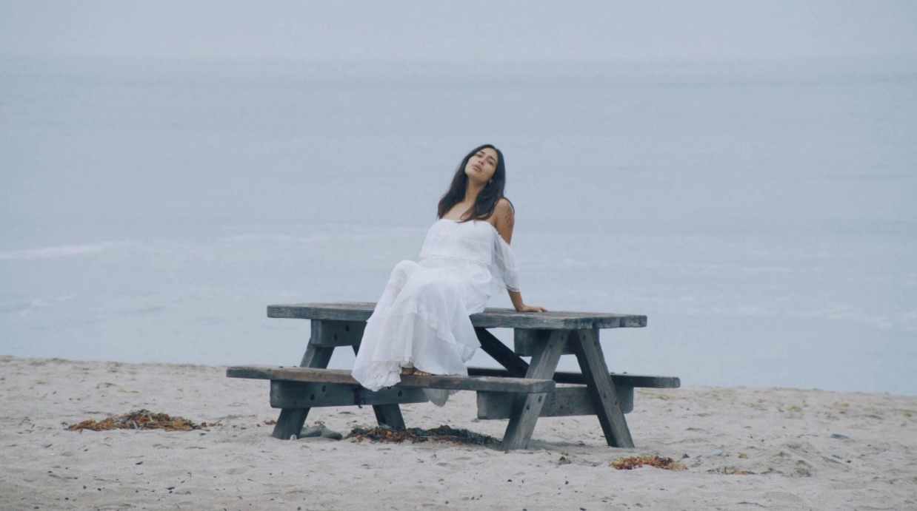

**New York, NY – October 29, 2021 –** Rising singer-songwriter and Southern California-native Niko Rubio has released an infectious new single titled **“All Mine”** – [LISTEN HERE](https://nikorubio.lnk.to/AllMine). Released today via Sandlot Records/Atlantic Records, the new song arrives alongside a mesmerizing visual by director **Austin Winchell** with creative direction from **Lauren Dunn** – [WATCH HERE](https://nikorubio.lnk.to/AllMineVisual).

*“’All mine’ is my cheesy love song. It’s just perfect for dancing with your lover in the living room or for a late-night drive with your hand on their thigh heheh. I wrote it in the heat of my wonderful relationship, and it brings me so much joy to share this beautiful story of shameless love to your ears.”*

**- NIKO RUBIO**



[DOWNLOAD HIGH-RES ARTWORK](https://press.atlanticrecords.com/niko-rubio/)

The new song from Niko arrives after the conclusion of her supporting leg of **Chase Atlantic**’s nationwide tour and follows her two stunning covers of **Paramore’s** [**“The Only Exception”**](https://www.youtube.com/watch?v=oielmd7QMpM)and **Ed Sheeran’s** [**“Lego House.”**](https://www.youtube.com/watch?v=MttgVLnxhds)

In addition to the covers, Niko celebrated the release of her debut EP, ***Wish You Were Here,*** in August which featured the standout singles [**“Bed,”**](https://www.youtube.com/watch?v=20SZ_bABSMA) [**“Saving Me”**](https://www.youtube.com/watch?v=faXfTsRh61s)and **“**[**You Could Be The One.”**](https://www.youtube.com/watch?v=bm337OC4Nc4)  ***Billboard*** praised the latter of the three as a, *“captivating showcase for the newcomer,”* adding that, *“the kicky pop-rock track allows Rubio’s tone to sink down low and soar skyward.”* ***PAPER*** also described Niko’s sound as *“…infused with waves of indie-rock and guitar riffs…in the most Californian style, of course.”*

Additionally, ***Latina Magazine*** commended Niko’s music as, *“the perfect soundtrack for riding in a seafoam-green convertible, top down, along the familiar Pacific Coast Highway,”* while also noting that, *“Rubio’s crisp vocals are like the breath of fresh air we all need after the past year-and-a-half…”*

[**DOWNLOAD/STREAM: *Wish You Were Here***](https://nikorubio.lnk.to/WishYouWereHere) **EP**



***Wish You Were Here* EP Tracklist:**

1. “You Could Be The One”

2. “Bed”

3. “Go With You”

5. “Saving Me”

5. “Amor”

6. “Can’t Pretend”

**ABOUT NIKO RUBIO:**

When creating her debut project, 20-year-old singer/songwriter Niko Rubio found a never-ending muse in the Pacific Coast Highway: the iconic stretch of road that runs along the ocean for nearly the entire length of California, including the Southern California South Bay area where she grew up. Expansive and euphoric, Niko’s radiant form of songwriting perfectly echoes the pure sense of possibility that accompanies driving down the PCH.  Drawing inspiration from the collage of artists she’s come to admire throughout her life including Vampire Weekend, Lana Del Rey, Erykah Badu & twenty one pilots, as well as the mariachi & banda music her grandparents played at home, Niko’s music is an amalgamation of these influences, but unique in its effervescent melodies and unpredictable textures. Using cinematically detailed references and her effortlessly untamed vocals, Niko is ready to take those who listen to her debut EP *Wish You Were Here* on a sonic road trip along the highway where it became a possibility.

**Press Contact:** Jason Davis – [jason.davis@atlanticrecords.com](mailto:jason.davis@atlanticrecords.com)

* * *

[**APPROVED PRESS IMAGES:**](https://press.atlanticrecords.com/niko-rubio/)

Photo Credit: Lauren Dunn

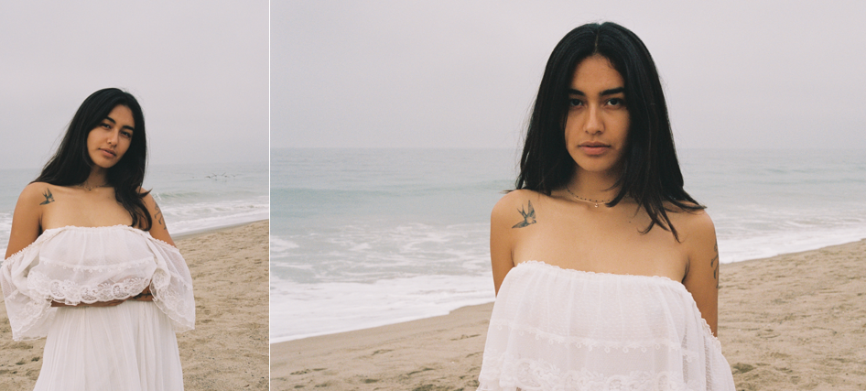

**CONNECT WITH NIKO RUBIO:**

[INSTAGRAM](https://nam04.safelinks.protection.outlook.com/?url=https%3A%2F%2Fwww.instagram.com%2Fholanikorubio%2F%3Fhl%3Den&data=04%7C01%7CBrian.Sommer%40atlanticrecords.com%7C01b069ddd36b42ab29e208d9454cbc69%7C8367939002ec4ba1ad3d69da3fdd637e%7C0%7C0%7C637617018138059847%7CUnknown%7CTWFpbGZsb3d8eyJWIjoiMC4wLjAwMDAiLCJQIjoiV2luMzIiLCJBTiI6Ik1haWwiLCJXVCI6Mn0%3D%7C1000&sdata=f1RsVe2lK7g65IeiZ9xUiusU67L1Ty1fxZlODSxsB1Q%3D&reserved=0) | [TWITTER](https://nam04.safelinks.protection.outlook.com/?url=https%3A%2F%2Ftwitter.com%2Fholanikorubio%3Flang%3Den&data=04%7C01%7CBrian.Sommer%40atlanticrecords.com%7C01b069ddd36b42ab29e208d9454cbc69%7C8367939002ec4ba1ad3d69da3fdd637e%7C0%7C0%7C637617018138059847%7CUnknown%7CTWFpbGZsb3d8eyJWIjoiMC4wLjAwMDAiLCJQIjoiV2luMzIiLCJBTiI6Ik1haWwiLCJXVCI6Mn0%3D%7C1000&sdata=X%2BQuOply%2Bj1r5%2BjC%2FPrOMoIklfG%2B%2B1wxcDIFHEB9MP4%3D&reserved=0) | [FACEBOOK](https://nam04.safelinks.protection.outlook.com/?url=https%3A%2F%2Fwww.facebook.com%2Fholanikorubio&data=04%7C01%7CBrian.Sommer%40atlanticrecords.com%7C01b069ddd36b42ab29e208d9454cbc69%7C8367939002ec4ba1ad3d69da3fdd637e%7C0%7C0%7C637617018138069838%7CUnknown%7CTWFpbGZsb3d8eyJWIjoiMC4wLjAwMDAiLCJQIjoiV2luMzIiLCJBTiI6Ik1haWwiLCJXVCI6Mn0%3D%7C1000&sdata=P9hbd0OXpyY6aVFaOar8OCRtRttGbpJbaehxQZT%2BsfY%3D&reserved=0) | [YOUTUBE](https://nam04.safelinks.protection.outlook.com/?url=https%3A%2F%2Fwww.youtube.com%2Fchannel%2FUCxKEF6kdZr_lysTAVBxboSA&data=04%7C01%7CBrian.Sommer%40atlanticrecords.com%7C01b069ddd36b42ab29e208d9454cbc69%7C8367939002ec4ba1ad3d69da3fdd637e%7C0%7C0%7C637617018138079838%7CUnknown%7CTWFpbGZsb3d8eyJWIjoiMC4wLjAwMDAiLCJQIjoiV2luMzIiLCJBTiI6Ik1haWwiLCJXVCI6Mn0%3D%7C1000&sdata=AhvtNipnFT7iMvwk7kWU5Xg3PxJ6%2B6alyR6UYWmBMmg%3D&reserved=0) | [PRESS SITE](https://nam04.safelinks.protection.outlook.com/?url=http%3A%2F%2Fpress.atlanticrecords.com%2Fniko-rubio%2F&data=04%7C01%7CBrian.Sommer%40atlanticrecords.com%7C01b069ddd36b42ab29e208d9454cbc69%7C8367939002ec4ba1ad3d69da3fdd637e%7C0%7C0%7C637617018138079838%7CUnknown%7CTWFpbGZsb3d8eyJWIjoiMC4wLjAwMDAiLCJQIjoiV2luMzIiLCJBTiI6Ik1haWwiLCJXVCI6Mn0%3D%7C1000&sdata=pG3Esc634Xf6Eyl%2FCmZTTrfc1Q19OMcq8ES78LNQ4FY%3D&reserved=0)

# # #