**NIKO RUBIO RELEASES DEBUT SINGLE “YOU COULD BE THE ONE”**

**BREEZY NEW SINGLE ARRIVES TODAY ALONGSIDE BEAUTIFUL LAUREN DUNN-DIRECTED VIDEO**

[**WATCH: “You Could Be The One” Official Music Video**](https://nam04.safelinks.protection.outlook.com/?url=https%3A%2F%2Fnikorubio.lnk.to%2FYCBTOVideo&data=04%7C01%7CBrian.Sommer%40atlanticrecords.com%7Cb5e204a71e174fe3478408d90b348927%7C8367939002ec4ba1ad3d69da3fdd637e%7C0%7C0%7C637553142535504890%7CUnknown%7CTWFpbGZsb3d8eyJWIjoiMC4wLjAwMDAiLCJQIjoiV2luMzIiLCJBTiI6Ik1haWwiLCJXVCI6Mn0%3D%7C1000&sdata=33WLNggK9eWWjMRmpeS06mYEdVCBITCeiaSQcLiZdRE%3D&reserved=0)

[**DOWNLOAD/STREAM: “You Could Be The One”**](https://nam04.safelinks.protection.outlook.com/?url=https%3A%2F%2Fnikorubio.lnk.to%2FYCBTO&data=04%7C01%7CBrian.Sommer%40atlanticrecords.com%7Cb5e204a71e174fe3478408d90b348927%7C8367939002ec4ba1ad3d69da3fdd637e%7C0%7C0%7C637553142535494896%7CUnknown%7CTWFpbGZsb3d8eyJWIjoiMC4wLjAwMDAiLCJQIjoiV2luMzIiLCJBTiI6Ik1haWwiLCJXVCI6Mn0%3D%7C1000&sdata=N1JBbZfb0cnzh3Rl95IOo4tzVsuLM43Ubv4qL86hO4M%3D&reserved=0)

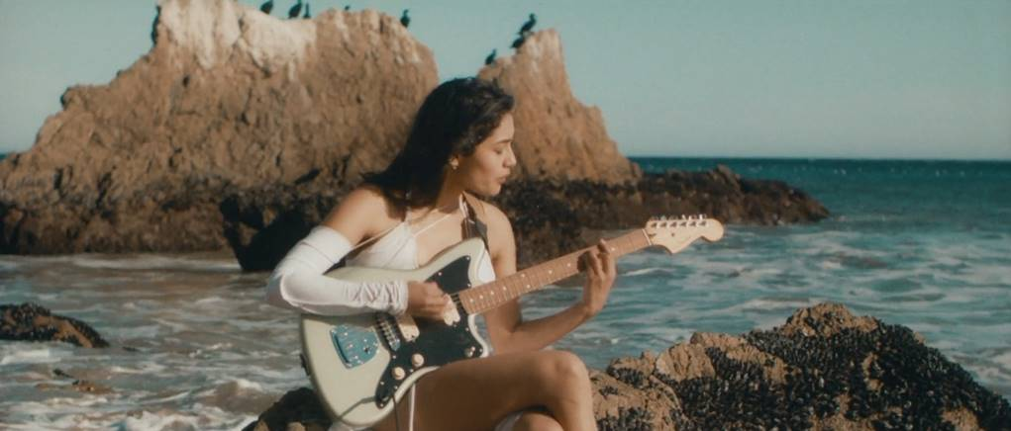

**New York, NY – April 30th, 2021 –** Hailing from the Southern California South Bay area, emerging singer/songwriter **Niko Rubio** displays her expressive writing style and captivating voice on her debut single, **“You Could Be The One,”** – [**LISTEN HERE**](https://nam04.safelinks.protection.outlook.com/?url=https%3A%2F%2Fnikorubio.lnk.to%2FYCBTO&data=04%7C01%7CBrian.Sommer%40atlanticrecords.com%7Cb5e204a71e174fe3478408d90b348927%7C8367939002ec4ba1ad3d69da3fdd637e%7C0%7C0%7C637553142535494896%7CUnknown%7CTWFpbGZsb3d8eyJWIjoiMC4wLjAwMDAiLCJQIjoiV2luMzIiLCJBTiI6Ik1haWwiLCJXVCI6Mn0%3D%7C1000&sdata=N1JBbZfb0cnzh3Rl95IOo4tzVsuLM43Ubv4qL86hO4M%3D&reserved=0). Arriving today alongside a gleaming visual directed by **Lauren Dunn** *(Kali Uchis, The Weeknd, LAUV, Becky G)*, **“You Could Be The One,”** crescendos into a shimmering chorus painted with pulsating guitars, groovy percussion and Rubio’s cascading vocals – [**WATCH HERE**](https://nam04.safelinks.protection.outlook.com/?url=https%3A%2F%2Fnikorubio.lnk.to%2FYCBTOVideo&data=04%7C01%7CBrian.Sommer%40atlanticrecords.com%7Cb5e204a71e174fe3478408d90b348927%7C8367939002ec4ba1ad3d69da3fdd637e%7C0%7C0%7C637553142535504890%7CUnknown%7CTWFpbGZsb3d8eyJWIjoiMC4wLjAwMDAiLCJQIjoiV2luMzIiLCJBTiI6Ik1haWwiLCJXVCI6Mn0%3D%7C1000&sdata=33WLNggK9eWWjMRmpeS06mYEdVCBITCeiaSQcLiZdRE%3D&reserved=0). “**You Could Be The One**” is the first song from Niko’s forthcoming debut EP, out this Summer.

[**DOWNLOAD/STREAM: “YOU COULD BE THE ONE”**](https://nam04.safelinks.protection.outlook.com/?url=https%3A%2F%2Fnikorubio.lnk.to%2FYCBTO&data=04%7C01%7CBrian.Sommer%40atlanticrecords.com%7Cb5e204a71e174fe3478408d90b348927%7C8367939002ec4ba1ad3d69da3fdd637e%7C0%7C0%7C637553142535494896%7CUnknown%7CTWFpbGZsb3d8eyJWIjoiMC4wLjAwMDAiLCJQIjoiV2luMzIiLCJBTiI6Ik1haWwiLCJXVCI6Mn0%3D%7C1000&sdata=N1JBbZfb0cnzh3Rl95IOo4tzVsuLM43Ubv4qL86hO4M%3D&reserved=0)

Written by Niko Rubio, Andy Seltzer & John DeBold; produced by Andy Seltzer; co-Produced by John DeBold

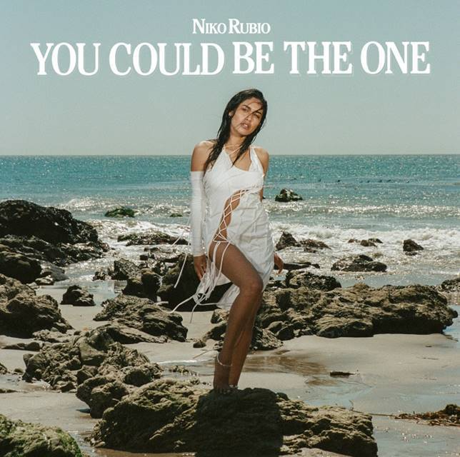

[DOWNLOAD ARTWORK HERE](http://press.atlanticrecords.com/niko-rubio/)

* * *

**ABOUT NIKO RUBIO:**

When creating her debut project, 20-year-old singer/songwriter Niko Rubio found a never-ending muse in the Pacific Coast Highway: the iconic stretch of road that runs along the ocean for nearly the entire length of California, including the Southern California South Bay area where she grew up. Expansive and euphoric, Niko’s radiant form of songwriting perfectly echoes the pure sense of possibility that accompanies driving down the PCH.  Drawing inspiration from the collage of artists she’s come to admire throughout her life including Vampire Weekend, Lana Del Rey, Erykah Badu & twenty one pilots, as well as the mariachi & banda music her grandparents played at home, Niko’s music is an amalgamation of these influences, but unique in its effervescent melodies and unpredictable textures. Using cinematically detailed references and her effortlessly untamed vocals, Niko is ready to take those who listen to her debut single, “You Could Be The One,” and forthcoming EP on a sonic road trip along the highway where they became a possibility.

**Press Contact:** Jason Davis – [jason.davis@atlanticrecords.com](mailto:jason.davis@atlanticrecords.com)

* * *

**APPROVED PRESS IMAGE:**

Photo Credit: Lauren Dunn

](https://nam04.safelinks.protection.outlook.com/?url=https%3A%2F%2Fwarnermusicgroup.box.com%2Fs%2Fs3u6nadey1ihikap100gr50kz0x8h60m&data=04%7C01%7CBrian.Sommer%40atlanticrecords.com%7Cb5e204a71e174fe3478408d90b348927%7C8367939002ec4ba1ad3d69da3fdd637e%7C0%7C0%7C637553142535504890%7CUnknown%7CTWFpbGZsb3d8eyJWIjoiMC4wLjAwMDAiLCJQIjoiV2luMzIiLCJBTiI6Ik1haWwiLCJXVCI6Mn0%3D%7C1000&sdata=PXw981qOxlzRXEoL8jQP0Sy1lD8nqWZEZKbym7G%2F5ys%3D&reserved=0)

**CONNECT WITH NIKO RUBIO:**

[INSTAGRAM](https://nam04.safelinks.protection.outlook.com/?url=https%3A%2F%2Fwww.instagram.com%2Fholanikorubio%2F%3Fhl%3Den&data=04%7C01%7CBrian.Sommer%40atlanticrecords.com%7Cb5e204a71e174fe3478408d90b348927%7C8367939002ec4ba1ad3d69da3fdd637e%7C0%7C0%7C637553142535514881%7CUnknown%7CTWFpbGZsb3d8eyJWIjoiMC4wLjAwMDAiLCJQIjoiV2luMzIiLCJBTiI6Ik1haWwiLCJXVCI6Mn0%3D%7C1000&sdata=PWqSDviKAz6aifGN5S8bvcledOMoXB3S30eqrUB9jVU%3D&reserved=0) | [FACEBOOK](https://nam04.safelinks.protection.outlook.com/?url=https%3A%2F%2Fwww.facebook.com%2Fholanikorubio&data=04%7C01%7CBrian.Sommer%40atlanticrecords.com%7Cb5e204a71e174fe3478408d90b348927%7C8367939002ec4ba1ad3d69da3fdd637e%7C0%7C0%7C637553142535524874%7CUnknown%7CTWFpbGZsb3d8eyJWIjoiMC4wLjAwMDAiLCJQIjoiV2luMzIiLCJBTiI6Ik1haWwiLCJXVCI6Mn0%3D%7C1000&sdata=LVAcBrqxxJjN56brgOZ3nwIa7i3V8Kxuz96B4spx7Uk%3D&reserved=0) | [YOUTUBE](https://nam04.safelinks.protection.outlook.com/?url=https%3A%2F%2Fwww.youtube.com%2Fchannel%2FUCxKEF6kdZr_lysTAVBxboSA&data=04%7C01%7CBrian.Sommer%40atlanticrecords.com%7Cb5e204a71e174fe3478408d90b348927%7C8367939002ec4ba1ad3d69da3fdd637e%7C0%7C0%7C637553142535534870%7CUnknown%7CTWFpbGZsb3d8eyJWIjoiMC4wLjAwMDAiLCJQIjoiV2luMzIiLCJBTiI6Ik1haWwiLCJXVCI6Mn0%3D%7C1000&sdata=oAHf1OgL0S43u0LuxVs5IqzTGPvMrnhHBqIKz6YGoSo%3D&reserved=0) | [PRESS SITE](http://press.atlanticrecords.com/niko-rubio/)

# # #