FOR IMMEDIATE RELEASE
FEBRUARY 2, 2022

ATLANTIC RECORDS INTRODUCES ITS NEWEST STARLET TAI’AYSHA

MULTI-TALENTED ARTIST UNVEILS DEBUT SINGLE + VIDEO
“ONE NIGHT TING (FT. SAWEETIE)”

WATCH “ONE NIGHT TING” HERE | STREAM HERE

NEW “TAI’AYSHA: DAY IN THE LIFE OF ME” VLOG OUT NOW
WATCH VLOG HERE

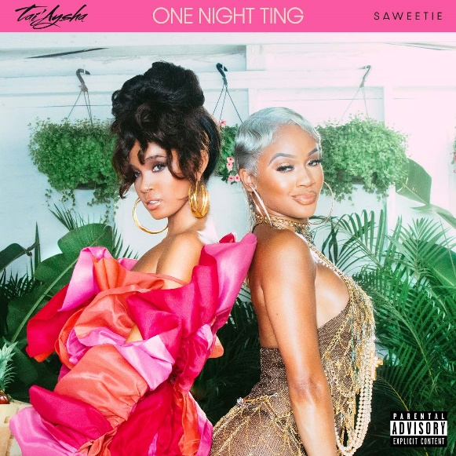
Download Cover Artwork
Courtesy of Atlantic Records

Atlantic Records, in partnership with Icon Music Group, is pleased to introduce Dominican-Cambodian singer, songwriter, and dancer Tai’Aysha as one of the newest multitalented artists to its history-making roster. The Boston-born, Miami-based starlet is celebrating with today’s video premiere of her infectious debut single, “One Night Ting (ft. Saweetie),” and is available now via Icon Music Group / Atlantic Records. Read the People.com exclusive story HERE.

“One Night Ting”, co-written by and co-produced by GRAMMY® Award-winner Stephen “Di Genius” McGregor [Drake, Burna Boy, John Legend], alongside hit-making duo, Money Well Spent—comprised of Verse Simmonds [Chris Brown, Kelly Rowland, Justin Bieber] & Akil “Fresh” King [Brandy, Beyoncé, Teyana Taylor]—features a scorching verse from multi-platinum artist/entrepreneur Saweetie and was born to light up dancefloors in a massive way. It’s an ideal embodiment of Tai’Aysha’s effortless confidence and sensuality. The track, which interpolates a sample of Shabba Ranks’ 1992 dancehall classic, “Ting A Ling”, is joined by an equally hot music visual, directed by Cameron Dean. Watch it HERE.

“It’s about cutting loose, letting go, and throwing yourself into the night,” Tai’Aysha reveals. “…but I’ve never actually had a one-night stand. I’ve tried, but they come to my house the next day or send me flowers.”

"Had hella fun making this record and we really tried to capture that feeling in the video,” says Saweetie. “Tai’Aysha’s fly so it was only right we link up on a song."

A free spirit in the truest sense, Tai’Aysha radiates confidence, speaks without filter, and might just brighten your day. See her bright personality shine through in her newly-released VLOG, “Tai’Aysha: A Day in the Life of Me”. Her music moves through R&B, pop, bachata, merengue, reggae, and hip-hop moods with a nimble and natural elasticity tailormade for the dancefloor. The Boston-born and Miami-based Dominican-Cambodian beauty started dancing almost as soon as she could walk. Growing up, she lit up every room she walked into and started modeling post-high school. In between a day job at a flower shop, her dance videos gained traction as she built an audience of hundreds of thousands on Instagram and local buzz from her home city. Seeing the bubbling local excitement around Tai’Aysha, Icon Music Group founder Steve Morales [Enrique Iglesias, Céline Dion, Beyoncé] felt prompted to reach out. He recognized her talent as a dancer and believed it indicated a certain “tone” as a vocalist. Turns out, he was very right. After one Miami session, he signed her to Icon Music Group and recorded with her at a prolific pace. Within a year, she inked a deal with Atlantic Records. Inspired by Lauryn Hill, Rihanna, and Sade, Tai’Aysha has cultivated a simmering, seductive, and scorching signature style of her own.

“My music should make you feel fun, excited, and sexy,” Tai’Aysha says. “When you listen to me, I hope you’re like, ‘I want to be her friend.’ I’m here for you to know you’re confident, cool, and sexy. That’s it.”

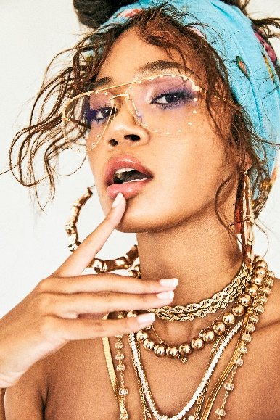
Download hi-res press photo(s), Credit: Jimmy Fontaine

CONNECT WITH TAI’AYSHA
INSTAGRAM | TWITTER | YOUTUBE

PRESS CONTACT
Fairley McCaskill | Fairley.McCaskill@atlanticrecords.com

