FOR IMMEDIATE RELEASE
APRIL 22, 2022

SARA KAYS USES “MATH” EVERY DAY OF HER LIFE

ACCLAIMED SINGER-SONGWRITER SHARES VULNERABLE NEW SINGLE

BIGGEST NORTH AMERICAN HEADLINE TOUR TO DATE BEGINS MAY 31 IN PHILADELPHIA

SPRING TOUR SUPPORTING ALEC BENJAMIN UNDERWAY NOW

LISTEN TO “MATH”

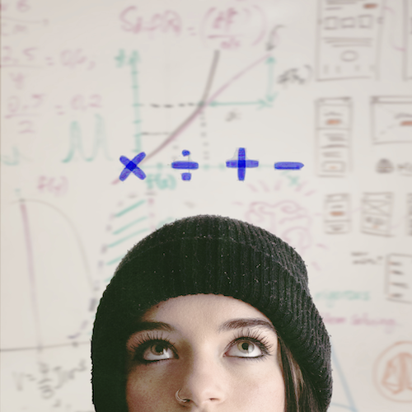
DOWNLOAD HIGH-RES ART + PRESS PHOTOS (CREDIT: CHASE DENTION)

RIAA gold-certified singer-songwriter Sara Kays has shared her vulnerable new single “Math” available now via Atlantic Records at all DSPs and streaming services.

“‘Math’ is about the way I see and use numbers in my life related to body image,” Kays says. “I hated math in school and I still hate it now.”

“Math” follows the release of “When You Look At Me” which Cosmopolitan named as one of “11 Sad Songs From 2022 That’ll Legit Have You Weeping,” writing, “Is there anything more heartbreaking than realizing the person you love no longer feels the same way? Probably not, tbh (but fret not—Sara Kays feels your pain).” The acclaimed Nashville-based musician first shared an early demo of “When You Look At Me” on her hugely popular TikTok and almost immediately earned more than 1.7M views and close to 500K likes. In trademark fashion, Sara was inspired by the response and quickly hit the studio to record an official version of the song.

Currently on tour alongside one of her favorite artists, Alec Benjamin, Kays will next embark on her biggest North American headline tour to date, getting underway May 31st at Philadelphia, PA’s The Lounge at World Café Live and then traveling through a much-anticipated hometown finale at Nashville, TN’s iconic The Basement East on June 28th. Highlights include shows at such legendary venues as NYC’s Bowery Ballroom (June 1st) and LA’s famous Troubadour (June 22nd). For complete details and ticket information, please visit www.sarakays.com/tour.

2021 proved a landmark year for Kays, with multiple highlights including her first-ever headline tour, international performances supporting Cavetown in the UK, and her late night TV debut performance of the RIAA gold-certified breakthrough hit, “Remember That Night?” on The Late Show with Stephen Colbert (streaming HERE).

Having cultivated an intensely engaged and supportive audience on TikTok nearing 2M followers, Sara is disarmingly raw about everything from body image to mental health as proven on her 2021 Struck By Lightning EP. Observations, thoughts, and truths straight from the Notes app on her phone inform diary-style stories spotlighted by gentle acoustic guitar, soft ukulele, and a keyboard murmur. Profiled for Billboard’s “Emerging Artists Spotlight” and named among People’s “Talented Emerging Artists Making Their Mark on the Musical Landscape,” the Indiana-born artist teased the EP’s arrival with “Backseat Rider,” “Traffic Lights,” “Future Kids,” and “Picture Of You.” In addition to her collaboration with Cavetown on the title track, which arrived alongside a music video co-starring both artists (watch HERE), the EP features the bitterly honest “Freeze” and is highlighted by her viral breakup anthem, “Remember That Night?” joined by an official video now approaching 12.5M views via YouTube HERE.

WHAT CRITICS ARE SAYING ABOUT SARA:

“Sara Kays’ music has something to offer for everyone.” – PEOPLE

“Sara Kays knows what it takes to craft heartfelt lyrics spun with velvet, tight-knit arrangements that simply elevate the already high-flying material.” – AMERICAN SONGWRITER

“Normalizing life’s struggles that often seem easier to avoid, Sara has carved out a unique space…quickly creating a community through her message.” – FLAUNT

“Sara Kays has cultivated a devoted following by wearing her heart on her sleeve. The rapidly rising artist's growing fanbase is a testament to her understated gift for empathetic songwriting.” – ONES TO WATCH

“One Of Pop Music’s Breakout Stars” – HUFFPOST

SARA KAYS ON TOUR 2022

APRIL
26 – Albuquerque, NM – El Rey Theater *
28 – Oklahoma City, OK – Diamond Ballroom *
29 – Kansas City, MO – The Truman *
30 – St. Louis, MO – The Pageant *

MAY
1 – Omaha, NE – The Admiral *
3 – Madison, WI – The Sylvee *
4 – Indianapolis, IN – Egyptian Room @ Old National Centre *
5 – Cincinnati, OH – Bogart’s *
6 – Grand Rapids, MI – GLC Live at 20 Monroe *
9 – Columbus, OH – KEMBA LIVE! *
10 – Pittsburgh, PA – Roxian Theatre *
11 – Buffalo, NY – Town Ballroom *
13 – South Burlington, VT – Higher Ground Ballroom *
14 – Providence, RI – The Strand *
15 – Portland, ME – State Theatre *
31 – Philadelphia, PA – The Lounge at World Café Live

JUNE
1 – New York, NY – Bowery Ballroom
3 – Washington, DC – Songbyrd
4 – Cambridge, MA – The Sinclair
5 – Montreal, QC – Bar Le Ritz PDB
7 – Toronto, ON – Velvet Underground
8 – Detroit, MI – The Shelter
10 – Chicago, IL – Lincoln Hall
12 – Minneapolis, MN – 7th Street Entry
14 – Denver, CO – Larimer Lounge
15 – Salt Lake City, UT – Kilby Court Gallery
17 – Vancouver, BC – The Fox Cabaret Projection Room
18 – Seattle, WA – Barboza
19 – Portland, OR – McMenamins’ Mission Theater
21 – Oakland, CA – The New Parish
22 – West Hollywood, CA – Troubadour
23 – Phoenix, AZ – Valley Bar
25 – Houston, TX – House of Blues Bronze Peacock Room
26 – Dallas, TX – House of Blues Cambridge Room
28 – Nashville, TN – The Basement East

* Supporting Alec Benjamin

CONNECT WITH SARA KAYS:
TIKTOK | TWITTER | INSTAGRAM | facebook | YOUTUBE | PRESS ASSETS

PRESS CONTACT:
ANDREW.GEORGE@ATLANTICRECORDS.COM

